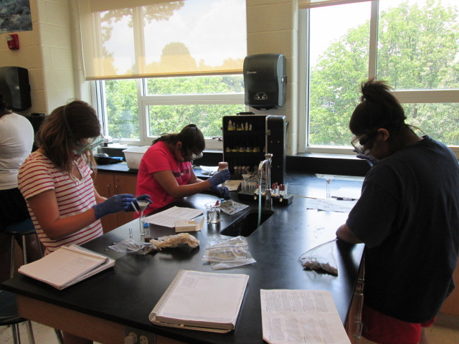
The effect of Location on Chloride levels (ppm)

By: Alanna Aboulafia, Kira Barrett, Briana Davis and Eva Frankel
Abstract
Significantly high levels of chloride were found in E.S.S.R.E. Site 4 during a general biota survey in July 2013. Chloride is absorbed by plants to help regulate the opening and closing of plant stomata and controlling the transpiration process plants use to transport materials. It is believed that chloride is essential in plant disease prevention. The E.S.S.R.E. 2013 Biota Survey revealed significant changes in plant life in Sites 1-3 as well since last year’s Biota Survey, and we wondered if the changes in plant variety might be the source of the observed differences in soil chloride levels. We hypothesized that white grass, with its small blade, would have significantly higher levels of chloride near its roots. On the other hand, sugar maple, with its larger size and numerous leaves, would have significantly lower levels of chloride near its roots. 15 cm deep by 2.5 cm wide samples were taken from the soil near the roots of sugar maple, spicebush, goutweed, white grass and English ivy, and all samples were tested for chloride (ppm). Contrary to our hypothesis, we found that English ivy had the lowest level of chloride near the roots. English ivy is a fast-growing invasive plant, and we suspect that it needs high levels of chloride in order to sustain its plant growth; hence the lower chloride levels absorbed in the soil around its roots. Further experimentation could be done by planting white grass and English ivy in two different pots with the same amount of chloride in a lab setting and then testing to see which plant absorbs chloride faster.

Introduction
Chloride, an ion of the element chlorine that is part of many common salts, is a nutrient essential for plant growth. Plants easily absorb chloride from soil (Hudler, n.d.), and it plays a crucial role in photosynthesis, aiding in the production of oxygen by controlling the availability of the water for the “splitting” process in photosynthesis in which water is converted into oxygen, hydrogen, ions, and electrons for photophosphorylation. (Lamond & Leikan, 2002 and Bard & Fox, 1995). Along with its role in photosynthesis, chloride also activates enzymes in the cytoplasm of plant cells (Broadley & White, 2001), and it is important to the process of osmosis, regulating the plant cells’ ability to release and absorb water. Chloride is also essential for opening and closing a plant’s stomata (Rashke & Schnable, 1980), the openings in leaves that a plant uses to regulate the loss of water that causes transpiration to take place (Jarvis & McNaughton, 1986). Transpiration is necessary in order to move minerals throughout the plant, cool the plant, and create water pressure in order to keep the plant upright (Whiting, Roll & Vickerman, 2010).
However, too much chloride in soil can result in drought-like conditions for plants (Hundler, n.d.), as the environment surrounding the plant becomes too hypertonic, preventing water from entering the plant (Lamond & Leikan, 2002). A surplus of chloride in soil leads to chloride toxicity (Lamond & Leikan, 2002) and can cause scorch marks on leaves (Hundler, n.d.). Hence, proper chloride levels in the soil are crucial for plant health and growth, but these levels need to be in proper balance in the soil in order for plants to prosper. Too little chloride in soil causes chloride deficiency in plants, leading to negative consequences such as a higher vulnerability to diseases.
During the 2013 E.S.S.R.E. Biota Survey (E.S.S.R.E. 2013), statistically significantly higher levels of chloride (800 ppm) were observed in Site 4 (N 39.35733; W 076.63840), as compared to Site 1 (112 ppm), Site 2 (125 ppm) and Site 3 (100 ppm). The same Biota Survey (E.S.S.R.E. 2013) revealed significant changes in plant life in Sites 1-3 as well since last year’s Biota Survey (E.S.S.R.E. 2012), and we wondered if the changes in plant variety might be the source of the observed differences in soil chloride levels. Prior research has shown that different types of plants respond differently to changes in soil chloride levels, and it is well documented that both sugar maple and English ivy are sensitive to salt damage due to excess to sodium or chloride in the soil (Luzadis & Gossett, 1996), while goutweed and spicebush are both likely to absorb more chloride than white grass as a result of their greater amount of stomata (Garske & Schimpf, 2009). Based on these previous findings, we hypothesized that the source of the discrepant chloride levels found in this year’s survey may be due to differences in the plant life found this year in the four E.S.S.R.E. microclimates. Consequently, we took soil samples at the roots of several different types of plants (goutweed, spicebush, white grass, sugar maple and English ivy) as well as soil samples from areas with no plants to serve as a negative control and tested these soil samples for chloride levels.

Methods
5 individual locations were selected for testing for soil Chloride levels (ppm) in E.S.S.R.E. Sites 1, 2, 3 and 4 (E.S.S.R.E., 2001) based on variations in the plants at each location. A cylindrical soil sample 2.5 cm wide by 15 c.m. deep was taken each morning at 11 a.m. for 5 consecutive days in July 2013. From Site 1 in Quadrant 2, a sample was taken near Spicebush (Lindera benzoin). From Site 2 in Quadrant 1, a sample was taken near English Ivy (Hedera Helix). From Site 3 in Quadrant 1, a sample was taken near a Sugar Maple (Acer saccharum) . From Site 4 in Quadrant 2, a sample was taken near Goutweed (Aegopodium podagraria). Also in Site 4, in Quadrant 1, a sample was taken near White Grass (Leersia virginica). Each sample was taken within 5 cm of each of the identified plants. An identical sample was taken from each location in the same area where all plant life was absent to serve as the negative control. All soil samples were tested for chloride levels (ppm) using the LaMotte™ Model STH-14 Combination Soil Test Kit.
Results
Graph 1.
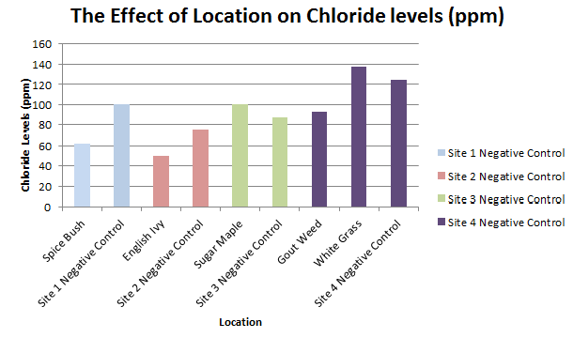
Chloride Levels (ppm) Every Plant vs. Every coresponding Negative Control
Figure 1.
T-Testing
(Top) P-Values of Each Plant vs. Each Plant
(Bottom) P-Values of Each Plant vs. the corresponding Negative Control

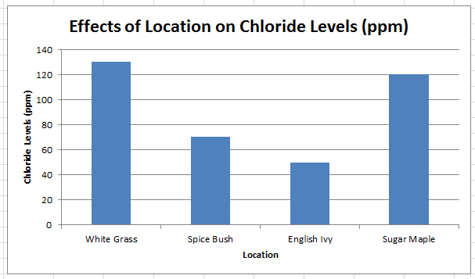
Graph 2.
Chloride Levels (ppm) White Grass vs. Spice Bush vs. English Ivy vs. Sugar Maple

Graph 3.
Chloride Levels (ppm) English Ivy vs. Gout Weed vs. White Grass
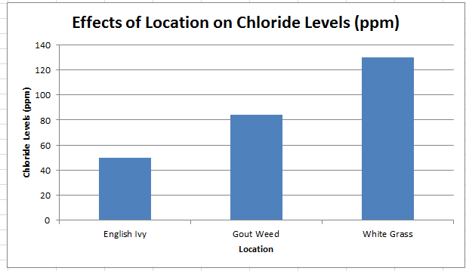

Graph 4.
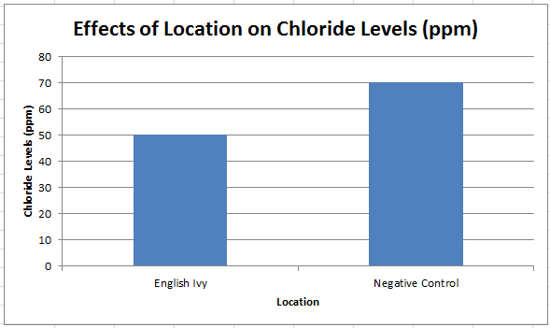
Chloride Levels (ppm) English Ivy vs. corresponding Negative Control
Discussion
Examining the data from different ESSRE sites’ collected during the 2013 ESSRE Biota survey (E.S.S.R.E. 2013), we hypothesized that the unusual Chloride levels observed in the soil in Site 4 this year (800ppm) are the consequence of the white grass population there. As both graph 1 and our p-values show (see Fig.1), our hypothesis was thoroughly disproved.
However, we did find that there were clearly several statistically significant differences in chloride levels in the soil corresponding to specific plant groups. As graph 2 shows, the type of plant located in soil with the lowest amount of chloride was consistently the English Ivy (50 ppm). It was statistically lower than the sugar maple (p=.252), the spice bush (p=.391), and the white grass (p=.102). And as graph 3 indicates, it was also significantly lower than the goutweed (p=.146). Even when compared with the negative control, as shown in graph 4, the English ivy had significantly low chloride levels (p=.114).
Upon further research, we found other possible variables which could have affected Site 4’s Soil chloride levels. English Ivy is an invasive species prevalent in parts of Site 4, and since invasive species are highly competitive for resources, so it is quite possible that English Ivy absorbs Chloride faster than native species (Brand, 2001 and USDA, 2013). The reason invasive species are so competitive for resources is because they can grow faster, which requires that they photosynthesize faster. Faster photosynthesis requires more active guard cells to control the opening and closing of the stoma, a process, of course, which depends on Chloride. Therefore it is possible a fast-growing plant like English Ivy maybe absorbing Chloride faster to meet its photosynthesis needs. For further experimentation, we could plant White grass and English Ivy in two different pots with the same amount of Chloride and see which plant absorbs it faster.
References
Bard, A.J. and Fox, M.A. (1995). Artificial Photosynthesis: Solar Splitting of Water to Hydrogen and Oxygen. University of Texas.
http://bard.cm.utexas.edu/resources/Bard-Reprint/582.pdf
Brand, M. (2001.) Lindera Benzoin. UConn Plant Database.
http://www.hort.uconn.edu/plants/l/linben/linben1.html
Broadley, M. and White, P. (2001). Chloride in Soils and Its Uptake and Movement Within the Plant: A Review. Annals of Botany.
http://aob.oxfordjournals.org/content/88/6/967.full.pdf
E.S.S.R.E. (2012) 2012 Site 4 Summary Information. Environmental Science Summer Experience for Young Women.
http://essre.rpcs.org/2012/TA%20Folder/2012%20site%204%20summary%20information.html
E.S.S.R.E. (2013). Annual Research Statistical Summaries. Environmental Science Summer Experience for Young Women.
http://essre.rpcs.org/ESSRE%20Survey%20Data/Total%20Site%20Data.html
Garske, S. and Schmipf, D. Goutweed. Plant Conservation Alliance.
http://www.nps.gov/plants/alien/fact/aepo1.htm
Hilty, J. (2013) White Grass. Illinois Wildflowers.
http://www.illinoiswildflowers.info/grasses/plants/white_grass.htm
Herb Society of America. (2010). Essential Facts for Spicebush. Herb Society of America.
http://www.herbsociety.org/herbs/documents/Linderabenzoin_000.pdf
Hudler, G. W. (n.d.) Salt Injury to Roadside Plants. Cornell University.
http://www.gardening.cornell.edu/woodies/pdfs/saltinjury.pdf
Jarvis, P.G. and McNaughton, K.G. (1986). Stomatal Control of Transpiration. Advances in Ecological Research, Volume 15.
http://www.ipef.br/eventos/2009/graduatecourse/20-jarvis_mcnaughton_1986.pdf
Lamond, R. E. and Leikam, D. F. (2002) Chloride in Kansas: Plant, Soil and Fertilizer Considerations. Kansas State University.
http://www.ksre.ksu.edu/bookstore/pubs/MF2570.pdf
Luzadis, V.A. and Gossett, E.R. (1996). Sugar Maple. Cornell University.
http://maple.dnr.cornell.edu/pubs/trees.htm
Ohio Public Library. (2013). Sugar Maple. Ohio Public Library Information Network.
http://www.oplin.org/tree/fact%20pages/maple_sugar/maple_sugar.html
Raschke, K. and Schnabl, H. (1980). Potassium Chloride as Stomatal Osmoticum in Allium cepa L., a Species Devoid of Starch in Guard Cells. Michigan State University.
http://www.ncbi.nlm.nih.gov/pubmed/16661151
USDA (2013.) Plants Database. Plants Database.
http://plants.usda.gov/classification.html
Whiting, D., Roll, M. and Vickerman, L. (2009). Plant Growth Factors: Photosynthesis, Respiration, and Transpiration. Colorado State University.
http://www.cmg.colostate.edu/gardennotes/141.html

Acknowledgements
We would especially like to thank our sponsors, Human Capital Development, Inc., Larry and Kathy Jennings, and Dr. Holliday Cross Heine who generously funded this program. We would also like to thank David Brock for guiding our research, giving us suggestions, and directing the E.S.S.R.E. program. We would like to thank Grace Laria, Meredith Kuser, and Maddy Shay for answering all of our questions and helping us with whatever we needed along the way. Finally, we want to thank Roland Park Country School for letting us use their science labs and backwoods which allowed us to perform our experiments.

