Alanna Aboulafia

April 2014

STEM 2B

Individual Impact Study

Stage-gate one was to cut a single plastic bag into 4 strips, and then fill them with sunscreen. The second stage-gate design was a new and improved package. Our final stage-gate design was created when the two “design” teams met and discussed possible design ideas.

1. Cost summary of Materials:

The group was given eight different materials to create design and construct the package for sunscreen. This package will be used to hold 88 ml of sunscreen. Since the package would hold a liquid, the materials used must be able to hold a liquid without getting ruined. The materials were:

1. Newspaper (one sheet): One sheet costs $.25
2. Cardboard Square (one square): One square costs $1.00
3. Plastic Baggies (one bag): Once bag costs $.25
4. Plastic Wrap (30 x 15 cm): One sheet costs $.75
5. Foil (30 x 15 cm): One sheet costs $.50
6. Wax Paper (30 x 15 cm): One sheet costs $.50
7. Duct Tape (2.5 cm): One inch/2.5 cm costs $.50
8. Making Tape (2.5 cm): Once inch/2.5 cm costs $.25
9. Physical summary of materials:
10. Newspaper: It is a lightweight and malleable material. It can be used to cushion your product. Although, when it comes in contact with water it is no longer viable.
11. Cardboard: It is used very often in the packaging business and it can be very strong and supportive. Although, it is hard to shape and it becomes unusable when wet.
12. Plastic Baggies: They can be used to reseal things, and keep them airtight. They can often hold a lot of air, but other than air, there is not padding for the bag and its objects inside it. Additionally, when thrown away, it takes a while to decompose and break down.
13. Plastic Wrap: Although this material is most commonly used to package food, it is also beneficial because it sticks to itself. This is useful because one does not have to use tape to seal it which means they can save more money. The negative of this material is that it does not provide any padding unless one uses a lot of it. This is detrimental to one’s wallet, and to the environment.
14. Foil: Like plastic wrap, foil is usually used to store food. It is perfect for storing food because it keep bacteria out, light, and moisture. It is also very easy to recycle. Once problem is that it is very thin, allowing damage to be cause very easily.
15. Wax Paper: This product is considered to be waterproof and biodegradable. Although it does not perform as well as plastic under water, and newspaper in the environment it is still a useful material.
16. Constraints:

We were asked to make a package that could hold 88 ml of sunscreen. In addition to just holding it, it should be able to survive the “normal” traveling and shipping conditions. If we used glue in our package, our cost limit would be $3.00 but if we did not use glue our cost limit would be $4.00.

1. Testing Materials Results:

|  |  |  |  |  |  |  |  |
| --- | --- | --- | --- | --- | --- | --- | --- |
| Materials | Drop | Shake | Weight | Throw | Water | Heat | Average: |
| Newspaper | 2 | 3 | 3 | 3 | 1 | 2.5 | 2.4 |
| Cardboard | 2 | 3 | 2 | 1 | 2 | 3 | 2.1 |
| Plastic Baggies | 3 | 2.5 | 3 | 3 | 3 | 3 | 2.9 |
| Plastic Wrap | 2 | 1 | 3 | 2 | 3 | 3 | 2.3 |
| Aluminum | 2.5 | 2.5 | 1 | 2.5 | 1 | 3 | 2 |
| Wax Paper | 3 | 2 | 3 | 3 | 3 | 3 | 2.8 |

**Note: The table above shows the results from when the materials were tested. These tests, challenged the strength of the package, and concluded whether or not it could be made into a viable product. **These are the average of five trials for each test.**

Key:

1 pt.- Lots of damage

2 pts.- Little damage

3 pts.- No damage

**Note: Plastic baggies had little to no damage done to them during the testing process.

We concluded that since the plastic bag had little to no damage, we would utilize this material when making our package. The aluminum and wax paper also survived the testing with minimal damage. We decided to utilize these materials too.

1. Our design: (Deniera, Jordan, and I)

Our package involves heating the plastic baggie into two parts. We discovered that the heat applied to the four strips of plastic was putting more holes into it, rather than sealing it. We decided to modify the four baggie idea, and just make two. The plastic bag would be cut into two parts, and sealed by heat. Therefore, it would be able to hold a total of 88ml of sunscreen. Then, the baggies would be laid down onto a piece of foil with wax paper on top. It would then be folded and sealed with duct, and masking tape. The materials we used were: aluminum foil, wax paper, a plastic bag, masking tape, and duct tape.

**Diagram of package:**



**Once the bag was cut into two, the open edges were sealed shut by the heat. Each bag could hold 88ml of sunscreen or more.**



**The plastic bag was cut into two pieces. This made two smaller bags. They still fit the products constraints.**



**The wax paper is laid on top of the foil. The two plastic baggies are then laid on top of the wax paper. The wax paper protects and stops any water from coming in or out of the package. The foil is then folder in; creating a brochure type package. Then, both duct and masking tape are used to seal the package.**



**Picture of package:**

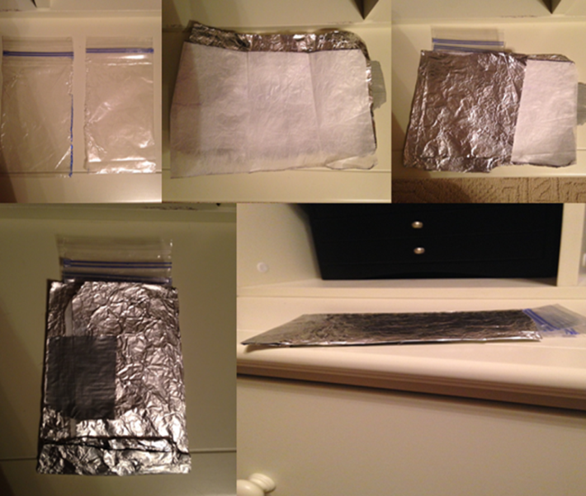

1. Cost Analysis:

|  |  |
| --- | --- |
| Materials | Cost |
| Plastic Bag | $0.25 |
| Wax Paper | $0.50 |
| Aluminum Foil | $0.75 |
| Duct Tape (2 inches) | $1.00 |
| Masking Tape (1 inch) | $0.50 |

Our package costs $3.00. Since we did not use any glue, we could have used $4.00. Since we have $1.00 left over, and an additional package design idea, we could use the dollar to improve our package.

1. Table of Test Results:

|  |  |  |  |  |  |
| --- | --- | --- | --- | --- | --- |
| Our package | Drop | Shake | Weight | Throw | Water |
| **Average of 5 test** | 3 | 3 | 3 | 3 | 3 |

**Note: Our package got a perfect score on the entire test. This shows that our package was a workable, and practical product.

1. Conclusion:

Our design is going to be the same design we use to make for our final package. Since this is our Stage 1 evaluation, we still have yet to come to a complete and viable package. The problems that are existing right now are that there are still a few holes on the sides of the bags, and we are trying to think of a more efficient way to seal (using heat) the bags. We will use the remaining $3.75 to improve our method of heating the bags, and improving the padding on our package allowing it to survive during the shipping and handling process. Our plans for the future include making our package more efficient and viable. This means that maybe we will change our design idea to make the package more practical.

**Final 6 person group package:

Individual Impact Study

Since this was out final stage gate, we were asked to work with the other group. When working with the other group, we took the best parts of our two different packages, and made a “super” package.

1. Cost summary of Materials:

The group was given eight different materials to create design and construct the package for sunscreen. This package will be used to hold 88 ml of sunscreen. Since the package would hold a liquid, the materials used must be able to hold a liquid without getting ruined. The materials were:

1. Newspaper (one sheet): One sheet costs $.25
2. Cardboard Square (one square): One square costs $1.00
3. Plastic Baggies (one bag): Once bag costs $.25
4. Plastic Wrap (30 x 15 cm): One sheet costs $.75
5. Foil (30 x 15 cm): One sheet costs $.50
6. Wax Paper (30 x 15 cm): One sheet costs $.50
7. Duct Tape (2.5 cm): One inch/2.5 cm costs $.50
8. Making Tape (2.5 cm): Once inch/2.5 cm costs $.25
9. Physical summary of materials:
10. Newspaper: It is a lightweight and malleable material. It can be used to cushion your product. Although, when it comes in contact with water it is no longer viable.
11. Cardboard: It is used very often in the packaging business and it can be very strong and supportive. Although, it is hard to shape and it becomes unusable when wet.
12. Plastic Baggies: They can be used to reseal things, and keep them airtight. They can often hold a lot of air, but other than air, there is not padding for the bag and its objects inside it. Additionally, when thrown away, it takes a while to decompose and break down.
13. Plastic Wrap: Although this material is most commonly used to package food, it is also beneficial because it sticks to itself. This is useful because one does not have to use tape to seal it which means they can save more money. The negative of this material is that it does not provide any padding unless one uses a lot of it. This is detrimental to one’s wallet, and to the environment.
14. Foil: Like plastic wrap, foil is usually used to store food. It is perfect for storing food because it keep bacteria out, light, and moisture. It is also very easy to recycle. Once problem is that it is very thin, allowing damage to be cause very easily.
15. Wax Paper: This product is considered to be waterproof and biodegradable. Although it does not perform as well as plastic under water, and newspaper in the environment it is still a useful material.
16. Constraints:

We were asked to make a package that could hold 88 ml of sunscreen. In addition to just holding it, it should be able to survive the “normal” traveling and shipping conditions. If we used glue in our package, our cost limit would be $3.00 but if we did not use glue our cost limit would be $4.00.

1. Testing Materials Results:

|  |  |  |  |  |  |  |  |
| --- | --- | --- | --- | --- | --- | --- | --- |
| Materials | Drop | Shake | Weight | Throw | Water | Heat | Average: |
| Newspaper | 2 | 3 | 3 | 3 | 1 | 2.5 | 2.4 |
| Cardboard | 2 | 3 | 2 | 1 | 2 | 3 | 2.1 |
| Plastic Baggies | 3 | 2.5 | 3 | 3 | 3 | 3 | 2.9 |
| Plastic Wrap | 2 | 1 | 3 | 2 | 3 | 3 | 2.3 |
| Aluminum | 2.5 | 2.5 | 1 | 2.5 | 1 | 3 | 2 |
| Wax Paper | 3 | 2 | 3 | 3 | 3 | 3 | 2.8 |

**Note: The table above shows the results from when the materials were tested. These tests, challenged the strength of the package, and concluded whether or not it could be made into a viable product. These are the average of five trials for each test.

Key:

1 pt.- Lots of damage

2 pts.- Little damage

3 pts.- No damage

We concluded that we should take the strongest materials and use them in our package.

1. Our design: After a day of discussing several ideas about the way our package should be made, and out of what we finally came up with a design. This was that we would just take one plastic bag, fill it with 88 ml of sunscreen, and the fold the bag into a rectangular shape. Then, take foil, cardboard, wax paper, newspaper, duct and making tape and seal the bag with them.
2. Diagram of our design:



**Step 2: Fill the plastic bag with 88 ml of sunscreen.**



**Step 1: Tape (using duct tape) foil to the front of the cardboard, and tape wax paper to the back of the cardboard. (Just one piece of cardboard).**

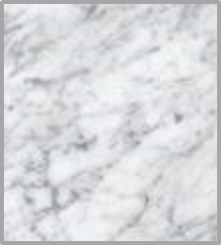







**Step 4: Fold the cardboard into a burrito looking shape, and seal it with duct tape. This leaves the plastic bag containing the 88 ml of sunscreen to remain protected from anything causing damage to it.**

**Step 3: Place the plastic bag (containing 88 ml of sunscreen) on top of the cardboard (with the foil facing down).**



1. Pictures of our package:
2. 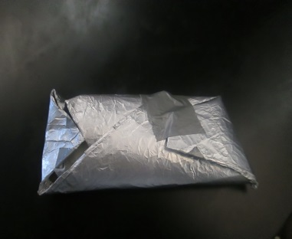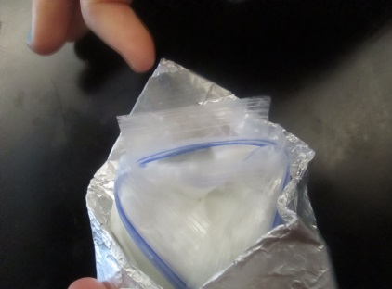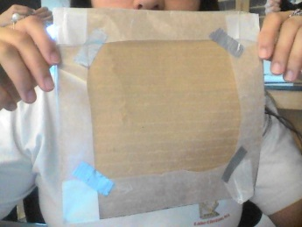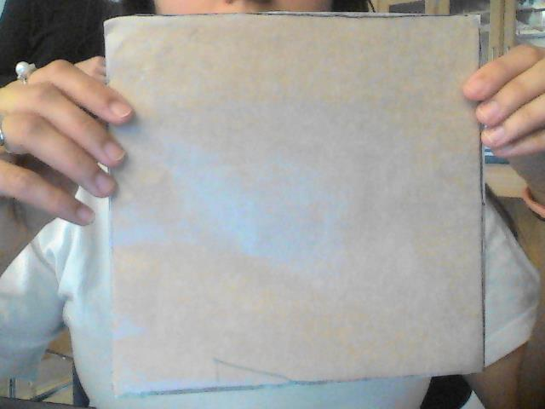
3. Rational for materials selected:
   1. Plastic Bag: used because it has a pre-made seal and it is waterproof.
   2. Cardboard: Study and it is very easy to bend its shape to properly assure the packages protection.
   3. Duct Tape: It cost less money to utilize it rather than glue. It is also easy to bend its shape.
   4. Wax Paper: It is sturdy and it can be bent into several shapes. It is also waterproof.
   5. Foil: Waterproof and flexible.

1. 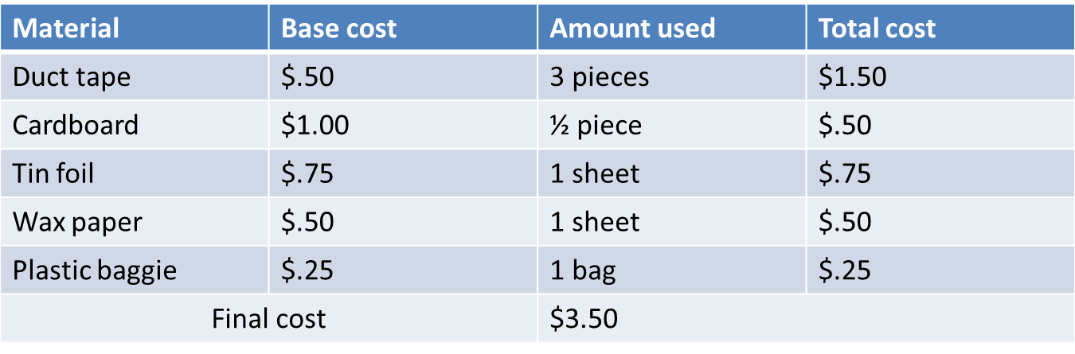 Cost Analysis:
2. Table Summarizing Test Data:

|  |  |  |  |  |  |
| --- | --- | --- | --- | --- | --- |
| Package | Drop | Shake | Weight | Throw | Water |
| **Average of 5 test** | 3 | 3 | 3 | 3 | 3 |

**Note: Our package got a perfect score on the entire test. This shows that our package was a workable and practical product.

Key:

1 pt.- Lots of damage

2 pts.- Little damage

3 pts.- No damage

We concluded that our package was ready to be released to the public for them to utilize.

1. Suggestions for the future:

We recommend that when making this package, carefully seal the plastic bag before inserting it into the outer shell (cardboard, foil and wax paper). We also recommend using every piece of material carefully, and make good use out of it all. Lastly, we believe that an additional material could have been used to cover the foil. Maybe plastic wrap to not only protect it from water, but to also protect the foil from overheating when in contact with the sun. We feel very confident in our package, we do not have any other suggestions.

1. Conclusion:

Our final design involves the ideas of Group one’s package design, and Group two’s package design. We worked together in deciding what exactly we wanted out package to do, and then we appropriately evaluated the materials we had. We then formulated a package that received a 3 on the Materials Preliminary Testing. That means that the package survived the entire test. This gave us enough confidence to then conclude that our package was completed and fit all of the necessary guidelines. The next step is to collaborate with the sunscreen group and add it into our package. Then, our package would be ready to be sold to the public.