Stem IB
Julia Potter and Alanna Aboulafia
May 23, 2013
Challenge Two Point-to-Point
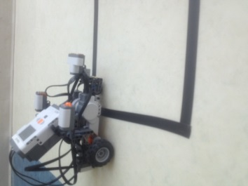
After many long lunches, study halls, class time, and club time tiresomely working on the second Robot Challenges: Point-to –Point, this is how close the Robot was able to get into the box.

For the Robotic Challenge Point-to-Point, the Robot Behavior was to start within a set one foot square box taped to the floor and end within a second one foot square box taped to the floor near the end of the corridor. In this, we were restricted to using rotation sensors and this was difficult because the hallway was curved. Certain design decisions which were made was that we did not use a loop. Whenever a loop was used the robot was unable to successfully get remotely near the black box. By not using loops we were able to specifically change each move block to go where we wanted. When testing the program that has a sequence of move blocks, it was more successful in getting closer to the black box. Also, in order to make the robot travel faster down the hallway (although this was not mandatory it was more efficient) we changed the gears. We put the 10 teeth gear on the wheel and the 20 teeth gear on the motor. By doing this we made the robot travel quicker. This occurs because one turn for 20 teeth gear is two turns for the 10 teeth gear which makes the wheel turn twice more. As a result of this, it goes a further distance for wheel turn. Also, for each of the power level’s we put them in a “neutral” zone. (From 70-80). If we put the power levels all the way up to 100 the robot would lose control.
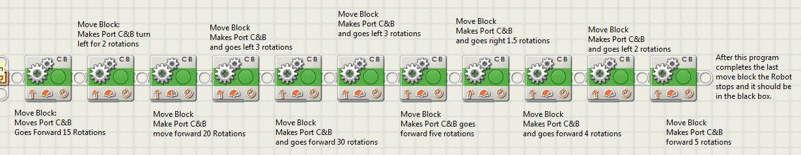
This is the sequence of the program. Each block are move blocks. Above and below each of the move blocks describes the function of the block and what the robot does.

