Briana Davis
STEM
25 February 2013
Clay Mask
Ingredients Used and the Cost
Item | Grams Used | Cost
Kaolin Clay | 5 grams | $0.042
White Sand | 0.5 grams | $0.00195
Honey | 1.2 grams | $0.01044
Distilled Water | 2.5 grams | $0.025
Altoids | 0.67 grams | $0.023
Aloe Vera | 2 grams | $0.051
 | 11.87 grams | $0.15339
Cost per gram |  | $0.012922

Order of Procedure:
- Add 5 grams of Kaolin Clay to the mortar.
- Crush .67 grams of Altoids in the mortar.
- Then add .5 grams of white sand to the mortar.
- Add 1.2 grams (1 squirt) of honey to the mortar.
- Then add 2.5 grams of distilled water to the mortar.
- After all of the ingredients are in the bowl, mix them up with a pestle.
- Mix ingredients until the product is smooth and all ingredients are mixed well.

Ingredient Analysis
The group chooses the ingredient Kaolin Clay because the group realized that Kaolin Clay has a smooth feeling meaning that it is free from unevenness. The group had also, chose the ingredient white sand because it’s an abrasive meaning it has a rough feeling, which means that it would be a good item to use to help get into the product users pores. Another ingredient that the group has chosen is honey. The group has chosen that ingredient because it’s a preservative, and also because it’s smooth and smells better than then the other preservative items the group had to choose from that’s a good thing because if the groups product smells good it would attract more people. The group had also chosen the ingredient distilled water because water makes the concoction less thick. Also, the group used aloe vera because it is a smoother and healer, meaning that it would make the skin smooth and heals scars or sores. Lastly, the other ingredient the group chose was Altoids. The group has chosen Altoids because it adds a nice scent to our clay mask. The other ingredients were not chosen to be put into our clay mask because the group had found that they had more cons than pros about them. Some of the cons were foul smell, it was clumpy or rough. Also, because from other times when the group was experimenting the group found that those certain items weren’t a good mixture in our clay mask. The group did not use Green Clay because the group didn’t like the color of the clay. Color mattered to the group because users would not want to put a nasty, dirty looking product on their face. Another ingredient the group did not use was Fuller’s Earth Clay because the group found that Kaolin Clay was a better option because of the color. The group did not use Flaxseeds because it smells bad and it also was difficult to break and mix. The group chose to use Tea Extract because it didn’t smell good and it was too grainy. The group used glycerin because it did not smell good and had already included a preservative in our concoction already. The mask did fall into the constraints because it was smooth because the group used Aloe Vera. By using the honey it made the mask easier to wash off of the skin. The group’s clay mask product did fall into the assigned budgets because the group stayed under two cents. Also, the group stayed at the use of six ingredients or under.

Cost Analysis
The initial analysis for the seven ingredients showed that the total production cost is $0.45. The Pareto analysis showed that the four most important ingredients to focus on cost were Aloe Vera, Kaolin clay, distilled water, and Altoids. Two out of these four items we were able to save money by buying in bulk.
Aloe Vera was the most expensive item. It can be purchased at CVS for $5.49 for a 24oz, or $5.99 for a 20 oz.
Kaolin clay can be purchased at starwest-botanicals.com for $9.83 per pound.
Distilled water can be purchased at myotc.com for $17.20 for one gallon.
Altoids could be purchased at Walgreens for $3.99 for 2 tins or $7.98 for 4 tins.
Some other observations or questions would be is there any other places where I can buy Aloe Vera for a cheaper price with a smaller amount?

Make vs. Buy Distilled Water
To buy distilled water from a store cost about 99¢ per gallon. To make your own distilled water, you must have a machine which costs $399. Adding to that $399 you have to include the cost of electricity that will be used to run the machine and filters. The cost of energy is 21¢ to run 1 gallon of distilled water. The costs of filters are $36 for 6 filters, meaning that it would be 10¢ per gallon in filters. The total cost for everything would be $38.80 per gallon pule the cost of the machine ($399).
To find where the two methods of acquiring water would cost the same amount, two equations were found, cost= .99 gallons and cost= .3 gallons+ 399. This would make 665 gallons of water for $658.35. Therefore, buying water would be the best. This is because it would be cheaper to buy the distilled water than to make it yourself.

Pareto Chart:
Graph
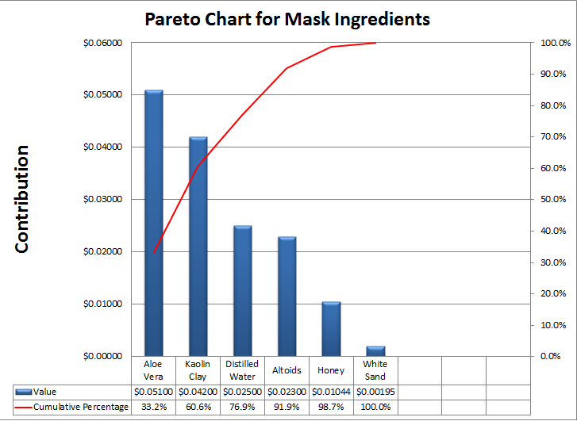
Data Table:
