Briana Davis

STEM

2 April 2013

Egg Drop Project

Material List:

* Cardboard
* Bubble wrap
* Saran wrap
* Starbucks cup
* Toothpicks
* Duct tape
* Cardboard paper
* Egg

Mass of package and egg: 128.4 g

Our egg was able or survival because we put a small cardboard box around the Starbucks cup to make an outer protector for the cup. Than inside of the cup we put a layer of toothpicks so that the egg wouldn’t touch the bottom of the cup because when the cup hits the ground it would crack, so we put the toothpicks so that it wouldn’t touch the bottom. Than we put balls of cardboard paper all around the egg to package it and protect it. Than we put a layer of bubble wrap across the top of the box so that if the egg fell out of the cup it would protect it. Than we put another layer of saran wrap over top of the bubble wrap for another layer of protection.

If we had another opportunity to do another trial, the old thing I would change about my project is that I would put more cushions inside of the box for more protection for the egg.

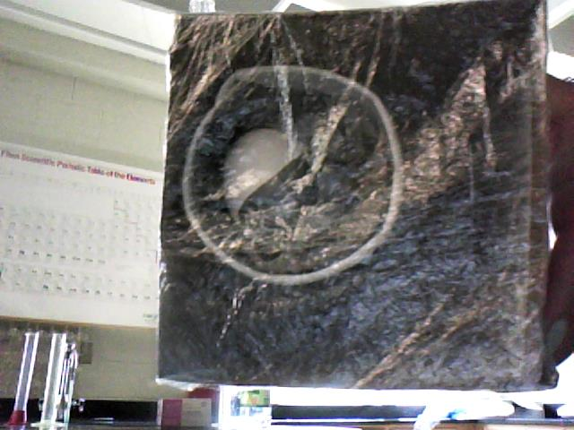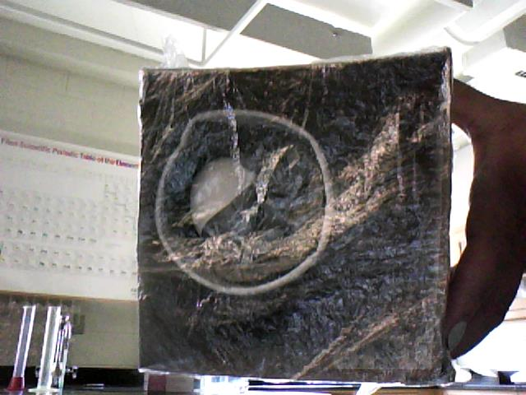



**Top view after**

**Top view before**