Brittany Jones

STEM IB

10 April, 2013

Egg Drop Paper

**Materials used for package:**

* Cotton Balls
* Foam Cup
* Bubble Wrap
* Toothpicks
* Cardboard
* Small Sweatband
* Duck/Masking Tape
* Air Bag

**Mass of Egg Package:** 63 grams

**Mass of Egg Package with Egg:** 113 grams

**Before Egg Drop:**

**Side: Top:**

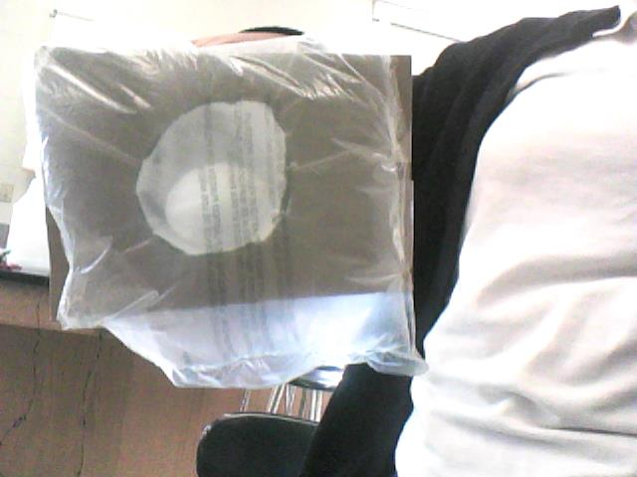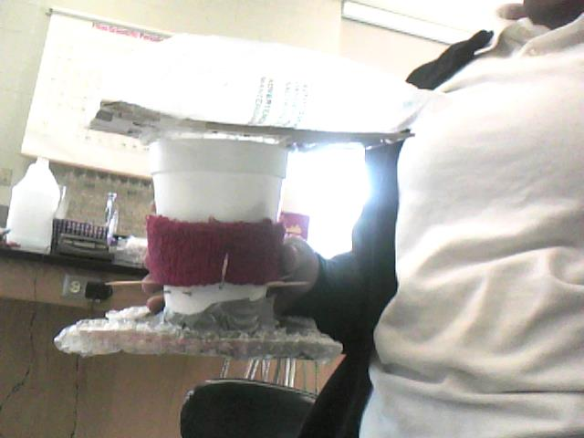

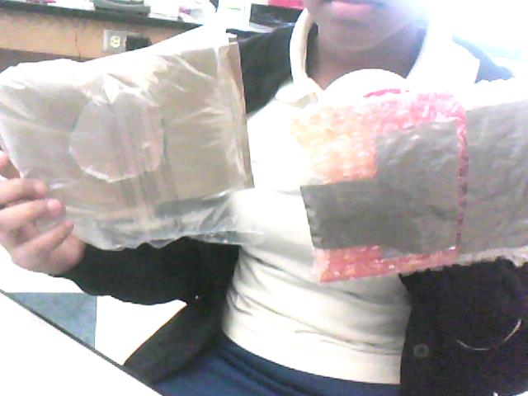**After Egg Drop:**

**Top & Bottom:**

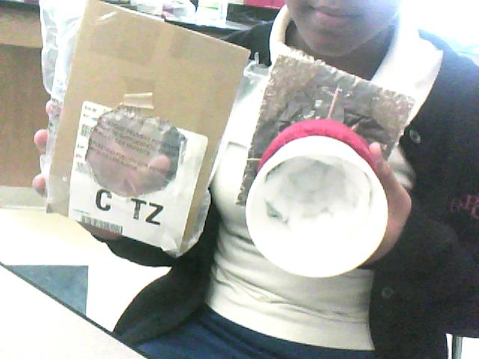

**Inside & Top:**

**Observation and Improvements:**

When we first dropped our egg it broke. I believe that our egg broke because of the quality of our package. Before the egg hit the ground the top of the package flew off and the egg moved around. I also believe that our package wasn’t the best because the egg wasn’t supported on the side as much as it was being supported on the top and the bottom. Knowing what happened on our first trial on dropping the egg we should try to improve our packaging. If we have an opportunity to re-drop our egg I would add more cotton balls around the sides of the egg and maybe wrap bubble wrap around the outside of the cup to add more protect to the sides to stop the egg from cracking when hitting the ground. I would also add more tape or glue to the items because as seen in the first drop pieces of our package flew off which made the egg more vulnerable to cracking.