Brittany Jones
STEM
4 May 2014

Final Stage-Gate Personal Project
The goal for the final stage-gate was the same as in our first stage-gate. The goal was to determine how much OM Cinnamate and Oxybenzone mixed would be able to pass the LD50 test that is incorporated within the FDA guidelines. If the amount is out of the FDA guidelines the sunscreen would be toxic and it wouldn’t be efficient and beneficial. The amount of OM Cinnamate cannot be above 2 grams and the amount of Oxybenzone cannot be above 5.28 grams. Other than OM Cinnamate and Oxybenzone the sunscreen will contain, Cetyl Alcohol (2g), Steric Acid (4g Glycerin (2g), Trethanol Amine (1g) and Distilled Water (78g). The feasible region states all of the possible values of OM Cinnamate and Oxybenzone that are in the projects constraints. OM Cinnamate cannot be more than 6 grams, but can equal 6 grams. For Oxybenzone it cannot be more than 7.5 grams, but can equal 7.5 grams. If the amounts falls above the feasible region the sunscreen will become toxic and it falls below the feasible region the product wouldn’t be considered sunscreen. The max SPF for OM Cinnamate is 7.5% and the low is 2%, for Oxybenzone the mas SPF was 6% and the low was also 2%. The cost equation for the project is cost= 8.05*Oxybenzone+6.67*Cinnamate.

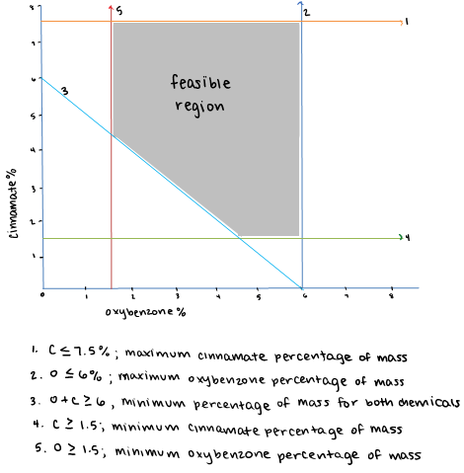

The LD50 test tests for how toxic the chemicals are by showing the survival rate. In order for a substance to pass the LD50 test, the survival rate has to be 50% or higher. The LD50 test uses a control, a medium, and a high value.
For the control, OM Cinnamate was not added, but for the medium and high level 22 drops (.5g) and 43 drops (1g) were added. Both of the values were below the feasible region because if more was added the solution wouldn’t be able to fit into the test tubes. The results show that there were problems in out LD-50 test. Such as too much ecoli was being killed. Here is the data table.

Data | Trial | # of Survival high | % of survival high | # of drops low | % of survival low | % of survival control
2/28 | 1 | 43 | 41.7% | 22 | 0% | 41%
2/28 | 2 | 43 | 24.45% | 22 | 33.08% | 21.03%
3/4 | 3 | 43 | 16% | 22 | 38.8% | 87%
3/4 | 4 | 43 | 29.4% | 22 | 9.14% | 75%
Averages: |  |  | 27.9% |  | 20.3% | 56.0%

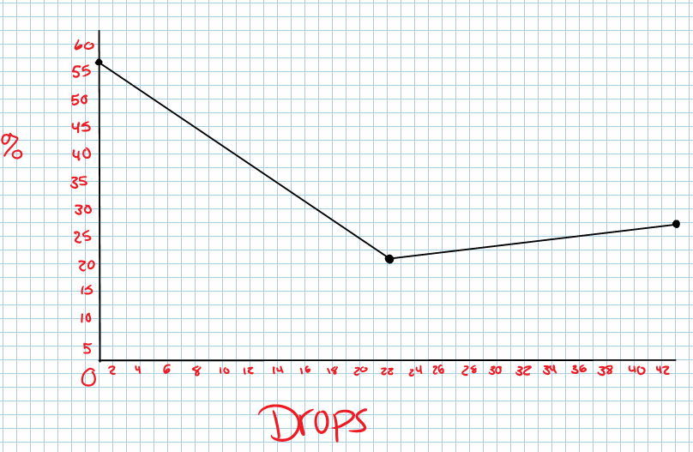

This shows that even though the test was below the feasible region it still killed too much ecoli. For further research the quantity of OM Cinnamate added should be changed to fall into the feasible region and not kill more than 50% of the ecoli.
The rationale was that to change each level of OM Cinnamate after each test to try to get a better LD50 test. During the first trial 1 gram and .5 grams of Cinnamate was used, but an LD50 was not found using those value, so less was used next. In the 2nd trial 0.5 grams and 0.25 was used, to see if an LD50 could be found. The LD50 was at about 0.36 grams, which made the group chose to add more because there was not a perfect LD50. In the 3rd and 4th trial, an LD50 trial wasn’t found. This started the group work with the Oxybenzone to see if an LD50 could be found by using both chemicals. In conclusion, an LD50 was not found throughout the test. A general idea was found of what the amounts would be, but a specific LD50 was not found. To fix this both of the groups needed to come together for the final project.

OM Cinnamate Trials for LD50
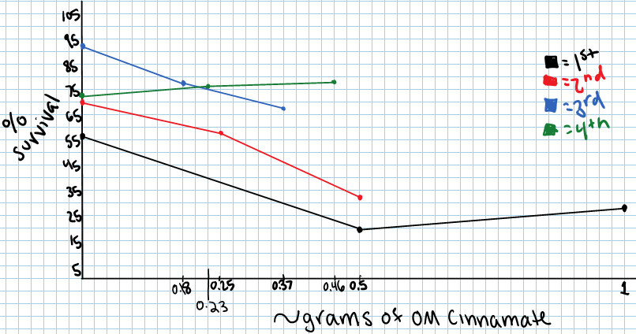

For the control when OM Cinnamate and Oxybenzone was added, neither OM Cinnamate nor Oxybenzone was added, but for our first and second trial high we added 6.6g of OM Cinnamate and 5.28g of Oxybenzone. For our low value we used 3.3g of OM Cinnamate and 5.8g of Oxybenzone.
First Trial Both OM Cinnamate and Oxybenzone:
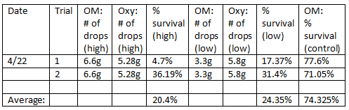
For the third and fourth trial the chemicals stayed consistent with the control by not adding neither OM Cinnamate nor Oxybenzone. For the high 3.3g were added of OM Cinnamate and 1.32g of Oxybenzone was added. The low changed by adding 1.65g of OM Cinnamate and 1.32g of Oxybenzone.
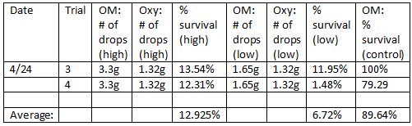
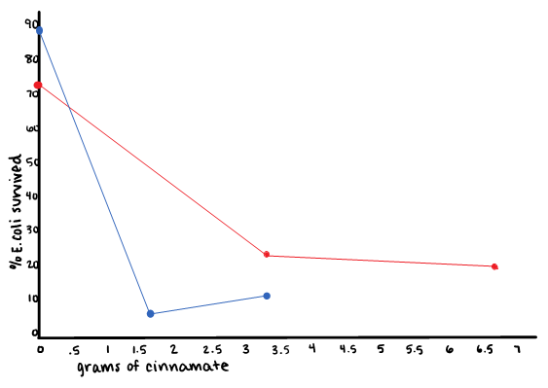

Trial 1: 5.28g oxybenzone
Trial 2: 1.32g oxybenzone

When More Oxybenzone & OM Cinnamate was added, the trend line was more at LD50.
The overall cost is: 2 grams of OM Cinnamate, 5.28 grams of Oxybenzone would be about 55.844 cents.
In the future, a better LD50 needs to be found. More tests should be done to receive a better LD50. There are other chemicals in the sunscreen that may play a factor in the outcome. Testing more chemical together could also change the results.

