Brittany Jones
Mrs. C
STEM

Clay Mask Analysis

Ingredients and Cost for Clay Mask

Items | Grams Used | Cost
White Sand | 1g | $0.0039
Mint Candies | 0.67g | $0.023
Aloe Vera | 3g | $0.051
Distilled Water | 6.5g | $0.055
Glycerin | 0.049g | $0.023
Fuller’s Earth Clay | 5g | $0.066
 | 16.219g | $0.2219
Cost-Per-Gram | $0.01368

Procedure:
- Crush an altoid with the mortar and pestle.
- Measure 5 grams of Fullers Earth Clay in a weigh boat using an electronic scale.
- Pour the measured out 5 grams of Fullers Earth Clay into the mortar with the altoid.
- Measure 1 gram of white sand in a weigh boat using an electronic scale.
- Pour the white sand into the mortar.
- Measure 3 grams of aloe vera using a pipet.
- Pour the aloe vera into the mortar.
- Measure 3 grams of aloe vera using a pipet.
- Pour the measured aloe vera into the mortar.
- Measure 6.5 grams of distilled water using a pipet.
- Pour distilled water into the mortar.
- Stir ingredients using pestle until mixed well.

While making our Clay Mask the team decided to use the ingredients that were chosen because of how beneficial we believed they would be in our clay mask. Our team used white sand because of how grainy and thin the texture of the sand was and our team believed that would mix well with the water and make the texture of the clay mask smooth. The team only decided to use one altoid because the smell of one altoid was enough. The team did not want the face mask to be too strong because it may irritate skin or could leave a strong minty smell on the face after the mask had been cleaned off. The aloe vera juice because of the way it is supposed to heal. The aloe vera is also smooth and it would make a great texture for our clay mask. Distilled water was chosen because our clay mask would need water. The water balances everything out in the clay mask. We decided to use glycerin because we never used that before in any other recipe and we thought it would be nice to see what it did. Last, we used the fuller’s earth clay because it was a really fine clay, and we thought it was better than the green clay. Other ingredients weren’t chosen either because we used it before and it wasn’t really good for our clay mask or we just never thought about using it. Our mask falls within the constraints because our clay is smooth, does not leave a residue, falls within the budget and it uses six ingredients.
Before Putting on Clay Mask
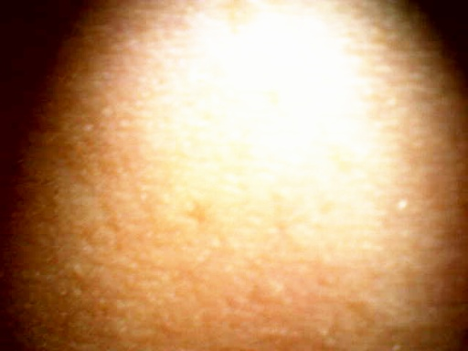

After Putting on Clay Mask
During the Clay Mask

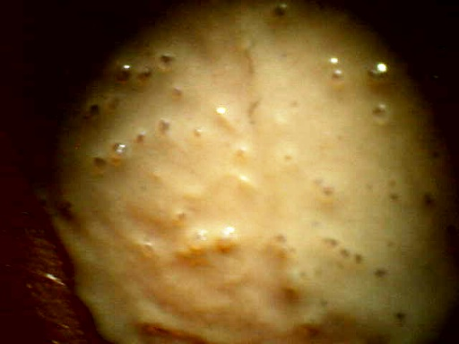
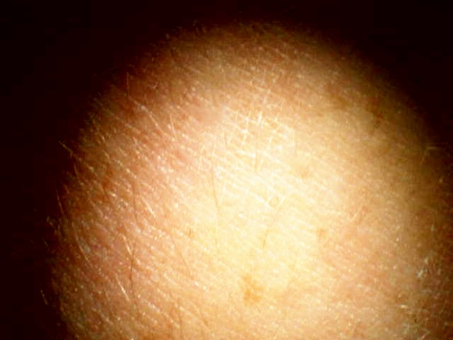

- A Pareto analysis showed that the three most important ingredients to focus on in our clay mask recipe were the ones that took up 80% of all of the ingredients. The three ingredients were aloe vera, Fuller’s Earth Clay, and distilled water. Our team made a conclusion which stated that only certain ingredients in our clay mask should be bought in bulk. Here are the results:
Pareto Chart Data for Mask Ingredients
Ingredient | Value | Percentage | Cumulative Percentage
Aloe Vera Juice | $0.0765 | 29.7% | 29.7%
Fuller's Earth Clay | $0.0660 | 25.6% | 55.3%
Distilled Water | $0.0650 | 25.2% | 80.6%
Glycerin | $0.0230 | 8.9% | 89.5%
Altoid | $0.0230 | 8.9% | 98.4%
White Sand | $0.0040 | 1.6% | 100.0%
Total | $0.26

- Fuller’s Earth Clay is main ingredient in my teams clay mask. Fuller’s Earth clay can be purchased at http://www.herbalhut.com/detail.aspx?ID=16085 with 25lbs being $146.25. This makes the cost per gram $0.0551 which is less than getting only 5lbs for $30.00.

- Aloe vera juice was the second main ingredient in my teams clay mask. Aloe vera just can be purchased at http://www.bulkapothecary.com/product/raw-ingredients/other-ingredients-and-chemicals/aloe-vera/ with 8lbs being $13.65. This makes the cost per gram be 0.0176 which is less thank getting 1gal for $7.44.

- Distilled water was the third most important ingredient in our experiment. For further information on distilled water see “Other Observations/ open questions”.

- Other Observations/ open questions:

In my teams water founding’s it shows that it is okay to make your own distilled water sometimes and it is okay to buy your distilled water sometimes. The cost of buying water at the stores is known by the linear equation of Y= 0.99X. This equations helps calculate how much money you would be spending if you buy the distilled water at the store. My teams second equation Y=456 + 0.00813X helps calculate the amount of money you would be spending if you decided to make your own water. After looking at the prices of the distilled water machine and the items needed to distill your own water my team came up with that if you need more than 270220.037 ml of water you should buy the distill water machine and make your own water and with any quantity of water under 270220.037 ml you should buy your water from a store.

