Jordan Tapp

Ms. Hruska and Mr. Mac

Stem IB

March 27, 2013

Egg Drop Write Up

**Materials List**

* Egg
* Scotch tape
* Paper towel
* Plastic cup and lid
* Bubble wrap



**Diagram of Package**



**Photograph of package before and after the drop**

Before:

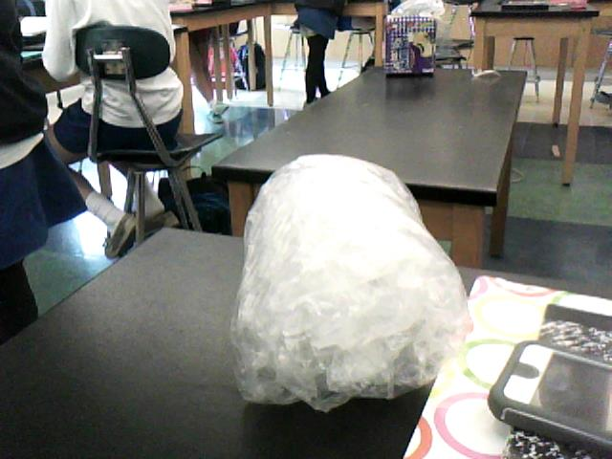

After:

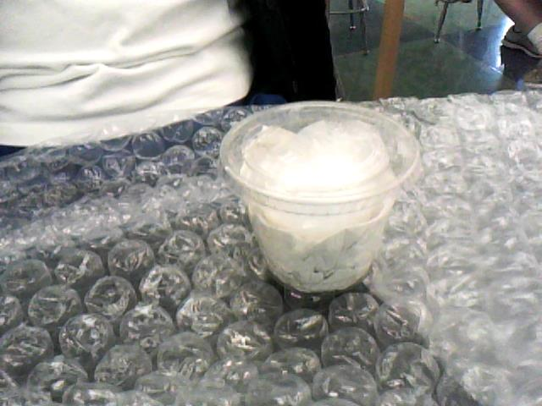

*Note: bubble wrap stayed intact during the fall. It was taken off to check if the egg was broken.*

**Mass of package and Egg:** 97.14 g

**Description of egg survival status**

* The first drop was not successful ☹
* The egg on the second drop did not crack or break whatsoever ☺

**Analysis Question**

If we had a third trial, we would have kept the inner layer of wrapping around our egg, the paper towel and the outer layer of bubble wrap in that order around the egg. However, we would have disposed of the cup because the cup weighed a lot. Although the cup added form, a lot of paper towel padding could have provided the same form that the egg did with significantly less weight.