Jordan Tapp

Mrs. Popp and Mr. MacDonald

Stem IIB

30 April 2014

Final Stage-Gate Individual Write Up

Looking back to stage-gate one, which was the plastic bag designs where plastic bags were cut and sealed with heat. From that stage-gate, an improved design was produced in stage-gate two. And in this final stage-gate, we collaborated with the other materials group and created a final package.

Product Constraints:

Not much has changed for the product constraint from stage-gate one, however here are the following:

* The product must be able to hold up to at least 88 ml of liquid
* The total cost of the package must be $4.00 unless glue was used making the package no more than $3.00

Analysis of the Materials in Isolation:

These are the results when various items were tested for their reliability for later making into packages for a product. **In addition, these results are the average of 5 trials for each test and material.**

|  |  |  |  |  |  |  |
| --- | --- | --- | --- | --- | --- | --- |
| Materials | Drop | Shake | Weight | Throw | Water | Heat |
| Newspaper | 3 | 3 | 3 | 3 | 1 | 3 |
| Cardboard | 3 | 3 | 3 | 2 | 1 | 3 |
| Plastic Wrap | 3 | 3 | 3 | 3 | 3 | 3 |
| Plastic Baggies | 3 | 3 | 3 | 3 | 3 | 3 |
| Foil | 3 | 3 | 3 | 3 | 3 | 3 |
| Wax Paper | 3 | 3 | 3 | 3 | 3 | 3 |

The scale for the testing is as follows:

3 – No damage, perfect condition

2 – Minor damage

1 – Damaged, bad condition

From these results, it can be concluded that plastic wrap, plastic baggies, foil and wax paper are the best materials to make a package because their average of perfect scores show that they can withhold different conditions which is ideal when thinking about packaging, handling, etc. It can also be concluded that newspaper and cardboard would not be good materials to use because they can be damaged in water for both and throw for cardboard. However, the fact that they were both damaged in water shows that they would not be good materials to use for a package considering their will be liquid inside of the packages; if those materials were used the package could be ruined which is not ideal.

My Personal Group Design (Myself, Deniera and Alanna):

The materials that we chose to use for our design are –

* Aluminum foil
* Wax paper
* Plastic baggies
* Duct tape
* Masking tape

We chose the following materials to use for our design because, aluminum foil, wax paper and plastic baggies all scored a perfect average score of 3 on the materials in isolation testing. This was very important for us because we wanted to use only the best materials for our package that would uphold not only the product constraints but also so the package would be durable and strong. We also chose aluminum foil, wax paper and plastic baggies because they could articulate the requirements for the package. We chose duct tape and masking tape because they were strong and cheap materials that could keep the package together when shipped and handled.



This is our package diagram –



So our package is made by the following steps –

* Take a plastic bag and cut it straight down the middle
* Apply heat to the open sides of the plastic baggie so that it will now be sealed (stage-gate 1 method)
* Place foil down, then wax paper, and finally plastic baggies one on top of the other in that order and fold the foil and wax paper inwards to cover the plastic baggies
* Apply masking and duct tape to the part of the package where the two sides of the foil and wax paper meet

Here are pictures of the package

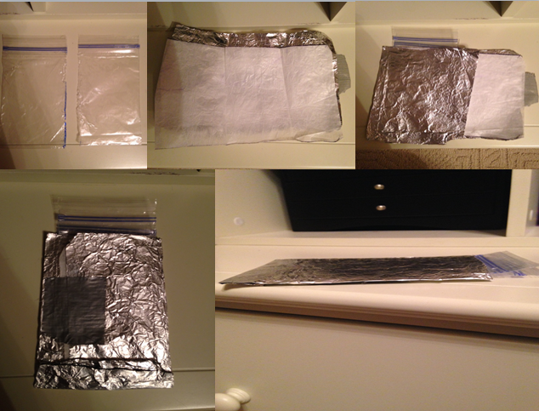

After the package was constructed, we did preliminary testing on the package to ensure the package withheld not only the requirements but also our liking.

|  |  |  |  |  |  |
| --- | --- | --- | --- | --- | --- |
| Package | Throw | Shake | Weight | Water | Drop |
| **Average Score of 5 tests** | 3 | 3 | 3 | 3 | 3 |

The average 3 is indicating that each test scored a perfect score; no damage was done to the package when the test was performed.

From the data above, it can be concluded that the package is very strong and can withhold many obstacles that it may face based on the preliminary testing. This data was very important to us because it showed that our package is strong and would be successful on the market.

Cost Analysis of Package –

The total amount of money that could be used for our package was $4.00

Our money was used in the following way

|  |  |
| --- | --- |
| Materials | Cost |
| Aluminum Foil | $0.75 |
| Plastic Bag | $0.25 |
| Wax Paper | $0.50 |
| Duct Tape (2 inches) | $1.00 |
| Masking Tape (1 inch) | $0.50 |

The total amount of money that was used for the package is $3.00. This leaves $1.00 remaining for advancement or improvement to the package.

Final Group Project (me, Deniera, Alanna, Molly Baker, Lexi and Blaire):

We were able to collaborate together and make a final and strong package by seeing what was wrong in our packages, using what we found our faults to be, found ways to improve them, and finally create a final package.

The materials we chose for our design we chose to use for our design are:

* Plastic baggie
* Cardboard
* Duct tape
* Wax paper
* Aluminum foil

We chose the following materials to use for our design because, aluminum foil, wax paper and plastic baggies all scored a perfect average score of 3 on the materials in isolation testing. This was very important for us because we wanted to use only the best materials for our package that would uphold not only the product constraints but also so the package would be durable and strong. We also chose aluminum foil, wax paper and plastic baggies because they could articulate the requirements for the package. We chose duct tape because it is strong and cheap that could keep the package together when shipped and handled. However we chose to use cardboard as well. In the materials in isolation testing, we (this includes the other group as well as they saw this in their material testing and saw that it did not do well in their personal package design) concluded that cardboard should not be used because it gets damaged when in water, however we discovered when we were creating that if you divide the cardboard in half by pulling the two sides apart it actually becomes a durable material that just needs an outer layer to stay protected. So we chose the cardboard to give our packing stability and make it strong.

Diagram of Package

* 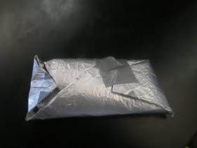inside of this package is first foil, then cardboard and then wax paper
* After that one full, not cut plastic bag is put on top of the layers of material
* The entire package is then folded up sort of like a burrito
* It is then sealed with duct tape so that it can stay in tact
* There is an opening at the top where the plastic bag can be accessed so the (soon to be product) can be squeezed out for use

After the package was constructed, we did preliminary testing on the package to ensure the package withheld not only the requirements but also our liking.

|  |  |  |  |  |  |
| --- | --- | --- | --- | --- | --- |
| Package | Throw | Shake | Weight | Water | Drop |
| **Average Score of 5 tests** | 3 | 3 | 3 | 3 | 3 |

* The average 3 is indicating that each test scored a perfect score; no damage was done to the package when the test was performed.

From the data above, it can be concluded that the package is very strong and can withhold many obstacles that it may face based on the preliminary testing. This data was very important to us because it showed that our package is strong and would be successful on the market.

Cost Analysis of Package –

The total amount of money that could be used for our package was $4.00

Our money was used in the following way

|  |  |  |  |
| --- | --- | --- | --- |
| Material | Base Cost | Amount Used | Total Cost |
| Duct Tape | $0.50 | 3 pieces | $1.50 |
| Cardboard | $1.00 | ½ piece | $0.50 |
| Aluminum foil | $.075 | 1 sheet | $0.75 |
| Wax Paper | $0.50 | 1 sheet | $0.50 |
| Plastic Baggie | $0.25 | 1 bag | $0.25 |
| Total Cost for Package: $3.50 Budget left for improvement: $0.50 | | | |

Suggestions for the future:

If there was more time improve the package we would add something else (another strong material, maybe such as laminate) that would go on the outside of the foil because after time foil can wear down and we want the package to stay durable for as long as possible. Also we would emerge with the suntan group so that we could use their sunscreen and put it into our package.