Jordan Tapp and Casey Wong

Ms. Hruska and Mr. Mac

Stem 1B

May 14, 2013

Speed and Accuracy Robotics Challenge Write-Up

**The project task is for the robot to follow a closed path created with wide tape. Additionally, the programmers and robot aimed to perform the task as quickly and accurately as possible.**

**Design Decisions:** We decided not to stop the motor when it turns on the line. This is so that it continues to follow the line while moving backwards; this is much more efficient than a swing turn (where the motor is stopped). In addition to increasing the power level, another decision was to use a small and large gear to power the motor and wheel. By having the large gear (on the motor) power the smaller gear (on the wheel axel to turn the wheel faster, thus making the robot to move faster. We also placed the light sensor on the back of the robot. This is so the robot can sense the position of the line closer in relation to the wheel, making more accurate turns.

**Calculations:** When beginning the program we had to calculate the threshold value of light and dark for our robot. So, using the view setting on the robot, we determined the values of light and dark and averaged them to get our threshold value of 38%. Despite the power levels chosen at the end, we did not form any calculations to determine the power level. Rather, we chose a very high and low power level (to simulate the swing turn) and then continued to test different combinations that would allow the robot to perform the task efficiently and accurately.

**Program Design and Explanation**

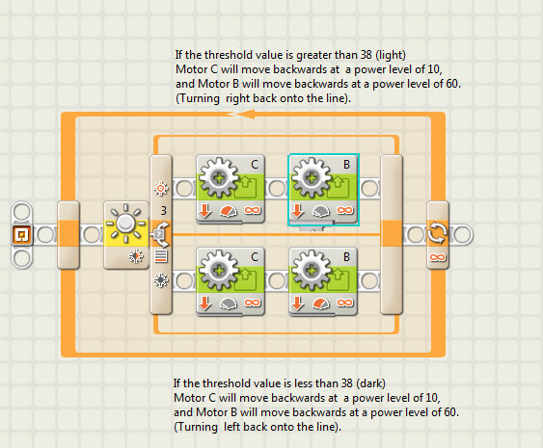

***Program Structure***

**Loop** – makes program run until the user presses the gray button to make the robot stop

**Switch** – using the light sensor, the robot determines the percentage of color reflecting off of the surface; if the value detected is greater than 38% the robot will execute the code on the top half of the program but if it is less than 38% the robot will execute the code on the bottom half of the program

***Top Half of Program:***

**Motor Block C** – as long as the light detected is above 38%, motor c will move backwards at a power level of 70%

**Motor Block B** – as long as the light detected is above 38%, motor b will move backwards at a power level of 10%

***Bottom Half of Program:***

**Motor Block C** – as long as the light detected is less than 38%, motor c will move backwards at a power level of 10%

**Motor Block B** – as long as the light detected is less than 38%, motor c will move backwards at a power level of 70%