The Effect of Music on Short Term Memory
By: Julia Potter and Jordan Tapp
January 17, 2013
Abstract:
The impact of an auditory distractor while doing a short term memory test was examined in this study. Fourteen high school girls, two high school boys, and one adult completed two short term memory tests, one test did not have an auditory distraction while the other one did. The results showed that individuals did better when there was not an auditory distraction ten out of eleven times the test was taken. However some testers did better on the test without the distraction. A t-test was performed and a p-value was calculated. The p-value was found to be higher than the accepted value for 6-8 number sequences indicating that the auditory distractor made an impact on the subject’s short term memory.
Introduction:
According to Access Science short term memory is, “The ability to store and access information that has been acquired through experience.” Short term memory is a crucial aspect of human thinking but it also has its limitations. According to Access Science, the average capacity of a person’s short term memory is found to be seven items, but newer data and research shows that the rule of seven is not as reliable as it once was and that when speaking different languages a person’s short term capacity changes. None the less, because short term memory is performed so often, questions surrounding it are frequently pondered. Questions like, what effects short term memory and what kinds of distractors effect short term memory the most are studied and experiments are conducted on these topics as well.
One experiment, studied a similar topic to the two questions above. In this experiment, the experimenter’s tested irrelevant sounds or noises, such as natural background sound, and its effect on short-term memory. From the experiment, these irrelevant sounds or noises were proven to interest the subjects and therefore caused distraction (Banbury, Macken, Tremblay, Jones, 1996). Subjects had to perform memory tasks, which involved remembering items, with and without an auditory distractor. The outcome of the experiment indicated that relatively quiet background sound will not affect a person while performing cognitive tasks as much as a loud auditory distractor would affect a person. In another experiment, experimenters tested elderly men and women by making them look at a picture for thirty seconds while a certain genre of music was playing. After the thirty seconds were up, the subjects had to fill out a questionnaire based on the picture. From this experiment, the researchers found that when listening to the band White Noise the subjects were not able to recall as much as when they listened to classical music or no music at all (Kirkweg 2009).
Lastly, in another experiment, researchers found that music does impact an individual who is doing work and that music a person prefers can be more distracting than music which is not preferred. The researchers studied this by taking twenty-five undergrads and made them complete several recall tasks while listening to a popular pop song and another time during an unpopular song that they all did not like that was heavy metal. The results of this experiment concluded that when listening to a popular pop song preferred, performance declined on a memory test compared to if they did not listen to any music at all or the song was not preferred (Perham, Sykora 2012).
Although a person’s short term memory capacity is debatable, the idea that auditory sounds hinder a person’s focus and short term memory are indubitable. From the research already completed on short term memory, we decided to further investigate auditory distractions revolving around short term memory. One auditory distraction that would affect a person’s short term memory would be music. This study seeks to determine if music will impact a person’s ability to recall grocery list items using short term memory.
Methods
Fourteen high school girls (mainly 9th graders), two boys, and one female adult were given a short term memory test where they were asked to recall grocery list items. To conduct the experiment, a short game was created using Scratch or BYOB (Built your own blocks). This particular program was used to test the short term memory of a high school girl by having them write down a few grocery list items. In order to create this memory game, one must make twelve backgrounds. The backgrounds included one direction slide (see image A), ten grocery item slides, a slide that says press the space bar to continue the test, and one that tells the subject they are finished taking the test. The grocery item slides were divided into two parts, one part without the distraction of music and one part with the distraction of music. The song Call Me Maybe by Carly Rae Jepsen was used as the distractor. Testing included five levels and each time more grocery items appeared on the screen. As one slide changed to another, the items on the slide increased from 2, 4, 6, and to 8 items. This is also same for the second test. Items such as yogurt, chicken, and milk flashed on the computer monitor for 5 seconds (see image C). Headphones were provided to each participant to minimize unwarranted distraction and to ensure the music distractor was heard consistently. After the items disappeared, it was necessary for the subject to write down all the items that she could remember on a paper provided by the experimenters. This paper was organized in a way that made the collection of data easy for the experimenters (see image B).

Image A: Test Instructions Image B: Handout used by Test Subjects
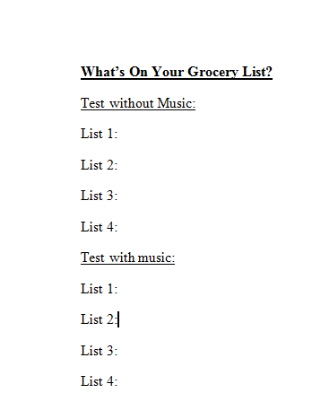
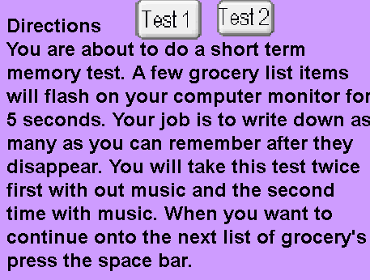

Image C: Example Grocery List
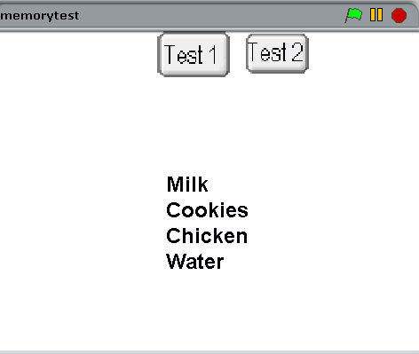

Results:
Graph 1 represents the percentage of correct responses as the number of items increases when music was playing. The direction and strength of this relationship is negative, linear, and strong. Negative, because the line of best fit (y=-10.1x +120) goes from high to low, where in the equation x is the number of items and y is the percentage of correct responses. The coefficient of determination or the r ² value, is 0.55. This means that 55% of the total variation in y can be explained by the linear relationship between x and y. The other 45% of the total variation in y remains unexplained. Overall, in graph 1 this data shows that as the amount of items increase the percentage of correct responses decrease when music was playing.
Graph 2 represents the percentage of correct responses as the number of items increase when music was not playing. The direction and strength of this relationship is negative, linear, and strong. Also, the line of best fit demonstrates this relationship because is also goes from high to low. The equation is y=-9.82x + 125, where in the equation x is the number of items and y is the percentage of correct responses. The coefficient of determination, or the r² value, is 0.50. This means that 50% of the total variation in y can be explained by the linear relationship between x and y. The other 50% of the total variation in y remains unexplained. Overall, in graph 2 this data shows a similar result from graph 1 which is as the amount of items increase the percentage of correct responses decrease when music is playing.
Graph 3 compares the slopes and lines of best fits from both graphs 1 and 2, representing the percentage of correct responses as the number of items increase when music was and was not playing. Overall, in graph 3 this data continues to show the similar pattern that as the amount of items increase the percentage of correct responses decrease when music is playing or is not playing.
A t-test which measures the difference between the groups as a fraction of their variability was performed on all data collected. It is another way to study data and find if the independent variable, which was the presence or absence of music playing during the test, was statistically significant. The p-value was used to verify statistical significance. The p-value is the probability of observing a difference of sample means at least as large as the one observed and indicated the distractors impact. If the p-value is less than 0.05 the distractor does not have an impact because it gives a 95% accuracy standard, but if the p-value is higher than 0.05 the distractor does have an impact because it is below the standard. For 2 and 4 items, the p-value was below 0.05. This means that when two and four items were present, the percentage of correct responses was not significantly different when comparing results from when music was playing and when music was not playing. For 6 and 8 items, the p-value was higher than 0.05. This means that when six and eight items were present, the percentage of correct responses was statistically different when comparing results from when music was playing and when music was not playing.

Graph 2: Grocery Items correctly remembered when music was not playing
Graph1: Grocery Items correctly remembered when music was playing

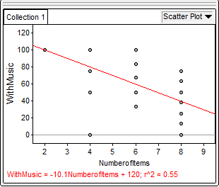
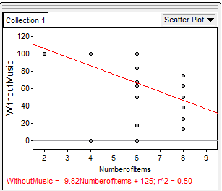
Number of Items

Percentage of Correct Responses

Graph 3: Grocery Items correctly remembered when music was playing and was not playing
Percentage of Correct Responses

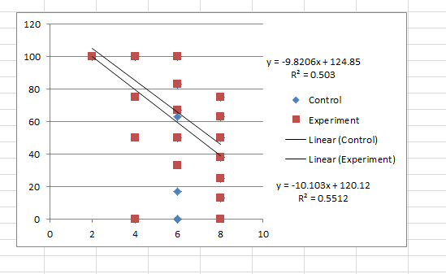
Number of Items
Percentage of Correct Responses
Corresponds to the line of best fit with no music

Corresponds to the line of best fit with music

Table 1: T-Test Results
# of items | P-Value
2 | 0
4 | 0.048
6 | 0.657
8 | 9.126

Discussion
From this experiment, the short term memory of a person changed based on the amount of items the person had to remember and if a distractor was present or absent. When the subjects had to remember 2 grocery items all seventeen subjects were able to remember both items with and without music. This means that our distractor (the music) had no impact on the subject’s short term memory and ability to remember two grocery list items. Also, the p-value was 0 which is below the standard value (0.05) that indicated whether or not the distractor has a significant impact or not. When the subjects had to remember 4 grocery list items all subjects but one recalled all four items when the distractor was not present. However, when music was playing nine subjects did not recall all of the grocery items. When calculating the p-value for 4 items it was 0.048 which is lower than the standard value therefore the distracter did not statistically impact the subject’s short term memory but changes in the data are beginning to show.
When the subjects had to remember six grocery list items, in general very few subjects were able to remember all six with as well as without the music playing in the background. The p-value this time was 1.657 which overpasses the standard value of the distractor having an impact on the something. As a result of the p-value, one can conclude that when having to remember a quantity of six items with a distractor such as music playing, it will have an impact on the person’s short term memory. Finally, in last test, which was test four, the subjects had to remember eight grocery list items. Since the last test overpassed the standard p-value of the distractor having an impact, it was likely that this test would surpass it as well; which it did. None of the subjects remembered all eight of the grocery items during both tests. When calculating the p-value, it greatly surpassed the standard value of 0.05 with 9.126 which meant that the distractor had a very large impact on the subject’s ability to recall items or short term memory. Therefore, it is impossible to know if it was the distracter’s impact’s or a person’s short term memory capacity having an impact on the subjects ability to remember the grocery list items.
From this analysis a trend is observed. As the number of items on the grocery list increases, one’s ability to recall those items decreases. The same trend was observed when the distractor was implemented. When comparing the results through a t-test, when two and four grocery items were shown the distractor did not have a significant impact because the p-value was below 0.05. But, when four grocery items were present the p-value did increase from 0.0 to 0.048, however the value was still below the standard. When comparing the results through a t-test, when six and eight grocery list items were shown the distractor did have a significant impact because the p-value was over the standard value. However, overtime the number of items cannot be correlated to a person’s short term memory with a distractor due to the short term memory’s limited capacity. The capacity of a person’s short term memory is seven and in this part of the experiment people had to remember 8 grocery items. Although the t-test shows that the distracter made an impact, it is impossible to tell because it is over the average limitation.
In the future, when conducting experiments similar to the one above changing certain aspects of the experiment could broaden the scope of the analysis and add a greater depth to the explanations. In this experiment, mainly high school girls with a focus on 9th graders were tested. Only two boys and one adult were tested. By testing more boys and different age ranges the experiment could open up different arguments and explanations for why one received certain results. Some of these arguments and explanations could be that children verses adults or verses girls could experience a significantly different reaction to the distractor.
Work Cited:
Panbury, S; Mackmen, W; Tremblay, S; Jones, D. (1996) Auditory Distraction and Short-Term Memory: Phenomena and Practical Implications. Cardiff University, Cardiff Wales.
Kirkweg, S. (2009) The Effects of Music on Memory. Missouri Western State University, Missouri.
Perham, N; Sykora, S. (2012) Disliked Music Can be Better for Performance than liked Music: Applied Cognitive Psychology. The British Psychological Society.
Schooler, J; Loftus, E. (2012) Memory. In Access Science. McGraw-Hill Eduation.

