Lexi Cohen

Mrs. Chainani and Mrs. Malfa

Stem

2 April 2013

Egg Drop Project

Material List

* Brown paper bag
* Cardboard
* Bubble wrap
* Vitamin water bottle
* Duct tape

Diagram of Package



Photographs

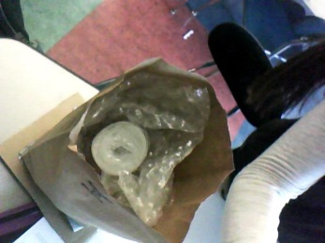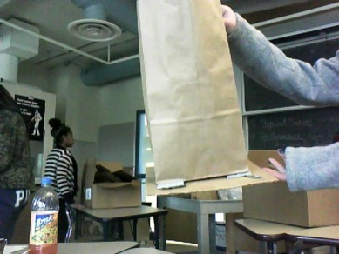

Before:

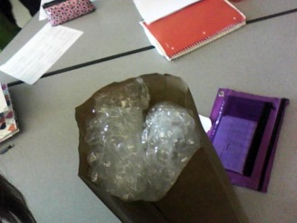

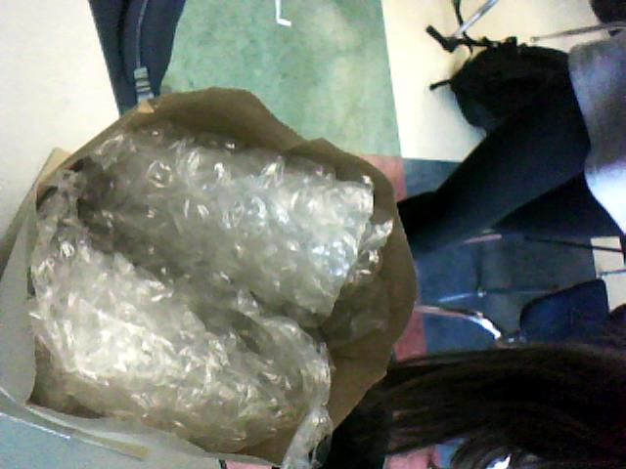

After:

Mass of package and egg: The package and egg together weighed 196 grams.

Description of the egg’s survival status: After the package was dropped, the egg was not cracked in any way.

If I had the opportunity to complete a third trial, I would make the cardboard that is attached to the bottom of the bag bigger and more stabilized. This would help make sure the bag fell straight down, and did not land on its side. Furthermore, I would use a sturdier bag because that would also help the package fall straight down instead of landing on the side. Also, I would add a cardboard cover that covered the bag so that the egg would not fall out. In order to make the package weigh less, but still be successful, I would place the bottle that contains the egg near the bottom of the bag, so that I could take out some of the bubble wrap near the bottom. Finally, I would also strategically take out some of the bubble wrap on the sides to make it lighter, but also ensure that there is still enough padding so that the egg will not break when it hits the ground.