Lexi Cohen
Mr. Mac and Mrs. Popp
Stem
14 March 2013
Impact study
This document is the final stage gate report on the package being created for sunscreen. It includes an analysis of the materials being used, a summary of how the preliminary package was made, an explanation of how the two groups came together, a cost analysis and the plans for the future. The constraints for this package are that it must hold 88 ml of sunscreen and the budget is $4.00.
Materials in Isolation
The following results were found from the preliminary round of materials testing:
Note: Each score is an average of five different tests. The score is based on how damaged the package was (3 = no damage, 2=little damage, 1=damaged).

Material | Drop Test Score | Water Test Score | Shake Test | Marketing Test | Weight Test | Heat Test | Throw Test
Newspaper | 3 | 2 | 3 | NA | 3 | 3 | 3
Cardboard | 3 | 2 | 3 | NA | 3 | 3 | 3
Plastic baggies | 3 | 3 | 3 | NA | 3 | 3 | 3
Plastic wrap | 3 | 3 | 3 | NA | 2 | 3 | 3
Foil | 3 | 3 | 3 | NA | 2 | 2 | 3
Wax paper | 3 | 2 | 3 | NA | 3 | 3 | 3

After the different tests on the different materials were done, it was discovered that Newspaper, wax paper and cardboard are damaged by water, plastic baggies got a 3 in all categories , meaning they are not easily damaged, both plastic wrap and foil are not very weight bearing, and finally, the foil was slightly damaged from the heat
It was decided that from these results, the following materials should be used:
- The two sides of cardboard (the paper part – described below) because it is sturdy, and it is also bendable.
- A plastic bag because it is waterproof and it is overall not easily damaged
- Duct Tape because it is less expensive than glue and it is sturdy
The Preliminary Package:
The last model of the package made is two pieces of cardboard paper that are taped together along the long sides of the triangle with a rectangular piece of cardboard at the top to close the package. At the vertex of the triangular shaped container, there is an opening so that the sunscreen can be put in through the opening and that opening is also where the sunscreen will come out. Inside the cardboard container is a plastic baggie that is folded and taped with duct tape into a triangular shape that fits inside of the outside container. The sunscreen will be held inside of the plastic bag.
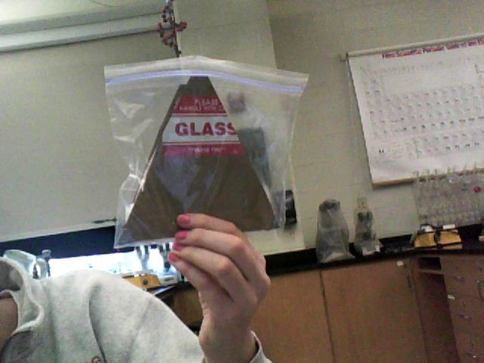
The preliminary package was tested with the drop test, throw test, shake test, and water test and the following results were found:
Note: Each score is an average from five trials
Test | Score (3 = no damage, 2=little damage, 1=damaged)
Drop test | 3
Throw test | 2.5 ( somewhat crushed)
Water test | 3
Shake test | 1 (cardboard very wet)

The results show that the package is damaged a small amount when it is thrown and it is very damaged when it is in contact with water. Therefore, adjustments need to be made to the package in order for it to survive being thrown and put under water.
Cost Analysis for Preliminary Package:
1 square of cardboard – $1.00. 1 Plastic baggie - $0.25. Duct tape – At least 4 pieces (2.5 cm) - $2.00
$1 + $0.25 + $2 = $3.25
Cost of our package: $3.25
Budget: $4.00
We are under budget by $0.75
Final Package Materials:
In order to decide what materials to use for the final package, the two groups looked at the problem areas of the two preliminary packages. After looking at the materials in isolation testing and the problem areas of the previous packages, the following materials were chosen for the final package:
- Plastic Baggie – They are waterproof and sturdy so they can hold the suntan lotion. They also have good seals
- Cardboard – It is sturdy and when the cardboard is peeled, it can be easily shaped and bent according to the suntan lotion
- Duct Tape – It is less expensive than glue, sturdy, and easy to bend and maneuver according to shape of package
- Wax Paper – It helps make the package more waterproof and study.
- Foil – It helps make the package more waterproof and sturdy.
The Final Package:
To make the final package, first, the two sides off of the cardboard were peeled off in order to make the cardboard more bendable and thin. Then, one piece of tin foil and one piece of wax paper were cut. They were each 18 cm by 18 cm. Then, to create plastic bag that will hold sunscreen, the plastic bag was taped in a rectangular shape. Then, the wax paper was used to line one side of the cardboard, allowing the excess on the sides to fold over. The corners were secured with duct tape. The same was done with the tin foil on the other side of the cardboard. The side with tin foil is the outside of the package. Then the plastic baggie was put inside of the cardboard on the side with wax paper with the opening of the bag facing a corner. The cardboard was folded over the bag to form a burrito shape, using duct tape to keep flaps down. The corner with the opening of the plastic bag is left opened and it will serve as the cap. Tuck that end of the cardboard under the sides of the cardboard to close the package.
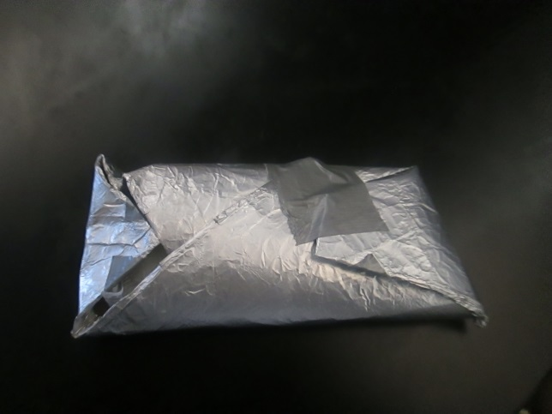

Testing Final Package:
Test | Score (3 = no damage, 2=little damage, 1=damaged)
Drop test | 3
Throw test | 3
Water test | 3
Shake test | 3
Heat Test | 3
Weight Test | 3

Note: Each score is an average of five trials.
Results from Testing:
The final package was successful as it met all of the requirements and passed all of the tests without becoming damaged.
Cost analysis for final package:
3 pieces of duct tape ($1.50), ½ piece of cardboard ($0.50), one sheet of foil ($0.75), one sheet of wax paper ($0.50), 1 plastic baggie ($0.25)
$1.50 + $0.50 + $0.75 + $0.50 + $0.25 = $3.50
Budget = $4.00
Amount used = $3.50

Future recommendations:
- If this project were to be continued, the groups would find a material that can go on the outside that is more durable than foil and find plastic baggies that are smaller, so they have less room for air, but can still hold 88 ml. The next step is to collaborate with the sunscreen group to have sunscreen to be put in the package

