Lexi Cohen and Briana Davis
Mr. Brock
Stem
16 December 2012

A Study of Short Term Memory and the Effect of Flashing Lights on Short Term Memory
By: Lexi Cohen and Briana Davis

Abstract
Data shows that short term memory is effected by the number of items one has to memorize, the age of the people memorizing the information, and whether the information is organized into categories or not. From this, we made the decision to see how flashing lights affect short term memory. To test this, we used the computer software program, Scratch, which enabled us to ask thirty students to memorize six, eight, and then ten letters, without flashing lights, then with slow flashing lights, and finally with fast flashing lights. We found that when the amount of letters being asked to remembered were between six and eight, the flashing lights had no impact. However, once people had to remember ten letters, the flashing lights decreased their ability to remember the letters. Based off of this information, in the future we might look at how other distractors such as music affect short term memory and how those other distractors compare to the flashing lights.

Introduction
Short term memory (STM) is what you can replicate right after you see it. It can be influenced by many different factors, and there is data to indicate that some people might be genetically predisposed to have better short term memory than others. (Ornstein, Haden 2001). One influence on STM is the amount someone has to remember. For example, it is harder for someone to remember a list of 20 items than a list of 10 items (Brady, Konkle, Alvarez 2011). Other research shows that when people have to memorize more than four objects, it is much harder than when memorizing less than four objects (Brady, Konkle, Alvarez 2011). Research has shown that people can memorize information better when it is put in categories. This was shown through an experiment in which the researchers had the participants categorize the objects after they saw the objects in the three conditions and the conditions. The conditions were 3 different stimulus types, and each set the participant saw could have one to four shapes in it. The conclusion of this research was that the undergraduate students could better memorize information when the information is in categories. (Olsson, Poom, Treisman 2005). In addition, it has been shown that children have a tougher time with short term memory than adults. In a verbal test that was given to people of all ages, the older participants did better than the younger participants (Ornstein, Haden 2001).
However, the research has not yet shows whether a particular distractor would impact people’s STM. So, we chose to ask the question, how does flashing lights affect one’s capability to memorize letters in a certain order? We found that there was proof that short term memory is affected by distractions, but we wanted to see if flashing lights was one of those distractors. Also, through our experiment we can see if the flashing lights, or any distractor, affect people no matter the amount of items they are remembering or if the amount of items, in fact does play a role.
Methods
Thirty students at Roland Park Country School between the ages of 12 to 17 were tested to see whether or not flashing lights negatively affects a person’s short term memory. The software, Scratch 1.4, was used to create this test. Subjects were asked to remember a series of different amounts of letters, while there were no flashing lights, while there were slow flashing lights, and then while there was fast flashing lights. Subjects were shown a screen that had the instructions for the test on it. (see figure 1). Next, subjects were told to press the space button to reveal a screen with six letters. After five seconds the screen disappeared and the subjects were told to write down the letters they remembered on the data sheet they were given before they started the test. Then they were told to press the space key, which made a new screen appear with eight random letters, and after five seconds the subjects were told to write down the letters they remembered on the data sheet they were given before they started the test. Then they were told to press the space key, and a new screen appeared with ten random letters, and after five seconds the subjects were told to write down the letters they remembered on the data sheet they were given before they started the test. After the students went through the first three screens, and wrote down the letters they remembered for each screen, they were told to press the “a” key. The “a” key led them to another screen with six letters, but this time there were flashing lights. The lights flashed once every 0.5 seconds. After five seconds, there were told to write down the letters they remembered, and then the same thing happened for the slides with eight and ten letters. After the students went through the three screens with flashing lights and wrote down all the letters they remembered for each screen, they were told to press the “b” key. Once they did that, a new screen appeared with a new six letters, but this time there was flashing lights that flashed every 0.25 seconds. After five seconds they wrote down the letters, and were shown a screen with eight letters and the same flashing lights. They were told to write down the letters they remembered and then they were shown a screen with ten letters and the same flashing lights and were told to write down the letters they remembered. After the subjects finished writing down the letters they remembered from the screen with ten letters and fast flashing lights, they were given instructions to press the “e” key, and that brought them to then finish screen (see figure 6).

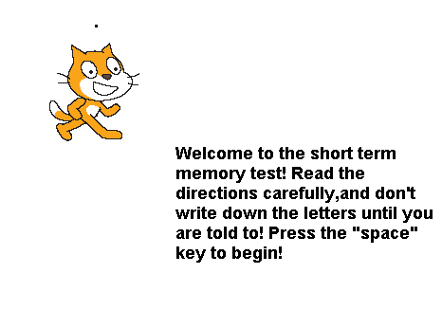
Results
Figure 1 -
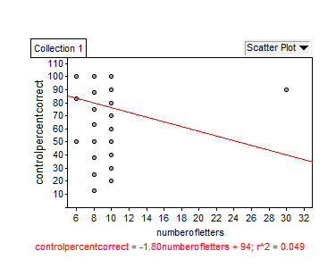

Figure 2 (no flashing lights, controlled experiment) -

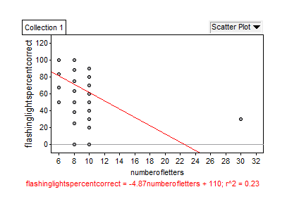

Figure 3 (slow flashing lights) -

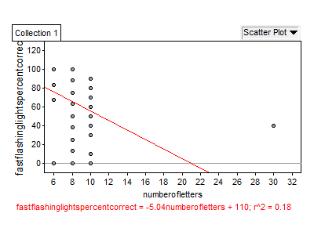

Figure 4 (fast flashing lights) -

figure 5 -
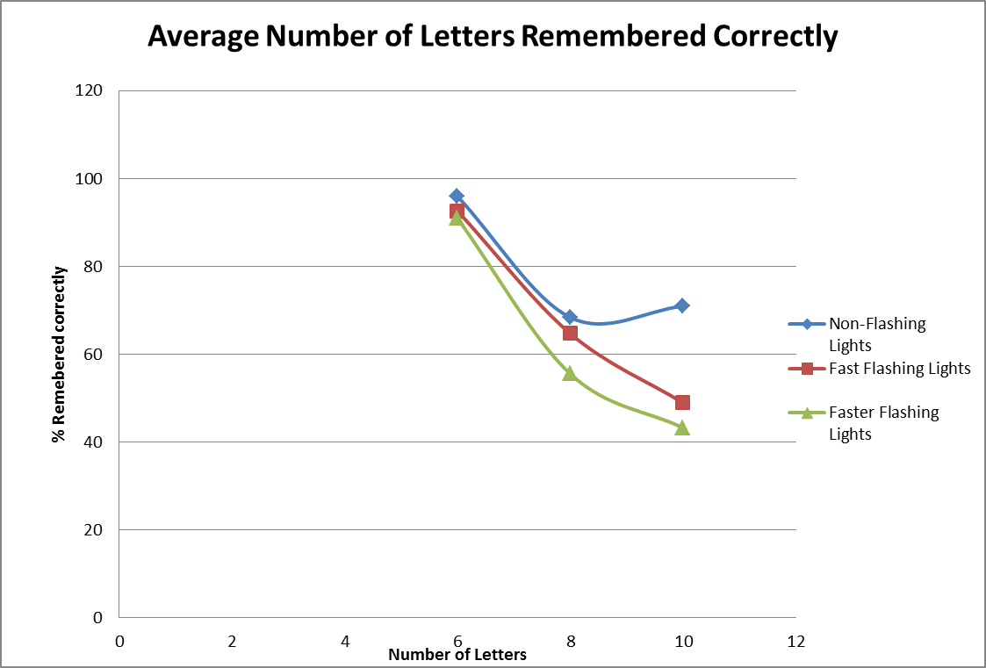

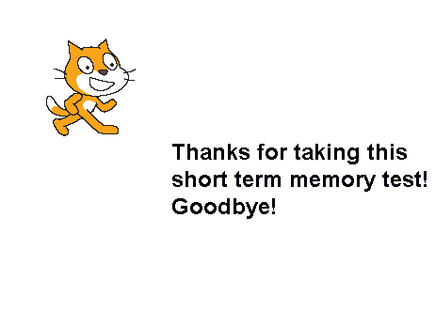
Figure 6 -

Discussion
Our data indicates that the correlation between the number of letters and the experimental conditions of no flashing lights, slow flashing lights, and fast flashing lights is not statistaclly strong (all r sqaured values < 0.5). In graph 5, however, it is clear that when the subjects were asked to remember up to eight letters, the flashing lights did not have an impact on their ability to remember the letters correctly (all p values greater than 0.5). Furthermore, graph 5 indicates that when the subjects were asked to remember ten letters, the flashing lights had a strong negative impact on their ability to remember the letters correctly (p= 2.89645 *10⁻⁴, flashing lights; p=6.41857 * 10⁻⁶, fast flashing lights). Therefore, we can conclude that once the subjects have to remember more than eight letters, flashing lights is a distractor, and negatively impacts people’s ability to remember letters correctly. In the future, we might look at how other distractors such as music affect short term memory and how those other distractors compare to the flashing lights.

Bibliography
Binney, J. (1957). Memorization and memory. The Clearing House, 31, 549-552.
Brady, T., Konkle, T., & Alvarez, G. (2011). A review of visual memory capacity: Beyond individual items and toward structured representations. Journal of Vision, 12, 1-34.
Haciomeroglu, G., & Erbilgin, E. (2005). Memorization. The Mathematics Teachers, 99, 228.
Mishkin, M., & Appenzeller, T. (1987). The anatomy of memory. 1-10.
Olsson , H., Poom, L., & Treisman, A. (2005). Visual memory needs categories. Proceedings of the National Acadmey of Science of the United States of America, 102, 8776-8780.
Ornstein, P., & Haden, C. (2001). Memory development or the development of memory?. Current Directions in Psychological Science, 10, 202-205.

