Alanna Aboulafia, Kendra Foster and Meredith Kuser
February 23, 2013
Ms. Hruska
STEM

RPCS- Roland Park Cosmetic Supplier
- Data Table:
Cost of each Product per gram
Item | Grams Used (g) | Cost
Green Clay | 3.27 g | $0.062
White Sand | 1 g | $0.0039
Tea Extract | 0.43 g | $0.0581
Honey | 1 g | $0.0087
Distilled Water | 6 g | $0.06
Mint Candies (Altoids) | .67 g | $0.0208
Total | 12.37 | $0.1159
Price per gram- $0.00937

- Procedure
- Using a spoon place 4 grams of green clay into a weigh boat. Place the weigh boat on an electronic balance to make sure the measurement of 4 grams of green clay is precise. Pour the green clay into the mortar.
- Using a spoon place 1 gram of white sand into a weigh boat. Place the weigh boat on an electronic balance to make sure the measurement in precise. Pour the sand into the mortar.
- Take 1 capsule of tea tree extract and open it up and add the powder to the mortar with the other dry ingredients.
- Using the honey squeeze 1 gram of honey into a weigh boat. Place the weigh boat on the electronic balance to ensure that 1gram of honey is measured. Using a plastic spoon scrape all of the honey from the weigh boat into the mortar.
- Finally using a 10mL graduated pipette fill with 6 mL of distilled water. Using the pipette add the 6 mL of distilled water to the mortar (6ml of H₂O= 6g of H₂O). Use the pestle mix together all of the ingredients.

- Justification:

- Before making a mask, there were five categories with which some of the ingredients went under. For example, the cleanser of the mask also known as the base had three options to choose from. There was green clay, kaolin clay and Fuller’s earth clay. The abrasive of the mask had two options to choose from, White sand and Flaxseed. The soother of the mask has two options to choose from, Tea extract and Aloe Vera. The preservative of the mask had three options to choose from; aloe vera, glycerin and honey. Lastly, other ingredients were Distilled water and altoids with various scents to them. When choosing which ingredients to use, there were several trials done. Once a mask was made, our teachers and peers critiqued what they liked, and didn’t like. This was later used to evaluate what ingredients should be chosen in the making of our mask. The cleaners used for the mask was the green clay. Those two ingredients were chosen because it was found that the Green clay had a “natural feel” meaning that it was soft what applied on the skin, and a nice “sea color” meaning the color of the clay was appealing to apply to their face. The green clay was a natural earth tone and felt clean and smooth on the skin. The abrasive used for the mask was the white sand. This was used because it was a very effective exfoliant. The sand works as an abrasive because it is rough and grainy and when massaged, the sand works deep into the pores to get grime out and ultimately clean the pores and remove dry flaky skin. The soother used for the mask was the Tea extract. The tea extract was used because many people said that the scent of the Tea extract was very nice and soothing. The tea tree extract had a cooling effect on the skin making if feel soothing and feel like the facial mask was cleaning out the pores. The preservative that was used to make the mask was honey. Honey was used because not only was it very easy to mix while making the mask, it also kept the skin feeling smooth after it was washed off. Another ingredient we used was a a wintergreen Altoid. The wintergreen Altoid combined with the tea tree extract created a very soothing scent. In addition, it added to the soothing feel of cooling when applied to the skin. The last ingredient we used was the distilled water. This was used because it combined all the ingredients into a smooth mask.
- The other ingredients were not used for several reasons. First, Fuller’s Earth Clay was not used because it was very thick and it smelled like dirt. We didn’t use Kaolin Clay because when it dried it looked brown; this gave it an unappealing look to use on one’s face. Flaxseed was not used because it was hard to mix and it stuck to one’s skin. Aloe Vera was not used for several reasons. First, it was too sticky. Second, it was hard to mix with other preservatives. Lastly, it was too watery. Glycerin was not used because it was too sticky to manage, and it took too long to dry when applied onto skin.
- The product falls within all of the constraints. This product only uses 6 ingredients one of which is water, but the ingredients work well together. The mask has a smooth homogenous mixture with no lumps. The product also has an appealing green color. The product also absorbs into the skin and does not just sit on top of the skin. The product has an average drying time of 9 minutes and when washing it off it easily comes off and does not leave behind residue or small clumps. The mask also does what it is supposed to and cleans the user’s pores. Using a blue digital microscope a before picture was taken of the user’s skin on the arm (figure 1) and then a picture was taken after using the mask (figure 2) . Figure 1 shows that the skin had many wrinkles and dry skin, but figure 2 shows that the mask cleaned the skin and helped to get rid of dead skin. The skin on the arm was much smoother and softer. Most importantly the product falls within the assigned budget. The mask costs $0.00937 which is just under 1 cent per gram of mask.

Before:
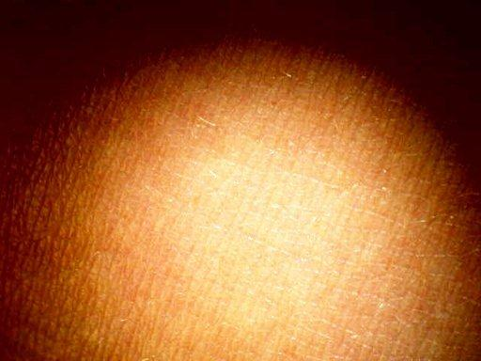
(figure 1)
After:
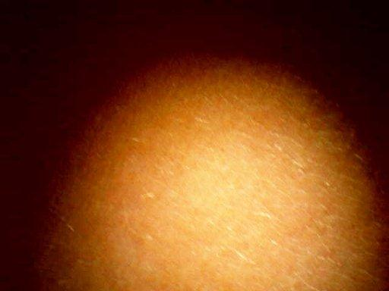
(figure 2)
Cost Analysis for RPCS Clay Mask Recipe
- Initial analysis of the 6 ingredients showed that each batch of clay masks would cost $0.3049 based on a retail purchase of ingredients.
- A Pareto analysis showed that the four most important ingredients to focus on are tea extract, mint candies (altoids), green clay, and honey. Instead of bulk buying all ingredients at one store a focused effort was made to improve the cost of those four items. The results are as follows:
  - We found green clay from luckyvitamin.com at a better price of $0.0141 per gram, Honey from vitacost and Swanson Health products at a price of $0.009 per gram. Also, Costco sells 12 tins of Altoids at a price of $.0208 per gram. Finally, Green Tea extract can be found at a lower proce of $0.0581 per gram at Doctor Vitamin site. We used distilled water from the store because it is more cost efficient to buy from the store rather than buying a distiller.
  - By focusing on these four ingredients it is possible to reduce the cost from $0.3049 to $0.1159.
- Other Observations/ open questions:
  - Buying a distiller and purchasing water intersect at 665 gallons which means that when you use 665 gallons of water you would be paying the same price. This clay mask recipe calls for 0.002 gallons of water. 665 divided by 0.002 equals 418, 950 mixes of masks. To put this in perspective RPCS would need to sell 3,500 masks.
  - RPCS recommends buying water instead of buying a distiller. Since RPCS is a new company on the market it would not be worth it to buy a distiller because it would take too long to sell 3,500 masks.

