Meredith Kuser
Stem IIA
Mr. MacDonald and Mrs. Reynolds
3 December 2012
Topology
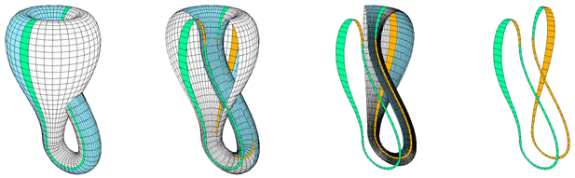
In the year 1790 and 1849, two mathematicians were born. One would eventually build off the other’s discoveries. August Ferdinand Möbius was born first in Germany in the year 1790 and loved mathematics, astronomy and physics. Felix Christian Klein was also born in Germany, but in the year 1849. He studied mathematics and physics while in school. Although they were born in two different centuries, both Möbius and Klein discovered mathematical objects in non-Euclidean geometry by one building off the other.
Figure 1- Möbius Bands in a Klein Bottle
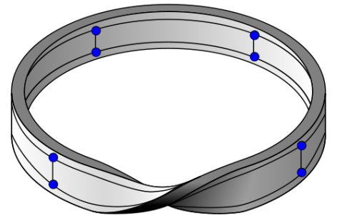
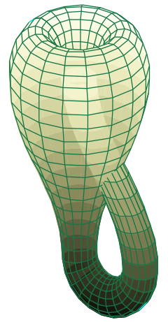
August Ferdinand Möbius was a pioneer in topology. Topology is ability to change one item to another through bending, twisting, stretch and shrinking. He was also an astronomer who has mathematical interests. He was the first to publish his findings on the Möbius strip in 1858. Before Möbius published his findings, he was a theoretical astronomer. He introduced the idea that when the extension of coordinate which would include “point at infinity.” He traveled to Göttingen to study astronomy under Gauss and Pfaff. Gauss was not only the director of the Observatory, but he was also the greatest mathematicians of his day. Although Möbius was an astronomer and worked for those who were astronomers and mathematicians, his greatest accomplishments and important work were in mathematics. In topology, a branch of mathematics, Möbius was not the first to discover the Möbius strip, it was Johann Benedict Listing. A few months earlier, Listing had discovered this loop, but since he did not publish about his discoveries, Möbius was given the credit. He accidentally discovered this loop in 1858 when he was answering questions about polyhendra. A Möbius strip is a narrow strip of material which has a half-twist before attaching the ends together. This forms a strip with one side. When this strip is cut in half, the shape turns into one large band with two sides and one full twist. Möbius’ published work helped another scientist to discover new ideas in topology.
Figure 2- Möbius Loop
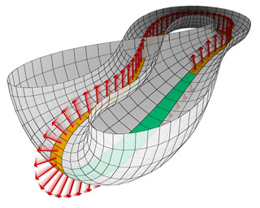
Felix Christian Klein built off of the Möbius strip to create a Klein bottle. Klein was known for unifying geometry and the properties of space. He edited one of the world’s leading mathematics journals, “Annals of Mathematics” in addition to supervising the “Encyclopedia of Pure and Applied Mathematics.” Klein succeeded in Göttingen with David Hilbert. There, he established a research center, and taught at the university until 1913 when he retired. The research center he established later became a model for the best mathematical research centers in the world. In 1882, Klein created the Klein bottle. To make the Klein bottle, Klein had imagined connecting two Möbius loops together; this makes a bottle with no boundaries and only one side. There is no edge or boundary on this bottle, much like a single Möbius loop, there in only one side. As shown in figure 1 and figure 4, when a Klein bottle is cut in half, the two Möbius loops are visible. This was one of the ideas that both Klein and Möbius shared.
Figure 3- Klein Bottle
Although these mathematicians were born and lived during different centuries, they were both interested in similar ideas and worked in the same area. Both Klein and Möbius worked in Göttingen at some point. While either Klein or Möbius worked there, they discovered new ideas and worked with some of the greatest mathematicians. In contrast to Klein’s fourth dimensional bottle, Möbius’ loops can be seen and understood in the third dimension. Also, there is no way to apply a Klein bottle in real life, since this is not a four dimensional space, the Klein bottle cannot be applied. But, Möbius strips can be used on a conveyor belt since there is now only one side to this belt. From Möbius’ accidental discovery, which leads to his published work about these loops, Klein became interested in how it worked and wanted to learn more. Klein was then able to make the Klein bottle from Möbius’ discovery.
Figure 4- Klein Bottle cut in half
These two mathematical discoveries may be made of the same materials and ideas, but they are very different from one another. Both Möbius and Klein made major contributions to the mathematical world, and helped to make ideas grow.

Works Cited
"August Ferdinand Möbius." Encyclopædia Britannica. Encyclopædia Britannica Online Academic Edition. Encyclopædia Britannica Inc., 2012. Web. 30 Nov. 2012. <http://www.britannica.com/EBchecked/topic/386818/August-Ferdinand-Mobius>.
"Felix Klein." Encyclopædia Britannica. Encyclopædia Britannica Online Academic Edition. Encyclopædia Britannica Inc., 2012. Web. 30 Nov. 2012. http://www.britannica.com/EBchecked/topic/319960/Felix-Klein>.
"topology." Encyclopædia Britannica. Encyclopædia Britannica Online Academic Edition. Encyclopædia Britannica Inc., 2012. Web. 03 Dec. 2012. <http://www.britannica.com/EBchecked/topic/599686/topology>.
http://im-possible.info/english/articles/klein-bottle/index.html
http://plus.maths.org/content/imaging-maths-inside-klein-bottle
http://upload.wikimedia.org/wikipedia/commons/thumb/5/5c/Klein_bottle.svg/240px-Klein_bottle.svg.png
http://upload.wikimedia.org/wikipedia/commons/thumb/c/c6/M%C3%B6bius_ladder_on_M%C3%B6bius_strip.svg/500px-M%C3%B6bius_ladder_on_M%C3%B6bius_strip.svg.png
O’Connor , JJ and Robertson, E F. “August Ferdinand Möbius.” School of Mathematics and Statistics. University of ST. Andrews, Scotland. 2003 <http://www-history.mcs.st-andrews.ac.uk/Biographies/Klein.html >
O’Connor , JJ and Robertson, E F. “Felix Christian Klein.” School of Mathematics and Statistics. University of ST. Andrews, Scotland. 1997 <http://www-history.mcs.st-andrews.ac.uk/Biographies/Mobius.html>

Weisstein, Eric W. "Klein Bottle." From MathWorld--A Wolfram Web Resource. Resource. http://mathworld.wolfram.com/KleinBottle.html

