Effect of Flashing Colors on Short Term Memory
Sarah Shmerler and Meredith Kuser

Abstract
A memory that can be maintained for a short amount of time called short term memory. The ability to memorize can be decreased by distractions using the same part of the brain as the task being memorized. We tested the effect of flashing colors on short term memory while memorizing letters. By using the Scratch software computer program, a program was created using a variety of letters with no background distractions, and another set of letters with a distraction of flashing colors in the background. This program was used to test the participants to see their average ability to memorize the letters with and without distractions. The data showed that the flashing colors did not affect the ability to memorize the letters. But on average, when there were seven letters the flashing colors impacted the memory in a positive way. We could further test our problem by adding more sequences with more letters, which could potentially show if the distractor continued to make a positive impact on the memory of the letters.

Introduction

All memory begins with input from stimuli. This information is normally maintained for only a second or two and is known as sensory memory. However if this input is maintained for longer than one or two seconds, then the information about the stimulus item is transferred into working memory or short-term memory (STM) ("Memory," 2007). There, it will only be maintained for a short amount of time, such as remembering a phone number only used once (Jonindes et al., n.d., p. 194) unless the information is rehearsed or is accompanied by an emotional experience. These conditions can cause STM to be transferred to long –term memory (LTM) (Lerner & Lerner, 2008) where it is stored in the pre-frontal cortex of the brain for retrieval into STM at a later time (Dubuc, n.d.). Consequently, working memory is used for almost every task, making it important for any and all learning processes (Jonindes et al., n.d., p. 194).
Under normal circumstances, short-term memory can hold on average up to seven individual letters or other discrete units of data (Taylor, n.d.). But according to the Department of Psychology at the University of Michigan (Jonindes et al., n.d., p. 199), the capacity of short-term memory often depends on the speed with which the items can be rehearsed before being forgotten. Rehearsal optimizes STM (Jonindes et al., n.d., p. 199) and more time given to memorize increases the ability to remember tasks. STM is also increased when the information is given in “units” such as one person’s name (Lerner & Lerner, 2008). Letters put into a sentence or a word can be remembered because “chunking” large pieces of information can be stored in long-term memory as a single unit, making it easier to recall later (Jonindes et al., n.d., p. 169).
However, while STM can be optimized through repetition, it can also be decreased through distractions. When the distractors use the same part of the brain as the information being memorized, there is interference, and individuals have a difficult time maintaining the input in STM. (e.g visual tasks interfere with visual memory while verbal tasks interfere with verbal memory). Intriguingly, though, the research is mixed when the distractor and input are using different parts of the brain. On the other hand, when one task uses one part of the brain, information using a different part of the brain does not impact the memory in the beginning part of the brain (Dubuc, n.d.). On the contrary, according to Dr. Taylor, any task that involves another input beyond visual or verbal result in poor memory especially counting while trying to memorize a reading passage (Taylor, n.d.).
Yet, although we already know that the memory is affected by tasks using the same neurons and parts of the brain, does the type of visual input matter when a visual distraction is presented to a subject? We wondered if the color of a visual distractor would negatively affect STM and decided to test the input of color in the background on the ability to memorize random collections of letters using computer stimulation as our research tool.

Methods
37 high school students, ages 14 to 16, were tested for the impact of flashing colored lights on memorizing a sequence of letters. Using the version 1.4 of the computer program “Scratch”, a computer simulation was developed for this test. Each subject was shown a sequence of 3 randomly ordered letters for 6 seconds (see in figure 1). After the 6 seconds, the subjects were shown a screen which instructed them to write down as many letters as they could remember, and then to press the space bar to continue (see in figure 2).
Figure 1
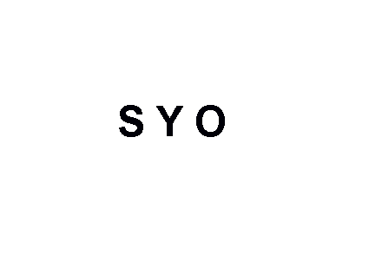
Figure 2
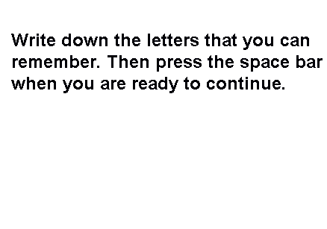
After pressing the space bar, the subjects were then shown a sequence of 5 randomly ordered letters for 6 seconds and then shown figure 2. Next, after pressing the space bar the students were shown a sequence of 7 randomly ordered letters for 6 seconds and again shown figure 2. After pressing the space bar the subjects were shown 9 randomly ordered letters for 6 seconds and shown figure 3.
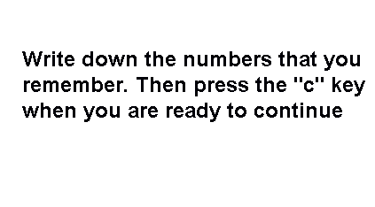
Figure 3

After the “c” key was pressed the screen switched to the directions as shown in figure 4. Then the process of showing sequences of screens containing letters and being shown figure 2 repeats however there was a distraction of colored lights in the order of yellow, blue, and pink lights that were flashing at 0.5 second intervals (see figure 3 for the colored backgrounds of the first sequence). Using the number of letters the subjects remembered correctly and the total number of letters shown, the percent of letters remembered was calculated for each sequence.

Figure 4
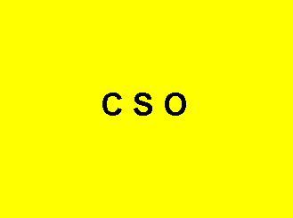

Figure 5

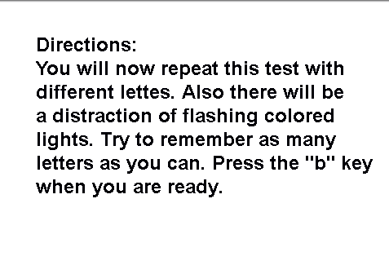

Results
Figure 6
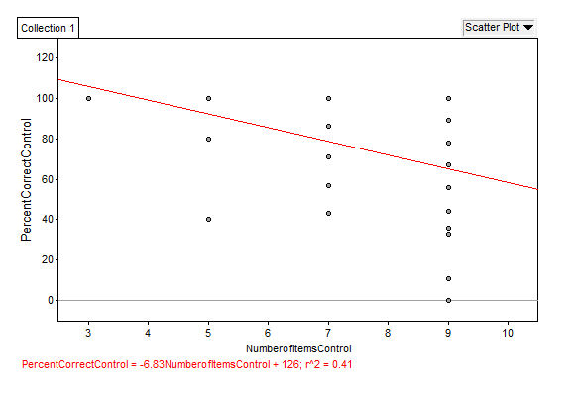
\

This graph also shows the relationship between the number of letters shown verses the percent of numbers remembered without lights flashing.

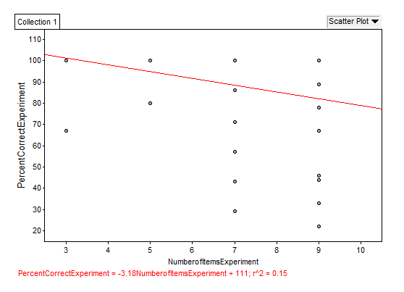
Figure 7

This graph also shows the relationship between the number of letters shown verses the percent of numbers remembered with lights flashing.

Figure 8
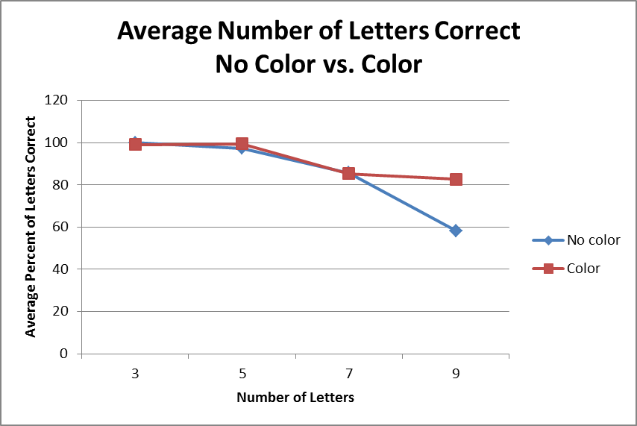
This graph shows the relationship between the number of letters remembered when shown letters with no lights flashing vs. with lights flashing.

Discussion
Our data appears to provide contradictory results. On one hand, the correlations between the amount of numbers shown to the subjects and how well they recalled them were not statistically significant (without flashing lights, r^2=0.41, and with flashing lights, r^2=0.15). On the other hand, as shown in figure 8, when subjects were shown 9 letters and asked to recall them, there was a significant difference (p=0.0000836) in recall ability between the control condition (58.27% correctly remembered) and the experimental condition (82.56% correctly remembered). Indeed the distractor not only had an impact on the ability to recall this amount of info; but it had a positive impact meaning with the distractor more letters on average were remembered correctly. In the future, testing again with using the same basic test but adding more sequences with larger amounts of letters shown could show if the distractor continued make a significant positive impact on the memorization of letters.

Bibliography
Brown, J., Ph.D. (n.d.). Short-Term Memory. Oxford Journals, 8. Retrieved from http://bmb.oxfordjournals.org/content/20/1/8.extract
Dubuc, B. (n.d.). Short-Term memory [Fact sheet]. Retrieved December 17, 2012, from http://thebrain.mcgill.ca/flash/d/d_07/d_07_cr/d_07_cr_tra/d_07_cr_tra.html#1
Jonindes, J., Lewis, R. L., Nee, D. E., Lustig, C. A., Berman, M. G., & Moore, K. S. (n.d.). The Mind and Brain of Short-Term Memory. Annual Review of Psychology. doi:10.1146/annurev.psych.59.103006.093615
Memory. (2007). In World of Scientific Discovery. Gale. Retrieved from http://ic.galegroup.com:80/ic/scic/ReferenceDetailsPage/ReferenceDetailsWindow?displayGroupName=Reference&disableHighlighting=false&search_within_results=&prodId=SCIC&action=2&catId=&documentId=GALE%7CCV1648500370&userGroupName=balt23720&jsid=32af7bf870eed8aa1604f11bc7e879e1
Memory. (2008). In K. L. Lerner & B. W. Lerner (Eds.), The Gale Encyclopedia of Science (4th ed.). Detroit: Gale. Retrieved from http://ic.galegroup.com:80/ic/scic/ReferenceDetailsPage/ReferenceDetailsWindow?displayGroupName=Reference&disableHighlighting=false&search_within_results=&prodId=SCIC&action=2&catId=&documentId=GALE%7CCV2644031396&userGroupName=balt23720&jsid=0f67029cd4a37da10ba700183674177d
Peterson, L. R. (n.d.). Short-Term memory. Scientific American, 90-95.
Taylor, A., Dr. (n.d.). Short-Term memory [Fact sheet]. Retrieved December 13, 2012, from http://home.sandiego.edu/~taylor/stm.html

Acknowledgements
We would like to thank students in both the 9th and 10th grade classes for taking their free time to be participants in our memory test.

