|  |
| --- |
|  |
| The Effect of Sound on Short Term Memory |
|  |
|  |
| **By: Blaire Miran and Najah Soudan** |
| **1/18/2013** |

1. Abstract

Over many decades, there have been more and more distractions around the world and it makes it harder to complete daily tasks. Many researchers have tested how sound can affect short term memory. In our experiment, we made a computer program where the student was shown the order of ingredients for a diagram of a burger and had to memorize it while hearing someone count down in the background. There were four trials and in each trial it got harder. The more the people had to hear and the sound of them counting made it harder for them to remember.

1. Introduction

Over the years, the world has gained more and more distractions, making it harder and harder to complete daily tasks due to the impact of these distractions on peoples’ short term memory. Distractions today come in many forms including auditory, visual, and factory, and they can include video, flashing lights, talking, songs, perfume, or even smelly feet.

Many researchers have tested the effect of sound distraction on the short term memory, and studies have shown that there is a strong correlation between irrelevance of the tone and short term memory (Elliot and Cowan, 2005). Likewise, the volume of noise can also have a strong impact, and studies have shown that higher classroom noises distracted student’s more than lower levels of noise (Klatte, Lachmann and Meis, 2008). In addition to tone and volume of auditory distractions, research has found that background noises can easily distract people when the test of short term memory is harder (Campbell, 2005).

Which of these factors, though, might influence or distract short term memory the most? We designed an experiment to see if people listening to someone counting down affected them remembering the order of layers on a burger.

1. Methods

30 high school students were selected between the ages of 14 and 18 at Roland Park Country School. The Scratch software version 1.4 was used to create a simulation to create a program used to test people’s short term memory. Each student was told to put earphones on, and asked to watch a computer screen for a set of instructions. She was shown the screen in Figure 1 below and then shown Figure 2 after pressing the “s” key.”

Figure 1

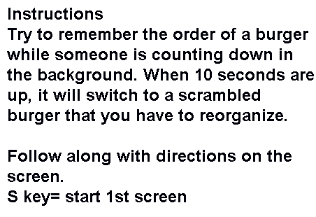

Figure 2

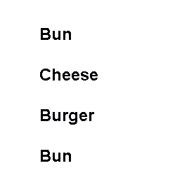

She was shown this screen while she heard a person count down in the background from 10 to 1, and then she was immediately shown figure 3.

Figure 3

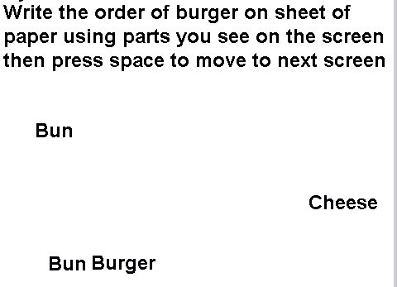

Then she was shown the screen in Figure 4 after she pressed the space key.

Figure 4

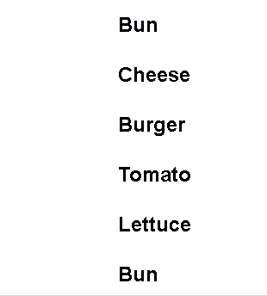

She was shown this screen while she heard a person counting down in the background from 10 to 1, then she was immediately shown Figure 5

Figure 5

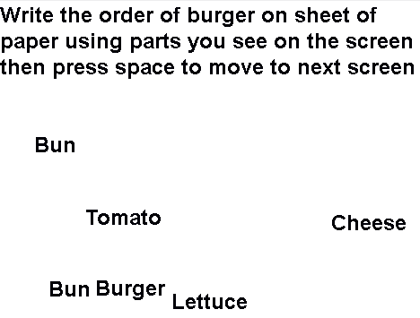

Then she was shown the screen in Figure 6 after she pressed the space key.

Figure 6

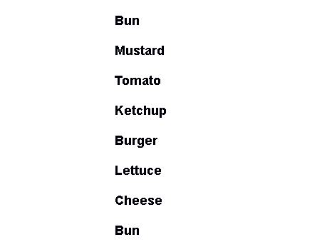

The she was shown this screen while she heard a person count down in the background from 10-1, and then she was immediately shown Figure 7.

Figure 7

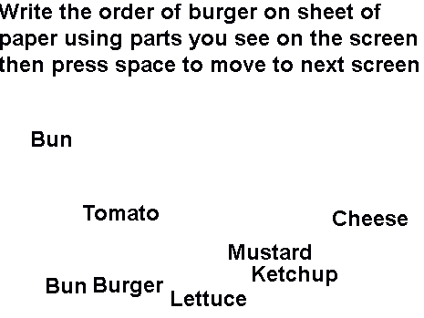

She was shown the screen in figure 8 after she pressed the space key.

Figure 8

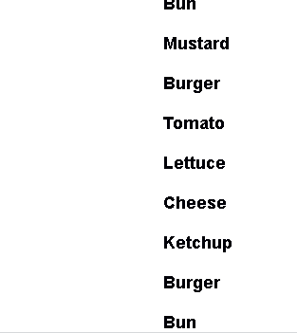

She was shown this screen while she heard a person count down in the background from 10 to 1, and then she was immediately shown Figure 9.

Figure 9

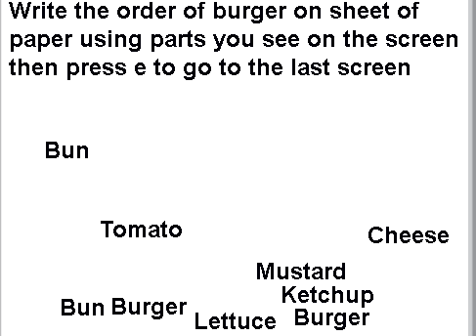

Then she was shown Figure 10 after pressing the “e” key.

Figure 10



To calculated percentages, I added the parts of each burger each person got right for each trial and divided it by how many parts of the burger for each trial there are. I did this for 30 students and then put it on Microsoft Excel. Then I used excel to calculate the averages by adding all of the scores for 30 students in each trial and divided the number 30.

1. Graphs

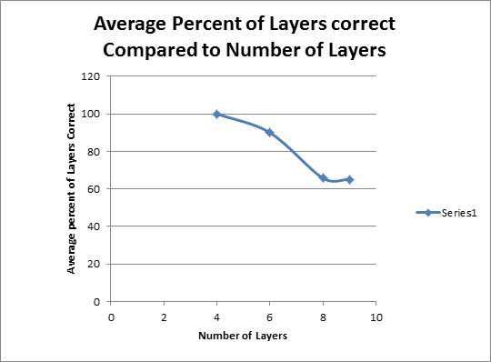Figure 11 Figure 12



1. Discussion

After we finished our tests, we realized we had left out studying a negative control. Without a negative control, we cannot correctly distinguish whether our data was significant or not.

Yet, in spite of the flaw in our experimental design, we still saw many interesting trends. One of those trends was that as there were more and more layers, people recalled the correct order of the layers less and less often. For example, when the students had to remember a burger with four layers with a countdown of 10 seconds in the back ground, the average score was 100%. Then when it got to six layers, the average score was approximately 89.98 % (p=0.00199). When the burger went up to eight layers, the average score was a 65.83% (p=0.00000000022722). Finally when the burger had ten layers, the average score was approximately 65.14% (p=0.0000000000816). Hence, it clearly got harder and harder for them to remember the correct order of the layers of the burger as the layers increased on their memory. Interestingly, when shown the screen with eight layers and the screen with nine layers, the scores started to level out. That meant that the trial four was just as challenging as trial three (p= 0.902).

Our test could be improved in the future by, as stated previously, adding a negative control to also see if the scores stay level. Also, we could have controlled who we tested in our data instead of choosing random students. Overall our results show that as the tests added more layers, the scores decreased.

1. Bibliography

Boman, E., Enmarker, and Hygge, S.(2005) Strength of Noise effects on memory as a function

of noise source and page. Retrived From

<http://www.noiseandhealth.org/article.asp?issn=14631741;year=2005;volume=7;issue=27;spage=11;epage=26;aulast=Boman>

D.G. Norris, (Dont have date) The Irrelevent Sound Effect: What needs Modeling and a

Tentative Model. Retrived from

<https://uhra.herts.ac.uk/dspace/bitstream/2299/2332/1/103184.pdf>

Elliot, E., Cowan, N. (2004, July 29) Coherence of the irrelevant-sound effect: Individual

profiles of short-term memory and susceptibility to task-irrelevant sounds. Retrieved

from

<http://web.missouri.edu/~cowann/docs/articles/2005/Elliott%20&%20Cowan%20M&C%2005%20coherence%20of%20ISE.pdf>

Jonides, John and Derek Evan Nee. (Sep. 16, 2008). Neural Correlates of Access to Short-Term

Memory. Jstor. [Retrieved] November 10, 2012, from

<http://www.jstor.org/stable/25464204?&Search=yes&searchText=short&searchText=term&searchText=memory&list=hide&searchUri=%2Faction%2FdoBasicSearch%3FQuery%3Dshort%2Bterm%2Bmemory%26acc%3Don%26wc%3Don&prevSearch=&item=20&ttl=123355&returnArticleService=show> FullText

Klatte, M., Lachmann, T., Meis, M. (Don’t have a date) Effects of Noise and Reverberation on

verbal short-term memory in young in a classroom-like setting. Retrieved from

<http://proceedings.envpsych2011.eu/files/doc/117.pdf>

Martin, Randi C. (2012, October 17). Components of Short-Term Memory and Their Relation to

Language Processing [article]. Retrieved from

<http://www.jstor.org/stable/20183025?&Search=yes&searchText=short&searchText>=

term&searchText=memory&list=hide&searchUri=%2Faction%2FdoBasicSearch%3F

Query%3Dshort%2Bterm%2Bmemory%26acc%3Don%26wc%3Don&prevSearch=

&item=1&ttl=122591&returnArticleService =showFullText

Preston, Alison. (September 26, 2007) How does short-term memory work in relation to long-

term memory? Are short-term daily memories somehow transferred to long-term storage

while we sleep? Scientific American. [Retrieved] November 10, 2012, from

<http://www.scientificamerican.com/article.cfm?id=experts-short-term-memory-to-long->

term&page=2