The Explanation for Dropping Nitrate Levels

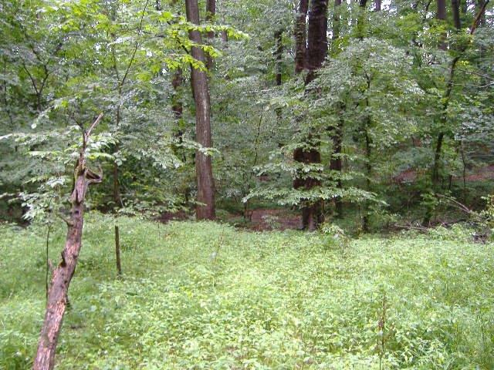

An investigation of Plants and Soil by Julia Garber, Kendall McCoach, Paige Shephard, and Najah Soudan

Introduction

The element nitrogen is a critical nutrient in the metabolisms of all organisms, and yet the majority of organisms are incapable of using nitrogen in its most common form, nitrogen gas (N2). Instead, all organisms in an ecosystem depend on a group of soil bacteria to perform “Biological Fixation” during which they convert the nitrogen gas into ammonium (NH4+). This ammonium is then broken down into nitrite (NO2-) which goes undergoes a process called “Nitrification” (Murphy, 2007) that converts the NO2-into nitrate (NO3-). Nitrate is an inorganic form of nitrogen that assists with protein synthesis in plants (Eckard, 2004), building the immune system and developing and producing seeds and so provides this critical element to the rest of the ecosystem through the food chain (Serchan and Jones, 2009).

One group of plants that is especially nitrogen dependent is members of the Poaceae family, more commonly known as the grasses. There are over 10,000 species of these types of plants which grow in all types of environments from desert to marine (Hilty, 2014). But one thing all members of this family of plants have in common is their prodigious appetite for nitrogen, specifically nitrate. Grass consumes large amounts of nitrogen from soil in order to complete its relatively short life cycle; therefore, since grass reproduces rapidly, it is able to deplete large amounts of nitrogen in a particular area (Encyclopedia Britannica Inc., 2014).

However, while the grasses and other plants are one of the main consumers of soil nitrate, they are not the only possible source of nitrate depletion in soils. The annual E.S.S.R.E. Biota survey (ESSRE, 2014) once again revealed statistically significantly low nitrate levels (5.6 ppm) in Site 4, a partial wetlands with an average pH level of 7.2 and therefore a location one would expect an abundance of nitrate available. But as figure 1 shows, nitrate levels have been steadily declining for over a decade, and as part of the E.S.S.R.E. program, members of the 2009 and 2013 research teams have been able to narrow the possible causes down either to the white grass (*leersia virginicia*) that has been steadily invading Site 4 or soil leaching due to the change of water flow in Site 4(Laria, Shay, & Kuser, 2014). Our research team decided to test the white grass hypothesis.

Figure 1

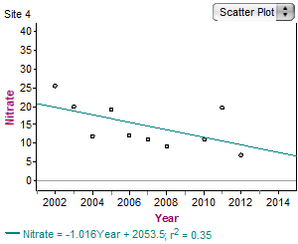

Method

In E.S.S.R.E. Site 4 (ESSRE, 2001), 4 ½ meter by ½ meter plots were determined based on the percentage of white grass (Leersia virginica) present among the plant life located in a given plot: plot 1 contained no plant life of any kind to serve as a positive control; plot 2 contained plant life but 0% white grass; plot 3 contained plant life that was 50% white grass and 50% the plant life found in plot 2; and plot 4 contained 100% white grass. Within each plot, 5 separate 15 cm deep soil samples were taken using a soil core extractor with a 2 cm diameter on a daily basis for 5 days. All samples were tested for nitrate levels (ppm) using the LaMotte MODEL STH-14 soil test kit.

|  |
| --- |
| Results  Table 1 |

|  |  |  |  |  |
| --- | --- | --- | --- | --- |
| P-Values Between Quadrants | | |  |  |
| Day 1 |  |  |  |  |
|  | pos. control | neg. control | 50% | 100% |
| pos. control | _ | 0.18 | 0.18 | 0.18 |
| neg. control | _ | _ | 1 | 1 |
| 50% | _ | _ | _ | 1 |
| 100% | _ | _ | _ | _ |
| Day 2 |  |  |  |  |
|  | pos. control | neg. control | 50% | 100% |
| pos. control | _ | 0.68 | 0.07 | 0.07 |
| neg. control | _ | _ | 0.37 | 0.37 |
| 50% | _ | _ | _ | 1 |
| 100% | _ | _ | _ | _ |
| Day 3 |  |  |  |  |
|  | pos. control | neg. control | 50% | 100% |
| pos. control | _ | 0.02 | 0.24 | 0.07 |
| neg. control | _ | _ | 0.1 | 0.18 |
| 50% | _ | _ | _ | 0.37 |
| 100% | _ | _ | _ | _ |
| Day 4 |  |  |  |  |
|  | pos. control | neg. control | 50% | 100% |
| pos. control | _ | 0.18 | 0.24 | 0.18 |
| neg. control | _ | _ | 0.07 | 0.18 |
| 50% | _ | _ | _ | 0.37 |
| 100% | _ | _ | _ | _ |
| Day 5 |  |  |  |  |
|  | pos. control | neg. control | 50% | 100% |
| pos. control | _ | 0.18 | 0.58 | 0.18 |
| neg. control | _ | _ | 0.07 | 1 |
| 50% | _ | _ | _ | 0.07 |
| 100% | _ | _ | _ | _ |

Table 1 shows the t-tests between the nitrate levels (in parts per million, or ppm) of the different research sites. Highlighted are the p values that are low enough to represent significant changes between the different sites.

|  |
| --- |
| Table 2 |

|  |  |  |  |  |
| --- | --- | --- | --- | --- |
| P Values Between Days | | |  |  |
|  | pos.control | neg.control | 50% | 100% |
| Day 1 – Day 2 | 0.73 | 0.37 | 1 | 1 |
| Day 2 - Day 3 | 1 | 0.13 | 0.37 | 1 |
| Day 3 - Day 4 | 0.59 | 0.18 | 0.24 | 1 |
| Day 4 - Day 5 | 1 | 1 | 1 | 1 |

Table 2 shows the results of t-testing on the nitrate data over a five day span.

Graph 1

**Total Nitrate Levels**

Graph 1 shows the changes in soil nitrate levels for the research sites over the course of five days

Discussion

Statistical comparison of the positive control plot’s data with that of the remaining experimental plots reveals that nitrate levels observed in our different research plots were significantly different between the 4 plots (p=0.02 to 0.37; see Table 1). Hence, we can be confident that the pattern in Table 1 is representative of what is happening to the nitrate cycle in Site 4. As Graph 1 shows, the positive control plot shows minimal fluctuation in the nitrate levels in its soil from one day to the next (p=0.59 to 0.73) which one would expect of a location where there is 0 plant life present to absorb it. Likewise, Graph 1 shows that within the negative control plot there is a significant amount of fluctuation in the nitrate levels from one day to the next (p=0.13 to 0.37), which one would also expect of a location with normal plant-soil interactions. Similarly, the 50% white grass showed the expected plant-soil interactions from one day to the next (p=0.24 to 0.37; see Table 1). However, as both Graph 1 and Table 1 indicate, the 100% white grass plot, like the positive control plot, shows no statistically significant fluctuation in nitrate levels, indicating that something is severely disrupting the normal plant-soil interactions.

The most likely source of this disruption is the location of the positive control and 100% white grass plots near the water flows through Site 4. Data collected for the first time this year in the 2014 E.S.S.R.E program is able to confirm the movement of water through the soil column proposed by Luria, Shay, and Kuser (2014) as the potential source of leeching that they argued is removing the nitrate from Site 4. Picture 1 shows a side view of the soil under the positive control and 100% white grass plots that

Picture 1

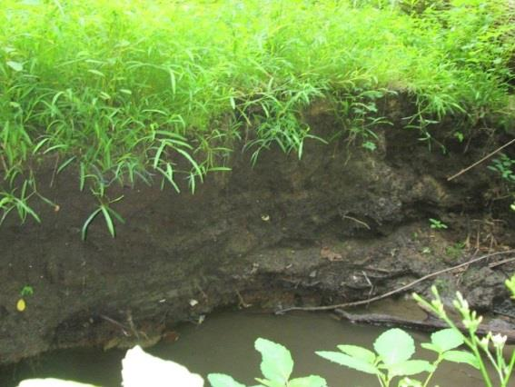

has been exposed since the 2013 E.S.S.R.E. program, and as the color of the subsoil clearly indicates, water is penetrating at least 2 meters or more beneath the surface of Site 4 at this location. Soil of this color is only observed when manganese in the soil and water interact, oxidizing the manganese to produce the black tint (Oram 2014) observed in the soil of both the positive control and 100% white grass plots. Hence it is clear that water is moving actively through the part of Site 4 where these plots are located, precisely the explanation proposed and supported by Luria, Shay and Kuser (2014): that active leeching is happening and explains why there is such low nitrate in this site. Therefore we are confident that the long term steady decline in E.S.S.R.E. Site 4 (see Figure 1) is due to leeching as the dam bordering Site 4 has steadily eroded in the same time period.

References

Eckard, R.(2014) Factors Affecting Nitrate Accumulating in Herbage . Retrieved from

<http://www.greenhouse.unimelb.edu.au/nitrogen/Nitrate.htm>

ESSRE.(2001) General Discription of the ESSRE Survey Sites. Retrieved from

<http://essre.rpcs.org/ESSRELocations.htm>

Hilton J. (2014) Comprehensive Description. Retrieved from

<http://eol.org/pages/1114464/details>

Laria G., Shay M. & Kuser M. (2014) Influences on Nitrate Leaching in the Soils of an Ecosystem

Deciduous Forest; A Case Study, 1-15.

Murphy, S. (2007) General Information of Nitrogen. City of Boulder/ USGS Water Quality Monitoring.

<http://bcn.boulder.co.us/basin/data/NEW/info/NO3+NO2.html>

Oram, B.(2014) Iron and Maganese in Water A Common Problem in Northeast Pennsylvania.

<http://www.water-research.net/index.php/iron>

Poaceae. (2014) In Encyclopedia Britannica. Retrieved from

<http://www.britannica.com/EBchecked/topic/465603/Poaceae>

Serchan S.& Jones D. (2009)The Baltimore Ecosystem Study Virtual Tour.

<http://www.beslter.org/virtual_tour/Nitrate.html>

Acknowledgements

We would like to thank our sponsors Dr. Heine, Larry Jennings, and Human Capital Development for their funding and support. In addition, we would like to acknowledge our peers Olivia Khanna, Lauren Adams, Julia MacGibeny, and Grace King for helping us with data collection. Thank you to our TA’s Katherine, Ella, and Taylor for going through countless drafts and making countless corrections. Lastly, we would like to thank our instructor, Mr. David Brock, for helping us all every step of the way.