Taylor Brewer
Mrs. Malfa &Mrs. Chainani
Stem 1B
23 February 2013
Face Mask
Ingredients Used, Amounts of Ingredients Used, and Cost of the Ingredients
Ingredients | Amount (grams) | Cost (dollars)
White Sand | 0.5 | 0.00195
Aloe Vera Juice | 2 | 0.051
Honey | 1.2 | 0.0087
Kaolin Clay | 3 | 0.0252
Distilled Water | 1 | 0.01
Fuller’s Earth Clay | 2 | 0.0264
Total: | 9.7 | 0.12325
Cost per gram= 0.01270619
Procedure:
- Place a plastic measuring boat on a portable sized gram measuring scale and zero the scale so the weight of the boat is not included in the measuring of the grams.
- Measure .5 grams of white sand in the measuring boat using the measuring scale and put in a bowl.
- Measure 3 grams of Kaolin Clay in a measuring boat using the scale.
- Place the Kaolin Clay in the same bowl.
- Measure 2 grams of Fuller’s Earth Clay using the measuring boat and scale.
- Add the Fuller’s Earth Clay to the same bowl.
- Squeeze one squirt of honey into the same bowl.
- Measure 2 ml of aloe vera juice using a pipette.
- Add the aloe vera to the bowl.
- Next measure 1 ml (gram) of water using a different pipette.
- Add the water to the bowl.
- Mix the ingredients in the bowl using a pestle for one minute until the mixture is smooth.
- Leave the clay mask on skin for about 10 minutes. Then rinse off the mask with water.

Justification
Each of the ingredients in the face mask has a specific purpose. White sand was used because it is an abrasive or course ingredient. This means that it exfoliates your skin and can help get rid of dead or old skin on your face, making your skin healthier. Aloe vera juice was used because it soothes the skin and is a treatment for minor sun burns and skin wounds. Honey was used because it is a preserver and promotes new tissue growth, keeping skin looking young and healthy. Honey also helps hold moisture, helping the actual clay mask to last longer and helping hydrate your skin longer. Kaolin clay was used because it is a cleanser, is able to dry the skin, and can fight off acne. It also decreases inflammation on your skin. Distilled water was used because it was required and it is generally known to clean skin. Lastly, Fuller’s Earth Clay was used as a cleanser. It is also beneficial because it absorbs unnecessary oils from the skin, helping prevent acne. There were some ingredients which were also not used in the Clay mask. Green clay was not used because it did not smell very favorable. Smell is important because people are not likely to by something that has an unfavorable smell. Flaxseed and Soy cereal were not used because they cause the clay mask to be clumpy. Being clumpy is undesirable because the texture is un even and more people would like a smooth texture. Next, tea extract was not used because the smell was not desirable. Again, having an undesirable smell would cause less people to buy the mask. Glycerin was not used because its texture was very gooey; therefore undesirable and not many people would like to buy a clay mask with an undesirable texture. Lastly, altoids were not used because their smell was too strong and its only benefit was the smell. Therefore, it was not necessary to use.
This clay mask meets all of the necessary requirements. It has a smooth and homogenous consistency because it has a reasonable balance of dry and liquid ingredients. In addition, from using the mask and observing its effects, it is concluded that the product absorbs into the skin and it cleans the pores as shown in pictures taken (see figure 1&2).
Figure 1 (Before the Clay Mask)
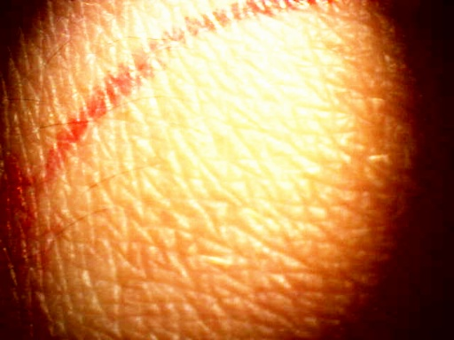
Figure 2 (After the Clay Mask)
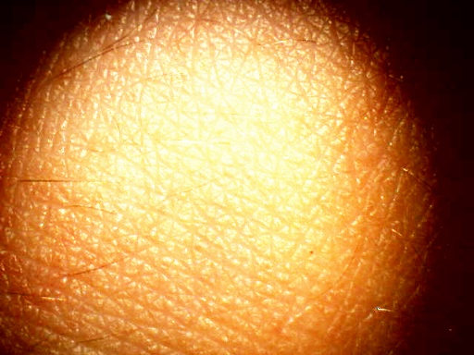
The mask is to be left on the skin for ten minutes. After these ten minutes, the clay mask is reasonably easy to remove. Also from experience, the mask leaves skin soft and it does not leave residue. In addition, our clay mask falls within budget requirements because for each gram, the clay costs 0.01270619 cents when using the original prices given. This is under 2-3 cents per gram. Lastly, the clay mask includes only 6 ingredients (including water) of water, Kaolin Clay, Fuller’s Earth Clay, aloe vera, honey, and white sand. Because there are no more than 6 ingredients, this constraint is met.
Cost Analysis
- Based on the original costs given of each of the six ingredients from various stores including Mountain Rose Herbs, Flinn Scientific, Walmart, Target, and a Local store, one batch of the clay mask (9.7 grams) would cost 0.12325. This means that per gram, the clay mask would cost 0.01270619 dollars. However, when buying Fuller’s Earth Clay and Kaolin Clay in bulk, the total price of the 9.7 gram batch of the mask would be 0.08095. This means that per gram, the mask would cost 0.008345
- A Pareto analysis showed that the three most important ingredients to focus on were Fuller’s Earth Clay, Kaolin Clay, and Distilled Water. Since these items were emphasized, it was made clear that these were the only items needed to be bought in bulk.
  - Fuller’s Earth Clay was the most expensive item used in the clay mask. The original price of the clay from the Mountain Rose Herbs store is .0132 dollars per gram. When bought from http://www.cineshoppe.com/fullers1.htm website. The cost of a 50 pound bag of Fuller’s Earth clay was $75. Therefore, per gram, the clay was 0.003307 dollars. The 50 pound bag of this clay would be enough for 11339.8 batches of this clay mask. Furthermore, this means that instead of costing 0.0264 dollars per batch, the Fuller’s Earth Clay would only cost 0.006614 dollars.
  - Kaolin Clay was the second most expensive ingredient in the face mask. The original price of it from the Mountain Rose Herbs store is 0.0084 dollars per gram, this means that it would be $0.0252 per batch of the clay mask. However, when bought off the http://www.sheffield-pottery.com/EPK-50-Pound-Bag-p/rmepk50.htm website, the Kaolin clay is $20.50 for a 50 pound bag; therefore 0.0009 dollars per gram. It also means that instead of costing 0.0252 per batch, the Kaolin clay would cost 0.0027 dollars. When using the 50 pound bag of Kaolin Clay, there would be enough Kaolin clay for 7559.87 batches of the clay mask.
  - The distilled water was also one of the significant expensive items in my clay mask. (See other observations for water analysis).
  - By focusing on Fuller’s Earth Clay and Kaolin Clay, the price per batch of the clay mask can be reduced from 0.12325 dollars to 0.008345 dollars. In other words 0.00086 dollars per gram of the batch. This means that we are saving a total of 0.114905 dollars per batch.
- Other observations/open questions
  - The water was originally bought from a local store and was .01 dollars per gram. There are no other places to buy water in bulk for less money, so buying a machine to make water was considered. For the cost of buying water from the local store and using the machine to be equal, there would need to be 1,757,982.26 grams, or 464.41 gallons of water used for the masks. Therefore if one was planning to use more than 1,757,982.26 grams of water, the machine would be the cheapest option. If one was planning to use less than 1,757,982.26 grams of water in the masks, then buying water from a local store would be the cheapest option.
  - Both of the clays make up a major part of the cost of this clay mask. Should we consider using cheaper clays?
  - Both aloe vera and honey are preservatives and are both fairly expensive. Should we consider only using one of them?

Bibliography
Stone, B. (n.d.). Is Aloe Vera Plant Good for Your Face?. Skin Care, Hair Care, and Beauty Tips - Daily Glow. Retrieved March 22, 2013, from http://www.dailyglow.com/is-aloe-vera-plant-good-for-your-face.html

