Taylor Brewer

Mrs. Chainani and Mrs. Malfa

Stem 1B

29 March 2013

The Egg Drop

**Materials List**

* A 8 ½ by 10 inch piece of cardboard
* A standard shopping bag
* About a 6 by 3 foot sheet of bubble wrapping
* One water bottle
* One raw egg
* Four square air filled packing supplies
* Clear wrapping tape

**Diagrams:**

Front View:



Bird’s Eye View:



**Pictures:**

Before the drop:

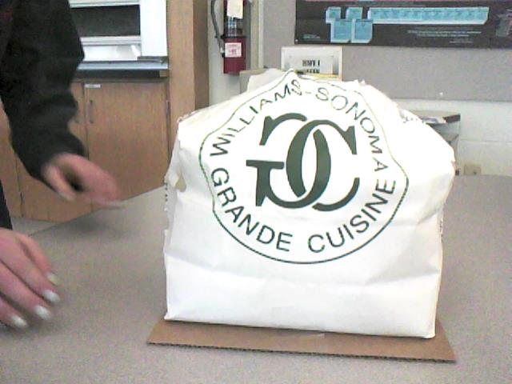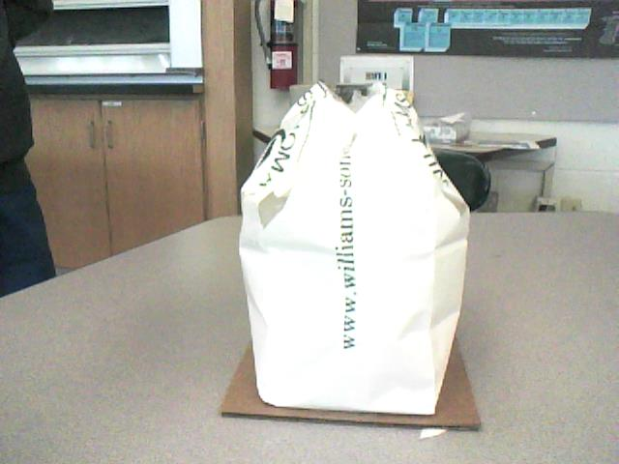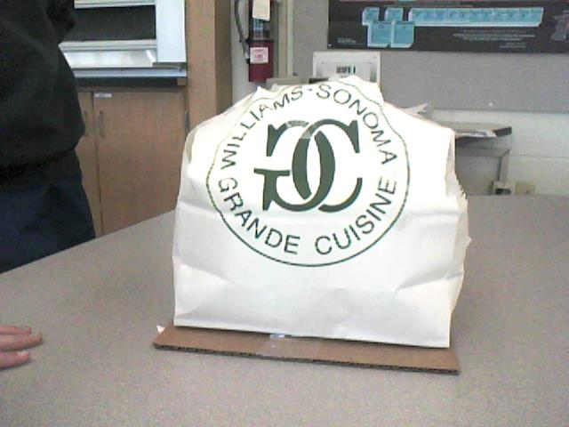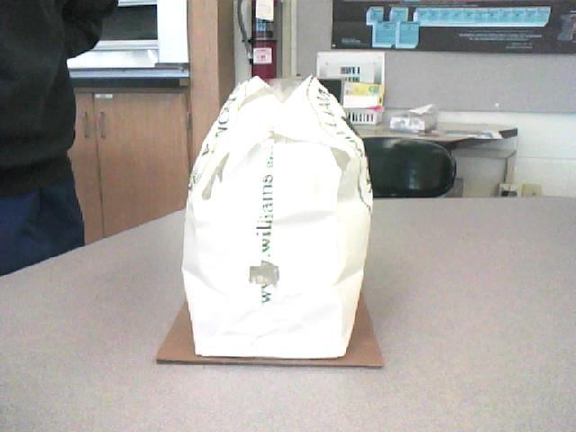

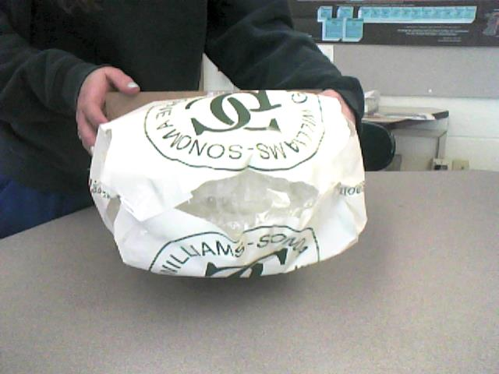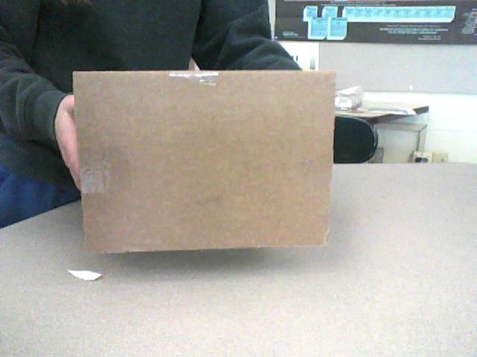

After the drop:

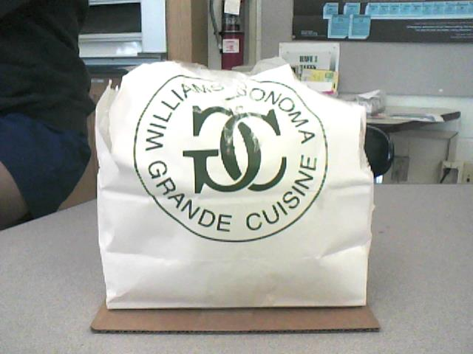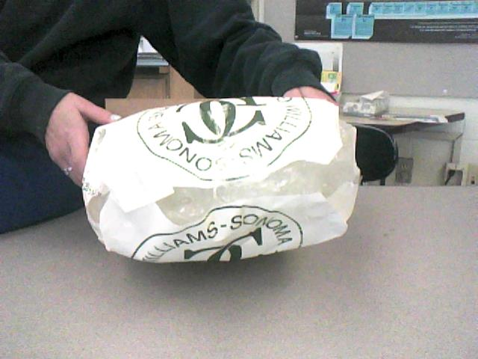

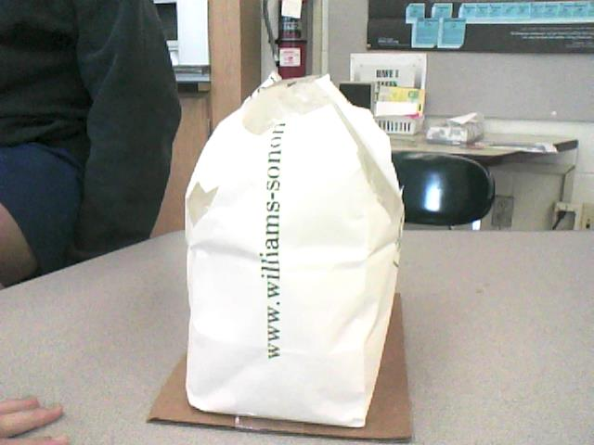

The egg:

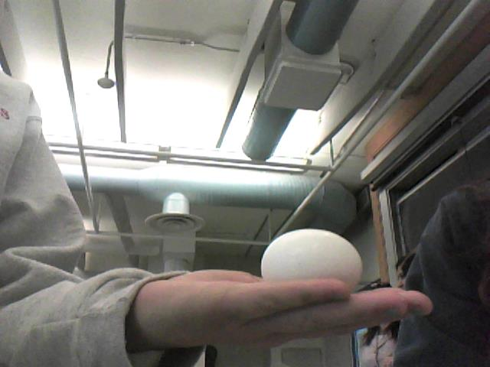

**Mass of Package and Egg:** 200 grams

**Survival status:** The egg survived the fall. It was not cracked or broken in any sense or way.

**Discussion**

Our first trial was a failure. The mass of the package and Egg was 199.3 grams. It was designed similar to the one showed in the pictures. However, the board on the bottom was uneven and rigid, causing the contraption to flip during flight. This resulted in the egg completely cracking when it hit the ground. Our second trial was much more successful because it resulted in the egg surviving. If the o cpportunity for a third trial was present, the design would include less bubble wrap to make the design more efficient while still preserving the egg. It would also include ‘wings’ or cardboard attachments on the side of the contraption because having ‘wings’ would slow down the speed of the egg dropping, causing the landing to be softer which would preserve the egg better.