The Effect of Music Volume on Short Term Memory



Taylor Brewer & Grace Laria

Abstract

It is a common phenomenon today for people to have background music in the workplace or school. Studies have shown that background music has both positive and negative effects on short term memory (STM), but little research has been done to analyze the impact of music’s volume on STM. In this study, thirty female high school students were shown a sequence of varying numerical digits for periods of seven seconds each, using a computer program developed with “Scratch 1.4 software.” Each subject was shown three different sequences of increasingly larger numbers and asked to recall the correct order of each sequence immediately after the seven seconds. Subjects completed the short term memory tests while exposed to three auditory conditions: silence and varying levels of classical background music (i.e. high and low volume). We found that low volume classical music significantly impacted our test subjects’ short term memory, increasing the percentage of digits remembered by approximately 13%. We suspect that tis may be due to a heightened level of focus produced by low volume music and in the future, we would conduct a study which included sudden spikes of high or low white noise volume throughout the test protocol.

Introduction

It is a common phenomenon today for people to listen to music or to have other background noises in the workplace or at school. Yet while many people claim background noise motivates them to focus on their daily tasks, it has been shown that people who often use several forms of media at once are unable to filter out irrelevant stimuli, diverting them from their goals. As a result, such “multitaskers” are unable to focus on specific pieces of information or effectively commit them to memory while in the presence of distractions such as background noise or other types of media stimulants (Nass, Ophir, & Wagner, 2009). Likewise, background noise present in a classroom environment has been proven to have a negative impact on the performance of students during testing, as sounds and other academic work coming from both inside and outside of the classroom have been shown to reduce both the speed and accuracy with which they complete their work in a time restricted period (Dockrell & Shield, 2006).

Other studies, though, have increasingly shown that background music, regardless of tempo or consonance, has no effect on the participants’ verbal memory skills (Jancke & Sandmann, 2010). For example, the presence of background music has been shown to have no significant impact on SAT reading comprehension and previously-memorized vocabulary scores. Hence it would seem that this particular type of distractor seems to have little effect on concentration skills or short term memory’s access to long term memory (Lindberg, 2001).

However, while studies have shown conflicting effects of background music on short term memory, little has been found regarding the impact of the volume of such noise on a person’s ability to retain knowledge and in particular on the ability of short term memory to retain newly acquired information. Unlike long term memory, short term memory’s function is to retain very limited amounts of data (usually 7-10 digits of information) for only short periods of time and its content often fades from the brain by the next day. Yet without this momentary awareness, long term memories cannot be stored. Hence, in a world where teenagers and young adults are increasingly exposed to an exponentially increasing amount of distracting media, it becomes crucial to examine how the mind processes data under these conditions and the impact of multiple audio distractions on the brain, particularly its ability to retain important information given that research has shown that retaining large amounts of information is more difficult when access to that information occurs in ever shorter time periods (Cowan, 2008). As it is common for many young people to subject their eardrums to very loud music while writing a term paper or struggling through a math problem, we were fascinated to know whether the volume of the song made a difference in the capacity of a person’s short term memory. We therefore created a simple model for testing this question by manipulating the volume of a classical piece while test subjects attempted to remember numerical digits of various lengths.

Methods

31 sophomore and freshmen American high school students, ages 13-17 years old, were tested for short term memory ability using a computer simulation written with the Scratch 1.4 software (see Figure One).

**Figure One**

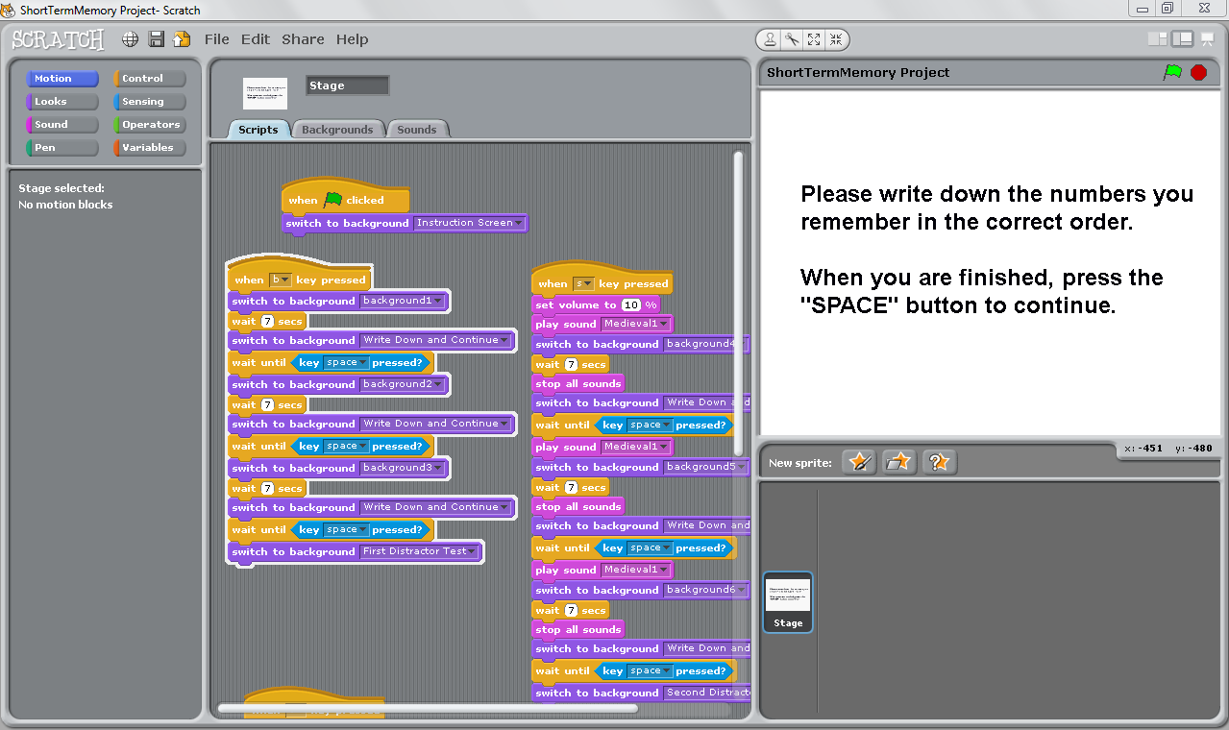

All screens consisted of white backgrounds and black colored text. When starting the test, the subjects were placed in a quiet hallway and were asked to wear a pair of headphones covering both ears. First, the subjects were shown an instruction screen telling the subject that several ordered sets of random numbers would appear on the screen with different volumes of classical music playing in the background (see figure two).

**Figure two**

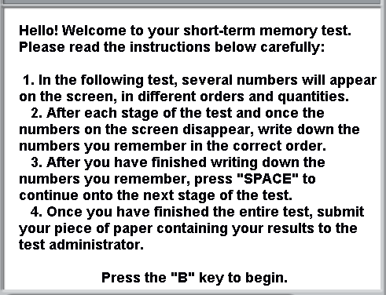

Subjects were told to write down the numbers in order in which they remembered when the slide displaying the numbers went away and to press the space bar when finished recording their recalled numbers. Next a screen containing a set of three random numbers (e.g. see Figure three) appeared for 7 seconds with no sound playing. The screen then went blank, and the subjects were asked to write down what they remembered from the previous screen after it went away. Once they had done so, they were required to press the space bar on the computer to continue.

**Figure Three**



Next, subjects were shown a screen containing a set of 6 random numbers for 7 seconds with no sounds playing, followed again by a blank screen when the subjects were asked to record the numbers they remembered in order. Once they had done so, they were required to press the space bar on the computer to continue. Finally, subjects were shown a screen containing a random set of 12 numbers for 7 seconds with no sound playing, shown a blank screen, and were asked to record the numbers they remembered in order.

Following the completion of the first part of this experiment, subjects were given the same instructions twice more. New sets of random numbers were used each time. Once with medieval 1 music, provided by the scratch software, playing at a 10% volume level and once while the same music was playing at a 100% volume level. Each subject’s responses were graded for accuracy and the percentage of each number set the subject got correct determined.

Results

As figure 4, 5, and 6 show, we found a significant negative correlation between the number of digits displayed and the ability of the test subjects to recall them (r2 >0.5). Furthermore, as figure 7 shows, we saw a significant difference in the ability of subjects to recall 12 digits when the volume of music was varied (p=0.013).

**Figure 4**

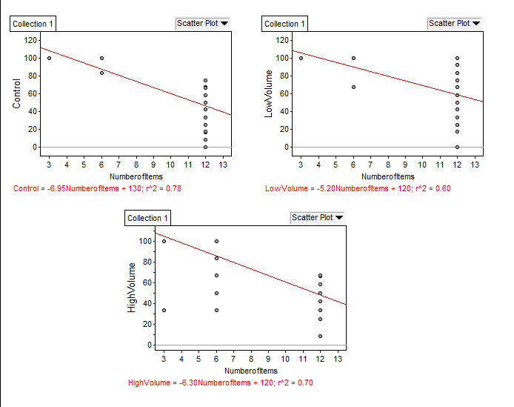

**Figure 5**



**Figure 6**





**Figure 7**

Discussion

As Figures 4-6 indicate, our data shows the negative, expected impact of increasing the number of digits in each sequence on short term memory. While the percentage of numbers remembered correctly remained constant when subjects were shown the 3 and 6 digit sequences regardless of how loud the music was (see figure 7; p = 0.325 for 3 digits, p = 0.103 for 6 digits) this percentage changed significantly once the test subjects were asked to remember a 12 digit sequence. The percentage of numbers remembered correctly during the twelve number sequence test increased by approximately 14% when the test subjects were exposed to low volume background music (p=0.013), indicating this type of stimuli has some manner of positive effect on short term memory.

But why just this volume of noise and why only the 12 digit sequences? We believe that this increase occurred because low volume music provides just enough background stimuli to help the test subjects focus, while refraining from distracting the test subject with high volume sounds. From an evolutionary standpoint, organisms have a need to respond by immediately diverting their attention away from their current task when exposed to a very loud noise, since such a sound is a likely indicator of a potential threat to that organism’s life. Lower volume sounds, on the other hand, could serve to heighten general awareness and mental focus in anticipation of a significant change in volume that might provide a stimulating background that causes organisms to focus while also keeping them alert to the possibility of a future attack. A person would then see the benefits of this heightened focus when the mental task at hand is more challenging (e.g. reading a twelve digit sequence carefully).Therefore, we think low volume music must be creating a sort of “middle” environment where the test subjects could concentrate while stimulated by quiet, classical music without becoming distracted by loud music.

In order to explore this hypothesis further, we would alter our current experiment design by using white noise at a variety of different volume levels, as white noise unlike classical or other forms of music does not engage the interpretative centers of the brain. Our alternative protocol could include sudden spikes of high or low white noise volume throughout the experiment so as to explore the validity of our proposed explanation. In addition, it would be beneficial to increase the test population size and diversity, including more people of a variety of ethnicities and cultural backgrounds, since an evolutionary root to the impact of low volume noise on short term memory should be present across the human population.

References

Cowan, N. C. (2008). What are the differences between long-term, short-term, and working memory?. *Progress in Brain Research*, *169*, 323-338.

Dockrell, J. E. D., & Shield, B. M. S. (2006). Acoustical barriers in classroom: the impact of noise on performance in the classroom. *British Educational Research Journal*, *32*(3), 509-525.

Hirokawa, E. H., & , (2004). Effects of music listening and relaxation instructions on arousal and the working memory task in older adults. *Journal of Music Therapy*, *41*(2), 107-127.

Jancke, L., & Sandmann, P. (2010, January 7). *Music listening while you learn: No influence of background music on verbal learning*. Retrieved from <http://www.ncbi.nlm.nih.gov/pmc/articles/PMC2828975/>

Krikweg, S. B. K. (2009). *The effects of music on memory*. Retrieved from <http://clearinghouse.missouriwestern.edu/manuscripts/230.php>

Lingberg, C. (2001). The effect of background music on memory for different tasks. *The Master of Science in Psychology*, Retrieved from https://esirc.emporia.edu/bitstream/handle/123456789/1112/Linberg 2001.pdf?sequence=1

Ophir, E. O., Nass, C. N., & Wagner, A. D. W. (2009). Cognitive control in media multitaskers. *National Academy of Sciences of the United States of America*, *106*(37), 15583-15587.

Smith, S. M. S. (1985). Background music and context-dependent memory. *The American Journal of Psychology*, *98*(4), 591-603.

Acknowledgements

We would like to thank the 9th and 10th graders of Roland Park Country School for their participation in our study and our teacher, Mr. Brock, for his constant support.