Taylor Brewer
May 3 2014
Final Stage Gate Evaluation: Creating Sunscreen
In the active and outdoor lives most people live today, it is important to maintain safety precautions when dealing with great amounts of sun exposure. One main type of sun protectant is sun-protective lotion which can either block or absorb different frequencies of the sun’s light such as UVB and UVA light frequencies. With this in consideration, the sunscreen made during class was aimed to provide the highest SPF levels possible to protect the user the most without causing major health risks to the consumer. Therefore the overall goal was to determine the maximum mass combination of OM Cinnamate and Oxybezone that passes a LD50 test and is within the FDA regulations. In attempting to create a high SPF level sunscreen, the maximum amounts of OM Cinnamate and Oxybenzone were aimed to be used since the higher amount of these chemicals results in a higher SPF level. According to government standards, the maximum SPF levels of 12-19 are resulted from the maximum amount of OM Cinnimate which can be used, 7.5% of the entire quantity. However when Oxybenzone is mixed with other chemicals, it can have a SPF level higher than 20, but it alone cannot exceed 6% of the overall product. In addition both of these chemicals must at least be 1.5% in the final product, and together, they must be more than 6% of the entire sunscreen. Still, a large amount of these chemicals can be dangerous. Therefore to test for the highest safe level of each chemical, the levels of OM Cinnamate and Oxybenzone underwent a LD50 test in which only the levels of the chemicals which killed less that 50% of the E. coli, used to imitate humans, pass the test and are able to be used in the final product. A more advanced species would, in theory, be used to imitate human reactions, but E. coli is all that were available in the classroom. Another primary factor needed to be considered when creating a sunscreen is the cost of the chemicals as it is desired to spend the least on needed materials to save money. When considering and graphing all of the restrictions of the two chemicals tested, a feasible reason was created. Each intersection point was then tested to see which point would cost the least to make given that Oxybenzone costs 8.05 cents/gram and OM Cinnamate costs 6.67 cents/gram. It was then determined using math that adding 1.5 grams of Oxybenzone and 4.5 grams of OM Cinnamate would result in the cheapest combination: a resulting value of 42.09 cents (see figure 1).
OM Cinnamate was first tested on E. coli in isolation to determine its LD50 value, the amount of OM Cinnamate that kills 50% of the E. coli population. Once this is determined, it can be made sure that less than that amount is added in the final product so in theory, less than half of the consumers should be affected negatively by the product. As seen in the raw data graph of the first round of testing OM Cinnamate (Figure 2), the control consisted of no OM Cinnamate, the low level consisted of 22 drops of OM Cinnamate, and the high level consisted of 43 drops of OM Cinnamate. As seen in the graph including the line for round 1 of OM Cinnamate in isolation (see figure 3), the higher level of OM Cinnamate kills less than the low amount of OM Cinnamate while the control value kills the least, providing inconsistent data as a more linear path would be expected. The first round also provided a clear LD50 value of about 4 drops. The second round was then centered on this LD50 value, the control still included no OM Cinnamate, but the high level included 22 drops as the low level included 11 drops (See figure 4 for raw data). The second round of various amounts concluded a more expected path; as the amount of OM Cinnamate increased, the survival rate of the E. coli decreased (see figure 3). However this second round provided a LD50 of 14.5 drops, a drastic change from the first round. Therefore this round individually concludes that OM Cinnamate is a toxic chemical and no more than 14.5 drops should be used of it. Continuing on, the third round’s values of OM Cinnamate were centered on the previous LD50 of 14.5 drops. In the third round, the control was still no OM Cinnamate added while the low amount was 8 drops and the high level of OM Cinnamate was 16 drops (see figure 5 for raw data). The results from this round did not provide a LD50 as all of the amounts of OM Cinnamate killed less than 50%. The slope of this graphed line is mostly linear and negative, suggesting that as the amount of OM Cinnamate increases, the more E. coli it kills. This drastic change from the previous rounds is most likely because from the third round on, a vortex was used to more thoroughly and aggressively mix the chemical with the E. coli. Since the third round did not supply a reliable LD50, the fourth round’s values were chosen a little bit more randomly within reason. The control was still when no chemicals were added, the low value was 10 drops of OM Cinnamate and the high level was 20 drops of OM Cinnamate (see figure 6 for raw data). In the graph seen in figure 3 again, it can be concluded that this round implies that as the amount of OM Cinnamate increases, the survival rate also increases; the complete opposite of the previous round. This round also does not provide an LD50 value. Overall, the effect of isolated OM Cinnamate on E. coli cannot be determined since half of the rounds proved that OM Cinnamate is toxic while half of the rounds proved it not to be toxic. Therefore since there cannot be a strong conclusion, no cost analysis can be performed.
It was then further tested to see if OM Cinnamate combined with Oxybenzone would have a different effect on the E. coli, ultimately resulting in more conclusive results. Since Oxybenzone came to a conclusion on a beneficial amount Oxybenzone that could be used, Oxybenzone was kept the same through each round while altering the amount of OM Cinnamate to see if clear conclusions could be made when it interacted with Oxybenzone. Again for each of these trials, a vortex was used. For the first round, a control consisted of only E. coli while a low level amount consisted of 5.28 grams of Oxybenzone and 3.3 grams of OM Cinnamate and a high level consisted of 5.28 grams of Oxybenzone and 6.6 grams of OM Cinnamate (see figure 7 for raw data). As seen in figure 8, this round provided a fairly consistent correlation between the two variables; as the amount of OM Cinnamate increased for a constant amount of Oxybenzone, the survival rate increased. The LD50 for this round was determined to be about 1.2 grams of OM Cinnamate. For the second round, the level of the chemicals was based on the previous LD50 found and the size of the containers. For the first round, all the chemicals barely fit in the test tubes, so this time, the level of Oxybenzone was divided by four and remained consistently that amount throughout the last round while the OM Cinnamate was decreased by a half of the first round of the chemicals being combined (see figure 9 for raw data). Therefore the second round had the same ratios of Oxybenzone to OM Cinnamate as the first round. However these results concluded to be less consistent as the most E. coli survived in the control, the second most survived in the high level, and the least survived in the low level of OM Cinnamate with a constant level of Oxybenzone. The LD50 of OM Cinnamate in the second round was .7 grams. Overall, these rounds concluded that the less Oxybenzone added, the more E. coli will survive as the toxicity of OM Cinnamate is still unclear. From this data, 1 gram of OM Cinnamate is recommended to be added final product because this estimated the average of the two LD50 values of the combined data. 5.28 grams of Oxybenzone is also recommended to be combined with the OM Cinnamate because less E. coli died when 5.28 grams were added than when 1.32 grams were added. Based off of these recommendations, the cost of the combination would be 49.17 cents per gram.
Figure 1
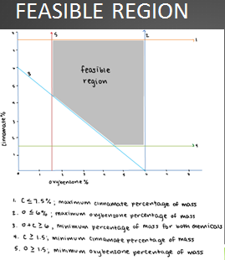

Figure 2
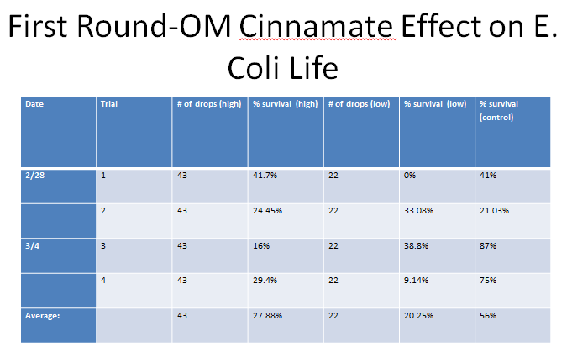
Figure 3
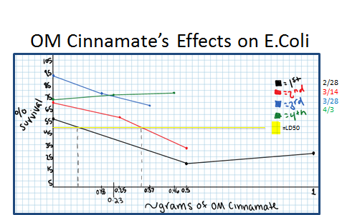

Figure 4
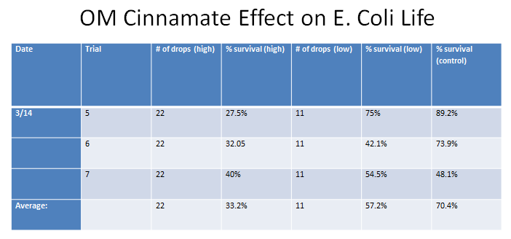
Figure 5
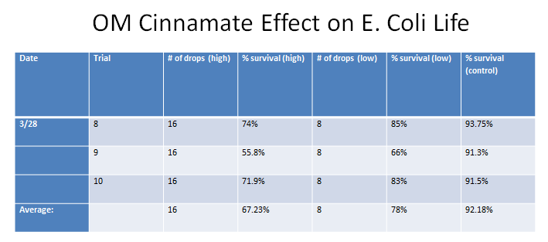

Figure 6
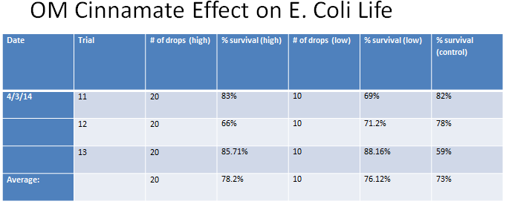
Figure 7
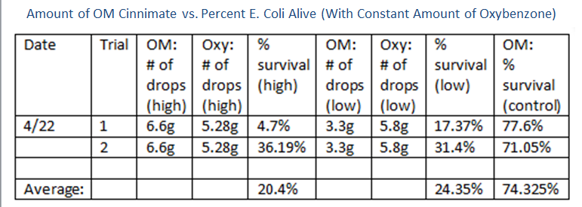

Figure 8
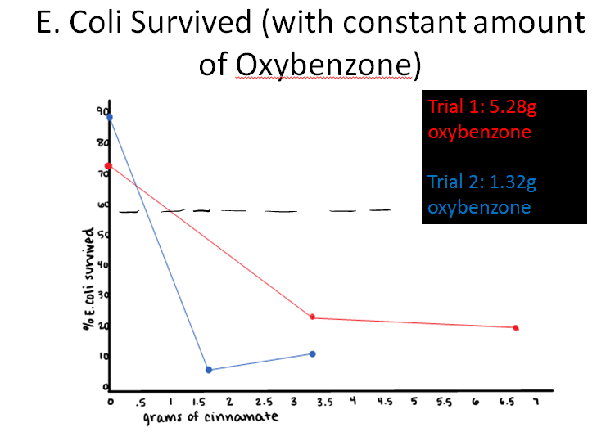
Figure 9
