Ariel Egbunine, Rebecca Mathew, and Hannah Song

17 January 2014

The Effect Background Noise has on Immediate Recall of Shapes

Abstract

Short term memory is one’s ability to recall information for a short period of time and it can be hindered by sights, sounds, tastes, feelings, and smells. It is hypothesized that visual short term memory will be negatively impacted by auditory speaking distractions. One test was performed, with two different sub-sections. The participants were shown and asked to recall different shapes in one setting with no noise, and then in a second setting with a voice recording playing over as on added distraction. The results showed a significantly higher rate of correct answers in the test without noise playing, than the test with the auditory distractor. A p-value of 0.04562 proves that the distractor did have an impact on the results of the subject’s ability to memorize the shapes.

Introduction

Short term memory is one’s ability to recall information for a relatively short amount of time as in 10 seconds to a minute, as mentioned by Mastin (2010). Distractors such as sounds, sight, taste, feeling, and smell impact one’s ability to recall needed or accurate information from short term memory. Elliott et al. (2009) describes two experiments that tested a person’s degree of vulnerability to noises and the impact noises have on short term memory. The test subjects of these experiments were asked to complete a visual span task. The expectation of the visual span was to remember the order of the digits after a retention interval which was the same amount of time as the visual list was presented. All of which tested for the ability of each test subject to resist the distraction. The results of these experiments state that memory is resistant to disruption. Jones et al. (2004) tested for the effects of irrelevant noise that goes away when it is suppressed, because the noise distracts the subjects. Mills et al. (2009) tested for the subjects’ ability to recall pictures, words, and picture and words presented to them at the same time using short-term memory. The test subjects in this experiment were shown 18 pictures (ranging from lamps to bears), a list of 18 words, or 18 pictures with the word of that picture next to it. In this study, they found that a monotonous voice gave inconclusive results. It can be concluded based off of their results that words and pictures together are easier to remember than pictures alone or words alone. Mather et al. (2013) tested to see if arousal would enhance one’s ability to recall events. The researchers proposed that arousal such as pictures and words during an event increases perception and long term- memory of the event. The results of the experiment contradict the proposal and indicate that the specific arousal distracted the test subjects from recalling the material presented to them. It also enhances the goal-relevant information and emotional arousal leading to enhanced processing of impaired information.

Building on the previously completed studies, we will be analyzing one’s ability to recall seven shapes in silence in comparison to one’s ability to recall seven shapes while a recording of ninth grade students talking plays in the background during the test.

Method

15 ninth grade students varying in age from 14 to 16 years old were tested. Each participant was a female from Roland Park Country School. The participants sat in a quiet room in front of a Lenovo ThinkPad tablet and were each given a pair of noise cancelling headphones to wear during the entire test. The test was created using BYOB (Build Your Own Block) Scratch.

To begin, participants were shown the instructions slide (see image 1) which prompted them to the instructions and to press the space bar when they were ready to begin. They were then shown a series of seven shapes that were drawn using the “paint new sprite” tool (see image 2). They were shown each shape individually for 5 seconds and all 7 shapes were shown consecutively. 2.5 seconds after the last shape disappeared, a screen came up with two shapes on it, one titled “A” and one titled “B” (see image 3). One shape had been shown in the sequence earlier, and one had not. On a sheet of paper, the subject circled the letter of the shape that they thought was in the sequence. There were seven questions in all, and the participants were given as much time as needed to answer each question.

When they were finished, they went to the second test. The second test was identical to the first test, except with different shapes shown and with sound playing (see image 4). Pre-recorded noise played throughout the entire second test. The noise consisted of multiple voices speaking understandably but the conversations were irrelevant. All of the speakers were girls, and the speaking varied from one person at a time to multiple people talking over each other. The sound was recorded directly to the scratch program with no editing done to it.

Image 1: Instruction Slide



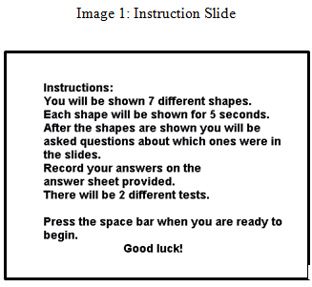

Image 2: Shapes without Distraction

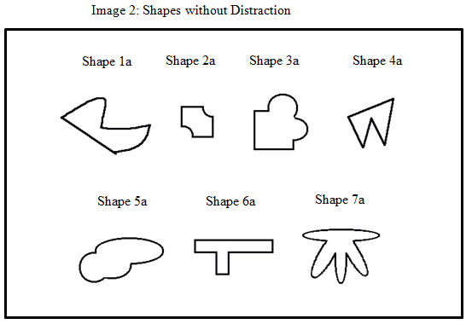

Image 3: Question Slide

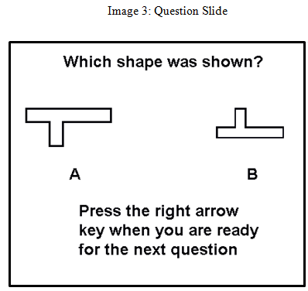

Image 4: Shapes with Distraction

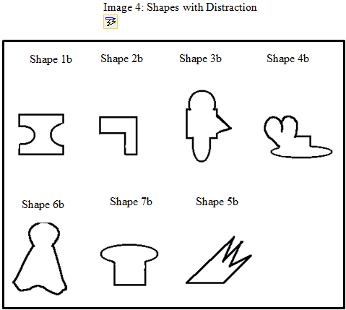

Results

The patterns we observed in our data were a higher percentage of correct answers without the distractor than with the distractor. The average percentage of correct answers with no distractor is 96.19%. The average percentage of correct answers with the distractor is 85.71% (see image 5). A t-test was completed to measure the difference between the distractor and no distractor tests as a fraction of their variability. The p-value that was found for the accuracy of the data was p= 0.04562. This was a significant number indicating that the results are 95% certain that the distractor had an impact on the results of the subject’s ability to memorize the shapes.

Image 5: Bar Graph of the Average Percentage of Correct Sequence Recall



Discussion

The pattern found in the results indicates that a distractor reduced the impact of one’s ability to remember shapes for a short amount of time. The results of the p-value verify that the distractor negatively affected the ability to remember the shapes. The p-value indicates that the distractor did impact one’s ability to recall an image and that the difference observed was not by random chance. The problem with this was that there were different shapes in each test, so there is no way to know if one test was harder than another, which could have influenced the results. The test that was performed was in fact, however, enough to prove that talking does negatively affect the short term memory of shapes, as was seen by the 10.48% in the bar graph of the data.

To provide a test for further research with more results, different tests with different kinds of sound could have been implemented to find out the most distracting form of noise. The sounds could have included whispering, shouting, relevant topics, etc. Various volumes would yield information about how the level of distraction would change with the volume of the speech, determining the optimal noise levels for minimal distraction. Relevant topics discussed as the distraction would determine if topics relevant to the test subject or what the test subject is doing would also distract them from their task more than irrelevant topics. The visual aspect of the test could have been made with different amounts of shapes in each test, the number increasing with each test. The test that was performed was in fact, however, enough to prove that talking does negatively affect the short term memory of shapes, as was seen by the 10.48% in the bar graph of the data.



Work Cited:

Elliott, E. M., & Cowan, N. (2009). Coherence of the Irrelevant-Sound Effect:

Individual Profiles of Short term Memory and Susceptibility to Task-Irrelevant Materials. Retrieved November 13, 2103: http:// [www.ncbi.nlm.nih.gov/pmc/articles/PMC2669750/](http://www.ncbi.nlm.nih.gov/pmc/articles/PMC2669750/).

Jones, D. M., & Nicholls, A. P. (2004). *The Phonological Store of Working Memory: Is It*

*Phonological and Is It a Store?* Retrieved November 13, 2013, from http://biomagnet.uni-muenster.de/PDF_library/006777.pdf

Mastin, Luke. (2010). The Human Memory, 2010. Retrieved November 13, 2013 from:  http://www.human-memory.net/types_short.html

Mather, Mara, & Sutherland, M. R. (2011) *APS*. Perspectives on Psychological Science.

Retrieved November 13, 2013, from <http://www.usc.edu/projects/matherlab/pdfs/ MatherSutherlandinpress.pdf>.

Mills, K.L., & McMullan, H.K. (2009) *National Undergraduate Research Clearinghouse Site*.

Retrieved November, 13 2013, from <http://clearinghouse.missouriwestern.edu/manuscripts/473.php>.