The Influence of High Sulfate Levels on Soil Fungi Reproduction

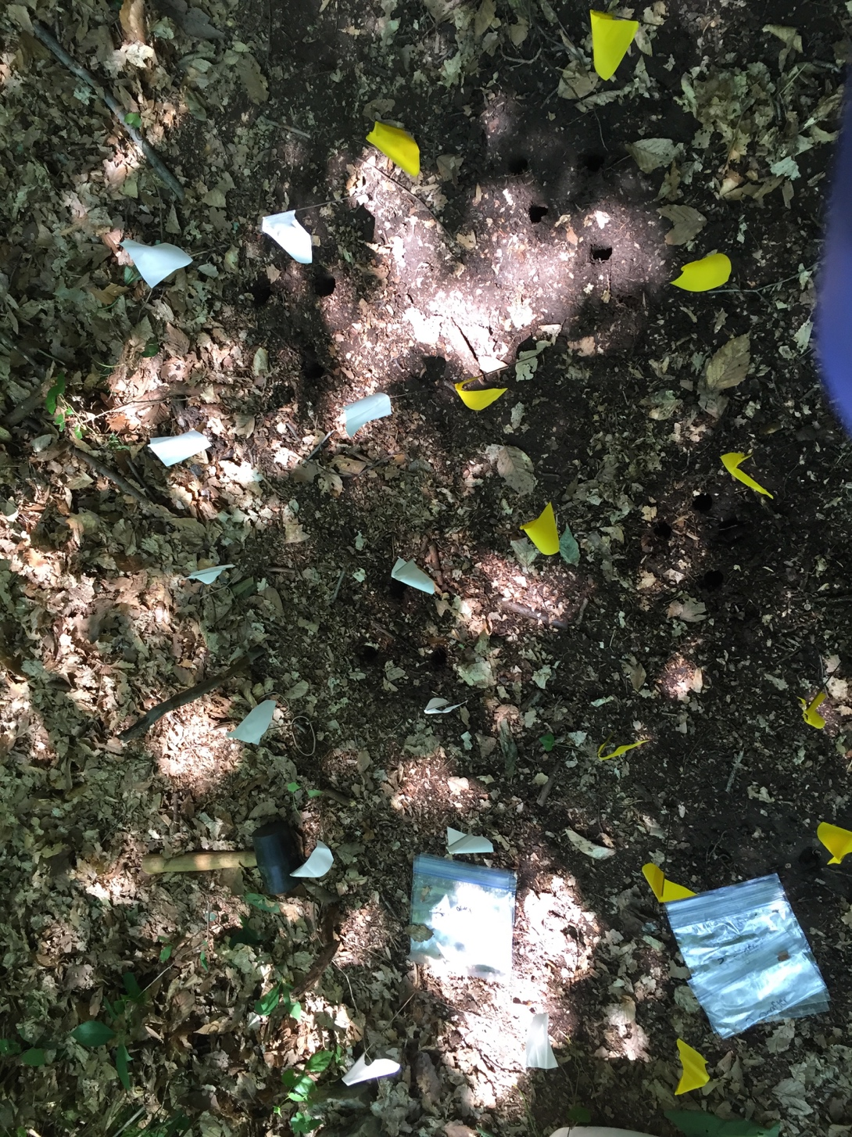

A Study by: Autumn Johnson, Shae McConnell, Madison Robinson, and Erin Waire

Abstract

Soil fungi play a critical role in the soil ecosystem. Soil fungi have two states, mold, a multicellular form, and yeast, a unicellular form. A fungus exists in a yeast state in order to protect itself from irritation due to the environment. In the 2016 E.S.S.R.E. biota survey in Microclimate 2 there was a large number of fungi, the majority of these fungi were yeast. Another anomaly found in Microclimate 2 were the low levels of sulfate. There is a type of cellular respiration that fungi perform called anaerobiosis, which require fungi to use a large amount of sulfate. Without anaerobiosis, fungi cannot reproduce properly. We believed that the samples were taken in site 2 when the yeast consumed the sulfate and the sulfate levels did not have time to replenish in the soil. We hypothesized that the addition of sulfate to the soil would increase the the yeast:mold ratio even more. Our results showed us that we did not successfully manipulate the sulfate levels in our plots, however there were two statistically significant differences in the sulfate levels. Based on the statistical significance from the sulfate soil plots from the day 2 data, our hypothesis is supported but not proven. For future research, we would increase the saturation of the sulfate solution in order to manipulate the sulfate levels in the soil.

Introduction

In an ecosystem, many organisms must have a mutualistic relationship in order for them to survive and thrive. One such group of organisms are the soil fungi. These critical microbes perform many of the tasks to keep the soil ecosystem running smoothly, including the decomposition and decay of dead material, the colonization of plant roots, and the cycling of nutrients. All soil fungi can take one of two key morphological forms, either a multicellular mold or a unicellular yeast, and the differences cause a fungus to adopt different reproductive strategies in the environment (budding for yeast and spores for mold) (Brock, 2006). A fungus is commonly in its mold state when it is in a wetter environment more conducive to reproduction while it will take its yeast form to protect itself through a chemical barrier surrounding the cell membrane when it is in a drier and more challenging environment (Fraser, 2016). In order for each of these forms of fungi to be able to carry out their metabolic and environmental tasks, they need nutrients such as sulfate, chloride, magnesium, and many other elements and salts that can be found in the soil. Without these, it is very difficult for the microbes to work efficiently (Olaniran and Balgobind, 2013). One of the most important internal metabolic functions fungi have to perform in order to complete their larger environmental functions is a form of cellular respiration called anaerobiosis, which is done without molecular oxygen. The absence of oxygen, though, requires greater access to sulfate to be able to perform anaerobiosis properly (English Dictionary, 2016). Without this form of cellular respiration, the fungi are unable to reproduce and complete its tasks that enable the ecosystem to thrive.

Because healthy fungi are needed for an ecosystem to function, discrepancies in their density or in the availability of nutrients they need for survival can be indicative of larger environmental problems. In the 2016 E.S.S.R.E. Biota Survey (E.S.S.R.E., 2016), we found that in E.S.S.R.E. Microclimate 2 (N 39.35740; W 076.63893), Quadrant 1 that the population of yeast was extremely high, averaging around 87,000/cc of soil while but the sulfate levels were abnormally low, averaging around 100 ppm. Given the extremely dry conditions in Microclimate 2, the unusually high density of yeast might be expected, but how could they be sustaining themselves on such low levels of available sulfate? We suspected that Microclimate 2, Quadrant 1, was surveyed at a point in time when the yeast had already consumed the available sulfate needed to survive and that the sulfate levels had not had time to replenish themselves in the soil when the original survey was performed. We therefore hypothesized that if additional sulfate were to be added to the soil in Microclimate 2, Quadrant 1, then the yeast:mold ratio would actually increase even more.

Methods

In E.S.S.R.E. Microclimate 2, Quadrant 1 (N 39.35740; W 076.63893), a 3 x 2 grid was created of 30 cm x 30 cm plots, with 20 cm between both columns and rows. The columns ran north to south and the rows ran from west to east. The 3 plots in the first column served as the negative control, while the 3 plots in the second column served as the independent variable. 3 15-cm x deep 2.5-cm wide diameter soil core samples were collected in three different locations within each plot at the same time on July 20, 2016 for a total of 18 samples. 1 L of tap water was then poured onto each respective plot in the negative control column, and 1 L of a saturated solution of magnesium sulfate was poured onto each respective plot in the independent variable column.

Serial dilutions and sulfate chemical tests were next performed simultaneously on one sample each from the negative control and the independent variable plots. The soil samples were tested for sulfate (ppm) using the LaMotte STH-14 test kit and each sample was serially diluted to 10⁻². 100 µl of each dilution from each soil sample was plated onto an individual 3M Petrifilm YM count plate and grown for 48 hours. The number of yeast and mold per cm³ of soil were then determined for each sample. Serial dilutions and sulfate testing were next completed for the second set of soil samples from each plot 24 hours after the first, followed by the third set of soil samples 24 hours after the second set.

24 hours after the tap water and sulfate solutions were applied to their respective plots, 3 15-cm deep x 2.5-cm wide diameter soil core samples were collected in three different locations within each plot at the same time on July 21, 2016 for a total of 18 samples. Serial dilutions and sulfate chemicals were then performed on the new 18 samples in identical fashion to the 18 samples taken before adding the varying solutions to the soil plots.

Results

Figure 1

Figure 2

Figure 3: Sulfate P-Values
Location | P-Values
Day 1 N.C. Soil Before – Day 2 N.C. Soil Before | 0.267
Day 1 N.C. Soil Before – Day 1 N.C. Soil After | 0.101
Day 2 N.C. Soil Before – Day 3 N.C. Soil Before | 0.567
Day 3 N.C. Soil Before – Day 3 N.C. Soil After | 0.65
Day 2 N.C. Soil Before – Day 2 N.C. Soil After | 0.75
Day 1 Sulfate Soil After – Day 2 Sulfate Soil After | 0.519
Day 1 Sulfate Soil Before – Day 1 Sulfate Soil After | 0.649
Day 2 Sulfate Soil After – Day 3 Sulfate Soil After | 0.423
Day 2 Sulfate Soil Before – Day 2 Sulfate Soil After | 0.183
Day 3 Sulfate Soil Before – Day 3 Sulfate Soil After | 0.66

Figure 4: Yeast:Mold Ratio P-Values
Location |  | P-Values
Day 1 | N.C. Soil Before – N.C. Soil After | 0.592
Day 2 | Sulfate Soil Before – Sulfate Soil After | 0.0033

Discussion

The sulfate levels in the soil in Microclimate 2 (N 39.35740; W 076.63893) were not significantly affected by the added sulfate solution (see Graph 1; p-values= 0.42-0.75). Likewise, the yeast:mold ratio also did not show the expected correlation for day one, July 25th, 2016, and day three, July 27th, 2016 because as the sulfate levels went down, the yeast:mold ratio also went down (see Graphs 1 and 2). Hence on both dates, the data appears to contradict our hypothesis. However, on day 2, July 26th, 2016, there was a strong statistically significant difference in the yeast:mold ratio before the addition of sulfate to after the addition of sulfate (p=0.0033). As the sulfate levels went up, the yeast:mold ratios significantly went down, showing some support for our hypothesis.

Due to the fact that the sulfate levels in the soil were not manipulated enough and only day two shows a direct correlation between the sulfate levels and the yeast:mold ratio, it can be said that day 2 shows minimal support for the hypothesis. Furthermore, the hypothesis is not supported by the other sets of data shown in the results.

The high levels of yeast found in Microclimate 2 when the original Biota Survey was conducted may have been attributed to the dry soil rather than the high sulfate consumption as hypothesized. Higher levels of sulfate are usually found in moist and acidic soils, so the dryness of the soil could have then lowered the sulfate levels even though the soil in Microclimate 2 was also acidic. The results of the controlled experiment also may have been affected by a limited number of days for soil sampling. In addition, the concentration of the added sulfate solution that was added to the soil could be increased to supersaturated as opposed to saturated. Precautions could be made to ensure that the solution filtrates deep into the soil of each plot, such as more accurate placement of the solution. Also, more plots could be made in different areas within the same microclimate and quadrant to get a more widespread data set.

References
Brock, D. L. (2006). Infectious Fungi. New York, NY: Chelsea House Publishers.
English Dictionary (2016, April). Anaerobiosis. Retrieved July 25, 2016. http://englishdictionary.education/en/anaerobiosis
E.S.S.R.E. (2016) E.S.S.R.E. Microclimate Database. The Environmental Science Summer
Research Experience. http://essre.rpcs.org/ESSREMicroclimateSurvey.htm
Fraser, R. (2016). Fungi. Retrieved July 21, 2016, from Microbiology Online. http://www.microbiologyonline.org.uk/about-microbiology/introducing-microbes/fungi
Ingham, E. R. (n.d.). Soil Fungi. Retrieved July 25, 2016, from Soil Biology. https://extension.illinois.edu/soil/SoilBiology/fungi.htm
Larners, L. P. M., Govers, L. L., Janssen, I. C. J. M., Geurts, J. J. M., & Van der Welle, M. E. W. (2013, July 22). Sulfide as a soil phototoxin- a review. Retrieved July 21, 2016, from NCBI. http://www.ncbi.nlm.nih.gov/pmc/articles/PMC3717504/
Olaniran, A. O., Balgobind, A., & Pillay, B. (2013, May). Bioavailability of Heavy Metals in Soil: Impact on Microbial Biodegradation of Organic Compounds and Possible Improvement Strategies. Retrieved July 21, 2016, from NCBI website: http://www.ncbi.nlm.nih.gov/pmc/articles/PMC3676836/

Acknowledgements

We would like to thank Mr. Larry Jennings for making this program possible. We would like to thank Mr. David Brock for giving us the opportunity to participate in the Environmental Science Summer Research Experience for Young Women, and Mrs. Janel Dutton for helping us plan our own research project. We would also like to thank the teaching assistants, Emma Wilson, Sally Askew, and Ava Drum for proofreading our papers and guiding us through our research and testing.

