Lauren Zollicoffer and Erin Waire
STEM
January 10, 2014
The Effect of Flashing Circles on Sequence Recall
Abstract
The short term memory experiment analyzed; do flashing shapes negatively influence one’s ability to recall a sequence of numbers and letters? The experiment was made up of 20 different sequences, 10 with flashing circles and 10 without flashing circles. The circles flashed a variety of colors at different rates. The data obtained indicates the flashing circles did not affect the participant’s short term memory. Based off the graph (see image 4), we conclude that the average percent correct with the flashing circles was higher than without the flashing circles.

Introduction
Short term memory allows one to recall information from your brain over a brief period of time. According to the research of Princeton University, short term memory is what you can repeat immediately after perceiving it (The Trustees of Princeton University, 2013). Much of research has been completed on short term memory, such as the length and capacity of recall as well as the impact of distractors on short term memory. Lloyd R. Peterson did a study analyzing if verbal habits rely on the effects of a given time, having to remember and repeat in the sequence. In experiment one Peterson used twenty-four students form psychology courses in Indiana University. These twenty-four students had to spell constant syllables and immediately speak a three digit number, counting backwards by threes or fours for that given number. In experiment two Peterson used forty-eight students from psychology courses at Indiana University, half of them where “silent” and half were “noise”. These forty-eight students had to do the same thing as the twenty-four students in experiment one but the length of rehearsal periods varied depending on the group. Peterson’s experiment resulted in data showing that if the subject has more time to respond they have better recalls. From these studies we concluded that there is minimal research on flashing objects distracting someone while they have to recall a sequence, thus this experiment will analyze if; Do flashing objects negatively influences one’s ability to recall a sequence of letters and numbers.
Methods
Twenty 9th grade female students at Roland Park Country School participated in this study where, ten were 14 year olds and ten were 15 year olds. The participants were tested to see if they could recall a sequence of numbers and letters while four flashing circles were placed around the sequence. A computer program, called BYOB (build your own block) Scratch, was used to generate the test. Prior to taking the test the participants recorded their name, age, grade, and current school on a piece of paper. The test began by displaying a direction screen (see image 1). A total of 20 sequences were shown to the participant, where the first 10 were shown with the distractor and second 10 were shown without the distractor. The sequence gradually got larger as the test continued by one, beginning with 2 numbers or letters to 11 numbers or letters. Each sequence was shown for a total of six seconds throughout the whole test, and the participant had as much time as they needed to record the sequence. The first 10 sequences had four flashing different colored circles. The circles flashed the colors black, green, yellow, pink, red, and blue. Each circle flashed at a different rate. One circle flashed a different color every 0.5 second, another circle flashed every 0.25 second, another circle flashed every 0.75 second, and the remaining circle flashed every one second.

Image 1: Direction Slide
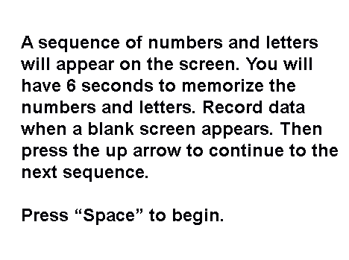

Image 2: Sequence 1
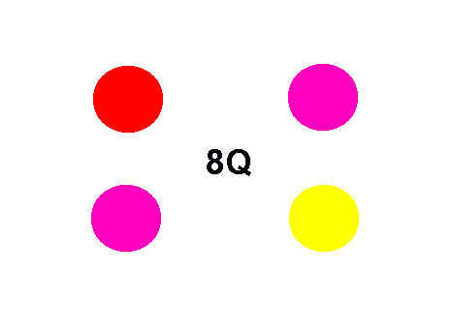
Image 3: Sequence 11
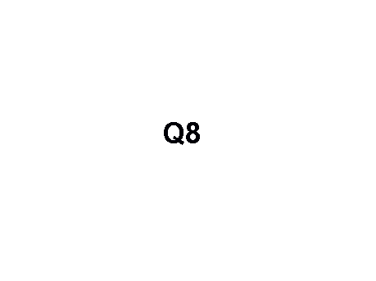
Results
Our graph shows the difference between how well the subject recalled their short term memory with flashing and without flashing. (see image 4) During sequences 1-4 the results stayed consistent, but as the sequences increased in length and difficult. As the sequence with the distractor increased in our experiment the amount of letters the subject got correct in the sequence increased also. (see image 4) thus this observation concluded us to say the distraction’s helped the subject get the correct answers. We used the 2-SampTTest to calculate our p-values which showed that the p-values are not above 0.05, so our results do not show a statistical difference between tests. There was no trend in the p-values, except for sequences one and two where they are exactly the same and sequences three and seven where they are also exactly the same. (see image 5)

Image 4: Graph of Average Percent Correct and Sequence Length with Flashing Circles and No Flashing Circles

Image 5: P-Value Chart
Number of Letters | P-Value
2 | 0.3298768011
3 | 0.3298768011
4 | 1
5 | 0.533281283
6 | 0.1851512993
7 | 1
8 | 0.120262876
9 | 0.0935234511
10 | 0.2630731042
11 | 0.3685803578

Discussion
Our test concluded that four flashing circles do not affect one’s ability to recall a sequence of letters and numbers. The conclusions were drawn from our graph (see image 4). The graph showed that when the sequence is shorter in length with no flashing/circles that the percentages correct is lower than the percentage correct with the flashing/circles. As the sequence length continued to raise the percentage correct from both flashing and no flashing sequences begins to lower. The difference between flashing and non-flashing sequences begins to grow. Ultimately, when the sequence contained the flashing/circles the average percentage correct was higher than the sequence that contains no flashing/circles. The pattern in the data meant that as the length of sequence increased that average percentage correct began to decline. However, there are two exceptions in our graph. The no flashing/no distractor, the average percentage correct when the sequence had a length of 9 was higher than when the sequence had a length of 8. For the flashing/circles, when the sequence had a length of 10, the average percentage was higher than when the sequence had 7, 8, and 9 numbers and letters. This may have been because the participant got bored of taking the experiment.
Our p-values (image 5) demonstrated that in all cases, the distractor did not have an impact on the experiment. The p-values we collected were all higher than 0.05 verifying that there is no statistical difference between the two data sets. The test proved that our hypothesis was wrong and that flashing objects do not influence one’s ability to recall a sequence of letters/numbers. In the future, our experiment may benefit from finding more participants and making the sequences with no flashing/circles before the sequences with flashing/circles.

Work Cited
Bremner, J. D., M.D, Scott, T. M., M.S, Delaney, R. C., Ph.D, Southwick, S. M.,
M.D, Mason, J. W., M.D, Johnson, D. R., Ph.D, . . . Charney, D. S., M.D.
(n.d.). Deficits in Short-Term Memory in Posttramatic Stress Disorder.
Retrieved January 8, 2014, from http://userwww.service.emory.edu/~jdbremn/
papers/bremner__deficits_in_memory_PTSD_s_03848.pdf
Fuster, J. M. (n.d.). Neuron Activity Related to Short-Term Memory. Retrieved
December 19, 2013, from http://www.cns.nyu.edu/~wendy/class/2006sp/reading9/
Fuster_1971.pdf
Peterson, L. R., & Peterson, M. J. (n.d.). Short Term Retention of Individual
Verbal Items. Retrieved January 16, 2014, from
http://hs-psychology.ism-online.org/files/2012/08/
Peterson-Peterson-1959-duration-of-STM.pdf
The Trustees of Princeton Universty (Ed.). (n.d.). WordNet. Retrieved January
15, 2014, from WordNet Search website: http://wordnetweb.princeton.edu/perl/
webwn?s=short-term%20memory

