Hailey Morris and Marsie Salvatori

16 December 2013

Cell Phone Notification Impact on Short-Term Memory

Abstract

The effect of different iPhone notifications (ringtone and vibration) on short term memory were analyzed in this study. Data was collected by showing sequences of random consonants and vowels that increased from 2 to 10. The subjects were then asked to recall these sequences as best as they could while the notification was playing in the background. The results were analyzed using a t-test, where the p-values indicated that the default ringtone on the iPhone did not statistically impact one’s ability to recall a sequence. It was found that the vibration also did not statistically impact one’s ability to recall a sequence. Our participants noted that they utilized the vibration function on their phones frequently which may have caused them to be accustomed to this noise. For future testing, randomizing the vibration or ringtone during the test instead of playing these noises on a set time pattern would foster more realistic conditions, mimicking the actual distraction of the cell phone that students face daily.

Introduction

Short-term memory is information which can be held in the mind for a brief time period. According to End et al. (2010), one can remember about 7 items (plus or minus two) in his/her short term memory, where this information only remains for about 15-30 seconds. Peterson (1966) concluded that sequences are easily forgotten when they are only shown once. In his experiment, it took longer for a subject to recall a sequence he had only been shown once compared to a sequence he had been shown twice. The scientists Klatte et al. (2010) found that there are distractors that tamper with short term memory, including noise. The scientists showed their subjects the same sequences with no noise as they did with noise (irrelevant speech and classroom noise), and they noticed a significant decrease in the number of correctly recalled letters when noise was present. An extension of this was concluded by End et al. (2010), who did the same kind of test as Klatte, except they replaced noise with a cell phone ringtone. The participants during this experiment were inside a classroom watching a video. They had to take notes on the information in the video. The noise would be sounded as a distractor and the participants were later asked to recall the information from the video at the time the distractor sounded. They concluded that subjects who were distracted by a cell phone ringtone could recall less information from a video that was included in the test than those who were not distracted. Because of this, we decided to study the effect of different iPhone notification signals on short term memory.

Methods

Fifteen female Roland Park Country School high-school students were tested. These girls were tested in a quiet room without distractions. Each subject first filled out a questionnaire regarding their personal information and IPhone experience(see image 1). Once they had completed the first portion of the sheet, they were asked to put noise-cancelling headphones on which were plugged into the computer which had the test on it.

The test was created, and then later given on a program written using build your own block (BYOB) scratch. To begin the test an instruction slide (see image 2) was shown that told the subjects they would see multiple sequences of letters for 5 seconds. The subject was instructed to press the “s” key to begin the test and to press the space bar every time the subject was ready to move on in the test.

These sequences were random mixes of letters including both vowels and consonants without repeats (see image 3). The sequences started with two letters and increased to ten letters with each sequence length increasing by 2. None of the sequences were repeated throughout the entire experiment. The background of the screen was white and the letters were in black. Additionally, the letters were displayed in size 48 Helvetica bold font.

Directly after each display in the sequence was shown, the subject was asked to write down what they remembered from the sequence on the answer sheet. After these 5 sequences were shown with no distractors, another five sequences starting with two letters and ending in ten letters (increasing by 2) were shown with the iPhone vibration (obtained by recording the sound using the program Audacity) on a continuous loop even when the subjects were recording their responses. The same procedure applied as far as recording the data for these five sequences as well. Finally, another five different sequences starting with two letters and ending in ten letters (increasing by 2) were shown with the default iPhone ringtone, named “Opening”, on a continuous loop.

Image 1: Questionnaire

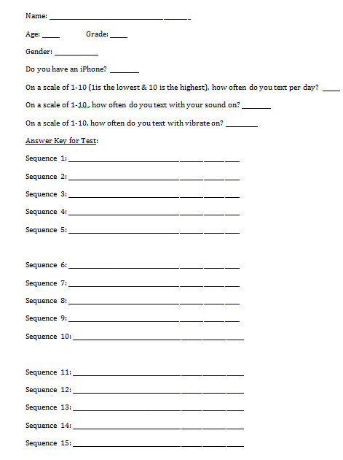

Image 2: Instructions Slide

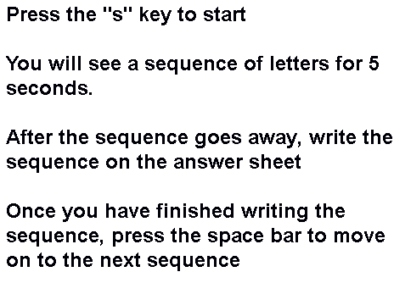

Image 3: Sample Sequence



Results

A graph of the effect of distractors on short-term memory is shown in image 5. This graph includes all of the averages of the complete set of data points among all of our subjects for each number of letters for each distractor. The subjects were graded by how many correct letters in the sequence the subject recorded correctly in the right place, out of how many letters were in the sequence. The blue line shows no distraction, the red line shows iPhone vibration, and the green line shows the iPhone “opening” ringtone. The blue line displays an average baseline for how a person would perform in a short-term memory test with no distraction. According to the points on the green line showing the distractor of the ringtone, the average number of correct letters recalled was lower than both vibration and no distractor for every sequence except for 2 and 8 where it was consistent with the blue and red lines. The red was almost always consistent with the blue line, besides when the sequences had 8 letters.

A t-test was used to determine if a statistical difference between tests occurred by analyzing the calculated p-values (see image 4). A t-test works for small samples (usually less than 30 people) and it tells if the probability of the difference measured could be explained by differences in the population among people. The lower the p-value is, the higher the probability that the distractor caused the differences observed in the data. In order to be able to determine that the difference in the data is in statistically sound, and not just due to a difference in population, the found p-value should be 0.05 or lower. A p-value of 0.05 means there is a 95% chance that the distractor was in fact what caused the difference in the data, instead of natural differences in the population among people. Our calculated p-values for both tests do not exhibit any consistent trends as the sequence increases. Also, all p-values are greater than the 0.05 threshold.

Image 4: P-Values Concerning the Data Collected from Short Term Memory Experiment

|  |  |  |  |  |  |
| --- | --- | --- | --- | --- | --- |
|  | Sequence with 2 letters | Sequence with 4 letters | Sequence with 6 letters | Sequence with 8 letters | Sequence with 10 letters |
| No distractor vs. vibration | 1 | 1 | 0.1643 | 0.5171 | 0.8128 |
| No distractor vs. ringtone | 1 | 0.3343 | 0.1005 | 0.6865 | 0.1905 |

Image 5: Graph of The Effect of Distractors on Short-term memory

Discussion

The observed trends in our graph (see image 5) occurred because one tends to be more distracted by a musical tone than either a rhythmic vibration or no sound at all. Based on our results, the averages of vibration and no sound were interchangeably higher and lower than each other as the sequence increased. Perhaps this is because a ringtone is especially made to grab one’s attention by using a sound that is not so often heard. Also, a vibration is a more typical noise to hear, for example, twelve out of the 15 people tested text with their vibration notification on, instead of the ringtone. By looking at our raw data we can conclude this; however our p-values are too high (above 0.05) to statistically validate that the two distractors caused the observed differences in our collection of data. By this, we can properly conclude that our distractors did not actually distract the subjects in the experiment as designed and that there is no statistical difference between the results in each test. If we were to conduct this experiment again, we would test more subjects, which could ultimately lead to our p-values giving more conclusive results. This is because we have data from more of the population We could also alter our testing procedure so that the vibration or ringtone distractors were more random, because usually receiving notifications from a phone is not on a set time pattern. This could possible alter our p-values to give more conclusive results as well.

Work Cited

Andrade, Jackie, Baddeley, Alan, & Larsen, Janet D. (2000). Phonological similarity and the

irrelevant speech effect: Implications for models of short-term verbal memory.

Psychology Press Ltd, 8, 145-157 <http://psypress.co.uk/ek5/resources/pdf/57qfmem020ubwjkx.pdf>

Craik, Fergus I. M., Li, Karen Z. H., Murphy, Dana R., & Schneider, Bruce A. (2000).

Comparing the Effects of Aging and Background Noise on Short-Term Memory

Performance. Psychology and Aging, 15, 323-334.

<http://www.researchgate.net/publication/232599295_Comparing_the_effects_of_aging_and_background_noise_of_shortterm_memory_performance/file/32bfe50fd7d26cf41c.pdf>.

End, Christian M., Mathews, Mary Bridget, Wetterau, Katharina, & Worthman, Shaye (2010).

Costly Cell Phones: The Impact of Cell Phone Rings on Academic Performance.

Routledge- Taylor and Francis Group, 35, 55-57

<http://www2.bakersfieldcollege.edu/brice/Psyc%20B1A/Costly%20Cell%20Phones.pdf>

Klatte, M., Lachmann, T., Schlittmeier, S., & Hellbrück, J. (2010). The irrelevant sound effect in

short- term memory: Is there developmental change?. *Psychology Press, 22 (8), 1168-1191.* [*http://www.sowi.unikl.de/fileadmin/frueh/publications/klatte_lachmann_etal_ise_ejcp_2010.p df*](http://www.sowi.unikl.de/fileadmin/frueh/publications/klatte_lachmann_etal_ise_ejcp_2010.p%09df)

Peterson, Lloyd R. (1966). Short-Term Memory. Scientific American, 215, 90-95.

<http://www.nature.com/scientificamerican/journal/v215/n1/pdf/scientificamerican0766-90.pdf>

Salamé, P & Baddeley, A. (1986). The Unattended Speech Affect: Perception or Memory?.

*Journal of Experimental Pyschology: Learning, memory, and cognition, 12, 525-529.* [http://books.google.com/books?id=fMgm2NXAXYC&pg=PA53&lpg=PA53&dq=pierre+salame+an d+alan+baddeley&source=bl&ots=jM1d5HhHHm&sig=cqCqROE5rCuNpbHh0HGzA0HUS4Q&hl=e n&sa=X&ei=EMpeUryxEJG84AOHgIHoCQ&ved=0CF4Q6AEwBg#v=onepage&q=pierre%20salame %20and%20alan%20baddeley&f=false](http://books.google.com/books?id=fMgm2NXAXYC&pg=PA53&lpg=PA53&dq=pierre+salame+an%09d+alan+baddeley&source=bl&ots=jM1d5HhHHm&sig=cqCqROE5rCuNpbHh0HGzA0HUS4Q&hl=e%09n&sa=X&ei=EMpeUryxEJG84AOHgIHoCQ&ved=0CF4Q6AEwBg#v=onepage&q=pierre%20salame %20and%20alan%20baddeley&f=false)

Vilimek, R., & Hempel, T. (2005). Effects of Speech and Non-Speech Sounds on Short-Term

Memory and Possible Implications for In-Vehicle Use.*,* *From the ICAD05 Workshop “Combining Speech and Sound in the User Interface” N/A, 344-35.* [*http://icad.org/Proceedings/2005/VilimekHempel2005.pdf*](http://icad.org/Proceedings/2005/VilimekHempel2005.pdf)