**The Effects of Decreasing Rainfall on Phosphate and Humus Levels at Varying Distances from a Broken Dam**

Sally Askew, Rebecca Mathew, Elizabeth McAslan, Keziah Palmer



Abstract

Phosphorus is a chemical that plays a key role in the lives of living organisms. It contributes to the transformation of energy and the structure of DNA in plants and animals. Phosphorus cycles through the earth in its organic and nonorganic forms, but it is only available to plants as a nutrient in its non-organic form. Plots were plotted along an East-West transect starting at the midpoint of the western boundary of ESSRE Microclimate 4. 15 soil samples with dimensions of 15 cm deep and a 2 cm diameter were collected and tested for their levels of phosphorus and humus. Results show that there appears to be a steady accumulation of phosphorus in soils closest to the broken dam where the highest levels of humus were also found, potentially affirming the positive correlation between phosphorus and humus in the soil located in Microclimate 4. In the future, we would test the phosphorus levels in plants, in each of the plots, in addition to testing the soil for phosphorus and humus in order to determine if the plants located in Microclimate 4 are also an influencing factor in this correlation.

Introduction:

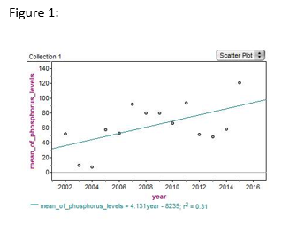Phosphorus is a common element found in a variety of forms in water, soil and other sediments and, in its organic form, plays a key role in the energy transformations and genetic processes of all living things. However, the majority of phosphorus remains trapped in the earth’s crust and is inaccessible to complex organisms such as plants and animals. In order for living things such as these to acquire phosphorus, they depend on either weathering to release phosphorus into the soil in its inorganic form (PO4-3), or they rely on bacteria breaking down the organic phosphate to remineralize it into this non-organic form. The phosphate then moves up the food chain starting with plants absorbing it from the soil, and when organisms die their matter decays, and the cycle repeats. (The University of Waikato, 2013).

Given its central role in living things, anything that alters the flow of phosphorus will have a tremendous impact on any ecosystem, and in E.S.S.R.E. Microclimate 4 (N 39.35733; W 076.63840) a pattern has been observed within the longitudinal data tested for soil phosphate levels in this site (E.S.S.R.E., 2015a). The average amount of phosphorus in this location has steadily increased over the past 15 years (see Figure 1). However, the source of this phenomenon has remained a mystery.

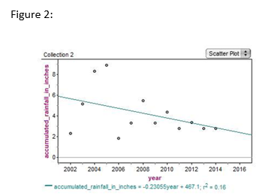One possibility is that weathering of the exposed bedrock in E.S.S.R.E Microclimate 3 (N 39.35797; W 076.63836) uphill of Microclimate 4 may have increased, releasing ever larger amounts of phosphorus into Microclimate 4. But as Figure 2 shows, the average amount of rain fall per month in the annual time frame of the E.S.S.R.E program over the past 15 years has decreased steadily (The Weather Channel, 2015). This inverse relationship suggests that the increase in phosphorus cannot correlate to an increase in erosion as a result of increased rainfall.

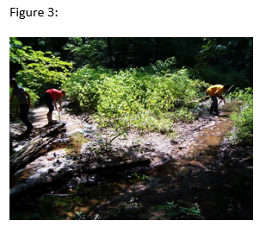Erosion, though, is only one of the two major ways phosphorus cycles through the soil. Decomposition of organic material also plays a crucial role in this cycling as well, and the rate of decomposition of organic material is directly correlated to how much phosphorus is released into the soil. Therefore, determining the amount of decomposition taking place in a given location could also provide a logical explanation for how much phosphorus is present in Microclimate 4 as well. This has historically been an urban wetland (see Figure 3) with water and retained by a dam, and thus resulting 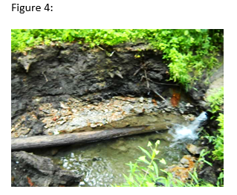in bog-like conditions (see Figure 4). Bogs limit the amount of oxygen available for organisms that decompose organic material (Northern Ireland Environment Agency, 2005) which could explain the low levels of phosphorus found in Microclimate 4 in the early years E.S.S.R.E.’s research program (E.S.S.R.E, 2015b).

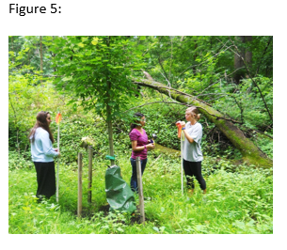However, since 2009 the dam has been deteriorating in E.S.S.R.E Microclimate 4, resulting in the transition of this location from a bog to a dry grass plain (see Figure 5). This transition could contribute to the steady increase of phosphorus in the site. Either the lack of water covering the soil gave way to more oxygen for microorganisms to use when decomposing organic material, or as discussed earlier, the steady decrease of rainfall could prevent the dead organic matter from passing through and past the dam. We hypothesized that the decreasing average of rain over the years contributed to the increase in phosphorus over the years on the supposition that there has not been enough rain and therefore water pushing the phosphorus past the broken dam, resulting in a steady accumulation of phosphorus in soils closest to the dam.

Methods:

In E.S.S.R.E. Microclimate 4 (N 39.35733; W 076.63840), 5 sets of 3 soil samples each 15 cm deep with a 2 cm diameter were collected along an East-West transect starting at the midpoint of the western boundary of Microclimate 4, with the first 3 being collected at the midpoint. Additional sets of 3 samples each were simultaneously collected at 5 m intervals moving east from the first 3 samples for a total of 15 samples. All samples were taken on July 16, 2015 at 9:30 am. All 15 samples were then simultaneously tested for their levels of phosphate (ppm) and humus (ordinal scale, 0-5) using the LaMotte Model STH-14 soil test kit. Additional sets of all 15 samples were collected on July 17, 2015 at 9:30 am, July 20, 2015 at 9:30 am, July 21, 2015 at 9:30 am, and July 22, 2015 at 9:30 am and also tested for phosphate and humus levels.

Results:

Figure 6:

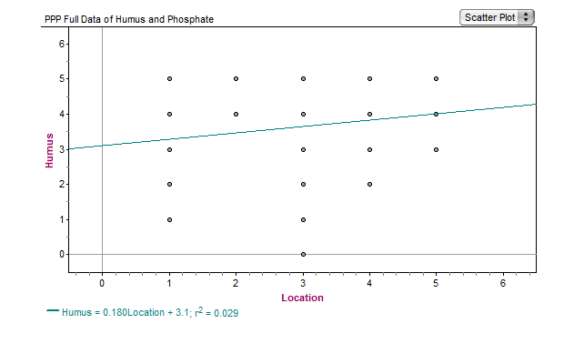

An ordinal scale was used for the Humus Test showing Decomposition.

Value 5 indicates the highest level of decomposition. Value 1 indicates the lowest level of decomposition.

*

Figure 7:

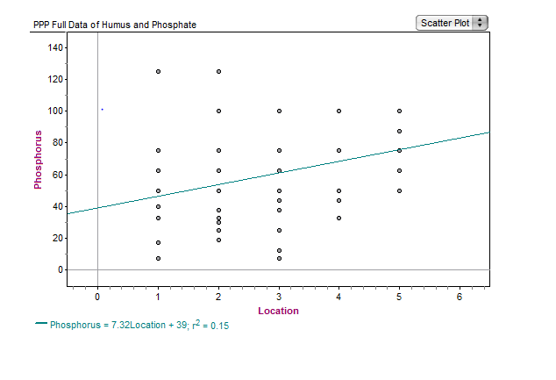

*

(ppm)

Figure 8:

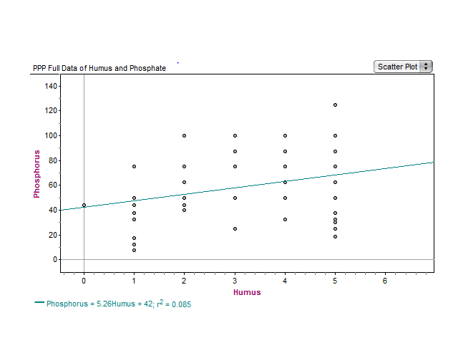

An ordinal scale was used for the Humus Test showing Decomposition.   
Value 5 indicates the highest level of decomposition  
Value 1 indicates the lowest level of decomposition

(ppm)

Figure 9:

Figure 10:

Figure 11:

Figure 12:

Figure 13:

Figure 14:

Figure 15:

Figure 16:

Figure 17:

* Location value dependent on distance from the dam located in Microclimate 4. Location 5 indicates the plot closest to the dam with Location 1 indicating the plot farthest from dam.

Figure 18 – 19: p-values for Phosphate and Humus Data

|  |  |
| --- | --- |
| Figure 18 | |
| Phosphate | |
| Plots compared | P- value |
| 1 – 2 | .253 |
| 1 – 3 | .884 |
| **1 – 4** | **.144\*** |
| **1 – 5** | **.002\*** |
| **4 – 5** | **.044\*** |

|  |  |
| --- | --- |
| Figure 19 | |
| Humus | |
| Plots compared | P- value |
| **1 – 2** | **.0000179 (1.791 10-5)\*** |
| **2 – 3** | **.0000527 (5.273 10-5)\*** |
| **3 – 4** | **.00251\*** |
| 4 – 5 | .467 |
| **2 – 4** | **.028\*** |
| **2 – 5** | **.000252 (2.52 10-4)\*** |

All p-values determined by 2-variable t-testing

* (significant)

Discussion:

As Figures 6 and 7 show, our hypothesis appears to be supported. The data in Figure 6 seems to indicate that the closer to the damn (i.e. closer to location 5), the higher the humus levels there are in the soils, indicative of a greater amount of decomposition taking place, potentially resulting in greater levels of phosphorus. Moreover as Figure 7 shows, there would also appear to be the consequent expected high levels of phosphorus closer to the dam. Finally, Figure 8 does show the expected correlation between humus and phosphate found in healthy, normal soils. However the linear regressions of the data in Figures 6 (r²=0.029), 7 (r²=0.15) and 8 (r²=0.085) indicate that there is no strong statistically significant correlation between the data, therefore at best minimally supporting our hypothesis.

Interestingly, as Figures 11, 13, 15 and 17 of the daily data show, there does appear to be a statistically significant pattern to the correlation of plot location and the amount of humus in the soil, and when examining the total average levels of humus found at each plot (see Figure 9), there is a statistically significant difference in the amount of humus in location 2 versus 5 (p= 0.00252) and 2 versus 4 (p= 0.028). Likewise, looking at the daily data for phosphate levels, there appears to be a statistically significant pattern as well to the correlation of plot location and the amount of phosphate in the soil. When examining the total average level of phosphorus found at each plot (see Figure 10), there is a statistically significant difference in location 1 versus 5 (p= 0.002) and in location 4 versus 5 (p= 0.044).

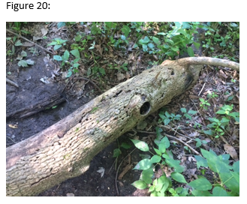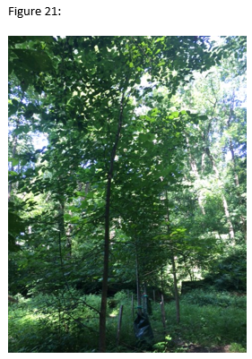Such significantly high values of phosphate in plot 5 correlate well with the fact that the second highest levels of humus are in the plots 4 and 5 as well (see Figure 9). Therefore an examination of the data would seem to confirm our hypothesis strongly. However, such a claim only has validity if there is a sound explanation for why there are such low levels of phosphate but such a high level of decomposition in plot 2. These patterns differ from the general trend that indicates the humus and phosphate levels gradually increase as the plots get closer to the dam, and it is only after taking a closer look at plot 2 that a potential explanation was revealed for this anomaly. There is an actively decaying log in close proximity to the soil extraction locations at plot 2 (see Figure 20), and this decaying log could be a reason for the unusually high levels of humus in the plot. Furthermore, in this same location, there is a large Sugar Maple living tree (see Figure 21), and this tree could be the reason for why the phosphate levels do not correspond to those expected from such high level of humus since the tree needs to be actively absorbing phosphate as nutrients to help it at this time of year to aid in photosynthesis. For future research we would test for the phosphorus levels in the plants located at each of the plots, as well as testing the soil for phosphorus and humus.

Acknowledgements:

A special thanks to our sponsors Dr. Holliday Cross Heine, the Jennings Family, Human Capital Development, Inc. for providing the funding for this learning experience. Also, a big thanks to our helpful program director; David Brock, as well as our Teaching Assistants: Annie Blalock, Emma Wilson, and Kendall McCoach.

References:

E.S.S.R.E. (2015a) E.S.S.R.E. Research Summary. The Environmental Science Summer

Research Experience for Young Women. <http://essre.rpcs.org/ESSRE%20Survey%20Data/ESSRE%20Data%2001%20to%2005.htm>

E.S.S.R.E. (2015b) E.S.S.R.E. Microclimate Data Base. The Environmental Science Summer

Research Experience for Young Women.[http://essre.rpcs.org/ESSREMicroclimateSurvey .htm](http://essre.rpcs.org/ESSREMicroclimateSurvey%20.htm).

E.S.S.R.E (2015c) E.S.S.R.E. The Influence of Stream Flow on the Moisture and Phosphorus

Levels in the Adjacent Soil. The Environmental Science Summer

Research Experience for Young Women. <http://essre.rpcs.org/2015/Erosion/Sample%20Results%201.html>

Northern Ireland Environment Agency. (2005). *Peat bogs*. Northern Ireland Environment

Agency website. <http://www.doeni.gov.uk/niea/nh008.pdf>.

The University of Waikato. (2013, July 30) The Phosphorus Cycle. Science Learning website.

<http://sciencelearn.org.nz/Contexts/Soil-Farming-and-Science/Science-Ideas-and-Concepts/The-phosphorus-cycle>.

The Weather Channel. (2015) Weather history for KBWI. Weather

Underground database. <http://www.wunderground.com/history/airport/KBWI/2014/1/7/DailyHistory.html>.