Reilley Chamness and Rebecca Sereboff
17 January 2014
Abstract
Short term memory was analyzed by testing one’s ability to recall long term memory and the effects short term memory has on that. This was done by having subjects recall various sequences of colored circles, and then recall the same sequences after answering multiplication facts, which are retrieved in the long term memory. After testing the subjects, there was a minimal relation found between the two types of memory, since the calculated p-values were not below 0.05, the number that would show a statistical difference. It should be noted that the test results showed a significant decrease in correct answers between short term and long term memory because the people tested had a greater difficulty to recall a sequence after utilizing short term memory verses before.
Introduction
Short term memory is the information one currently knows or remembers immediately after receiving or perceiving that information. This explanation of short term memory is very broad considering the information remembered could be anything from any situation. Tests are often conducted to test the ability an individual has to utilize short term memory when different forms of distractions are implemented. Color, sound, and images are common examples of distractions used in many short term memory tests because they are relevant to everyday life.
The first step to understanding short term memory is to observe how people utilize it. There is a capacity, seven on average, of what and how much can be remembered when it comes short term memory. Peterson (1966) stated that an auditory presentation makes less of an impression than a visual one on the memory. The article also mentioned that in visual short term memory, while memorizing a sequence of letters often one remembers a specific letter in a specific place which will “intrude” another sequence. In other words, one will remember that letter in that place in other sequences than the one it originally appeared in.
Buckner et. al. (1996) stated that the brain’s process overlaps while retrieving different types of information involving memory. This indicates that recalling different types of things involves utilizing the same general parts of the brain, including the prefrontal cortex, hippocampus and cerebral cortex. Buckner’s discovery had the strongest effect on the development of our question for our short term memory test. This is because long term memory, the general storage of remembered information over a long period of time, is more closely related to short term memory than we realized. Martin (2005) reveled that a sematic short term memory deficit may not derive from a rapid loss of semantic information. Instead, it may be caused by difficulty of inhabiting semantic information, often stored in the long term memory. This would mean that it is hard for long term memory to collaborate with short term memory since it distracts from the information in one’s brain that is only held temporary.
Building on previously completed research, we will test: how one’s ability to recall long term memory will impact their ability to utilize short term memory. A visual aspect will be used for the test instead of an auditory one, as the subject will have to remember a sequence of colors, and then remember the sequence later while being asked multiplication problems, which triggers the long term memory.

Methods
Fourteen ninth grade female students at Roland Park Country School between the ages of fourteen and fifteen years old and one forty-six year old male were tested in a classroom with minimal distractions. Each subject was tested individually using a program created on BYOB (build your own block) Scratch. For the first test, test participants were shown a series of colored circles lined up in a row across the screen (see Image 1). There were 5 trials where the series shown were 2, 4, 6, 8, 9. These numbers indicate the amount of colored circles on each test. Test subjects were shown the colored circles for 15 seconds and were then asked to write down the colors in sequential order. For the second test, participants were shown the same color sequences in a row across the computer screen. Before the participants could write down the color sequence they were shown a basic multiplication fact, making participants utilize their long term memory (see Image 2 and 3). The series of colored circles were identical to the series of colored circles in the first test. Test participants were given an answer sheet to write down their answers. The left column of the sheet had five boxes where the participants wrote down the color sequence. The right side of the answer sheet had two columns. On the right side participants wrote down the answer to the multiplication fact and on the left side participants wrote down the color sequence (see Image 4). Since the color sequences for both tests were the same, participants were asked to fold their answer sheet in half so the previous answers were not visible.

Image 1: Series of colored dots.
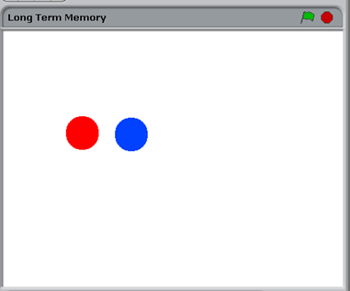
Image 2: Instructions after sequence is displayed.
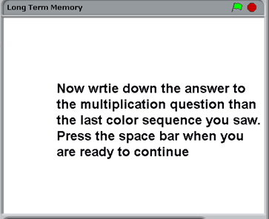
Image 3: Example of multiplication for triggering long term memory.
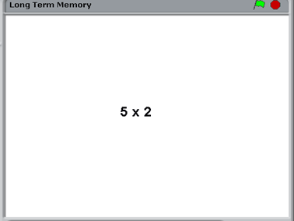
Image 4: Example of one row of the answer sheet.
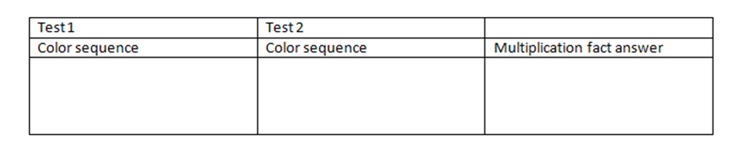

*note: the image above is only one answer section on the answer sheet; the answer sheet contained 5 rows of the image above because there were 5 trials in each test.
Results
The data was gathered by collecting all of the answer sheets and calculating the percentage of correct color placement within each written sequence for each individual question on every test. The data in Figure 1 shows that without a distractor a person can on average remember a sequence of: two and four colored circles 100% percent correctly, six colored circles 87.3% correctly, eight colored circles 68.2% correctly and nine colored circles 51% correctly. Figure 1 also shows that with the distraction of recalling long term memory, a person can on average remember a sequence of: two colored circles 96.67% correctly, four colored circles 87.867% correctly, six colored circles 86.13% correctly, eight colored circles 47.267% correctly and nine colored circles 31.93% correctly. Then, the information was put into a line graph to observe any visual changes (see Image 6).
Image 6 (see following page) includes the graphed information of the number of colored circles remembered, excluding the p-values within Image 5. The blue line represents the tests done without a distractor. As the colored circles within the sequences increased, fewer subjects recalled the sequences correctly. This was expected. The line is also rather consistent, meaning that the slope between points almost stays the same. This too was expected as the questions without the distractor were meant to be the negative control of the test. The red line, which represents the tests done with the distractor, is more scattered. This shows the struggle for the subjects to answer the sequences correctly. The line also decreases, meaning that it was harder to recall the longer sequences with the distractor than it was to recall the shorter sequences with the distractor. This fact is the only similarity between the two lines on the graph.
Obviously, there was a difference when the distractor was added. In order to know if the difference between these two tests is statistically sound, the p-values were calculated for each question using a t-test that compared the two color sequence, four color sequence, six color sequence, eight color sequence and nine color sequence, with and without the distractor (see image 5). The purposes of these tests were that the p-values would indicate a difference between the groups, distractor and no distractor; therefore the results would be impacted.
Image 5: The corresponding p-values to the sequences on both tests.
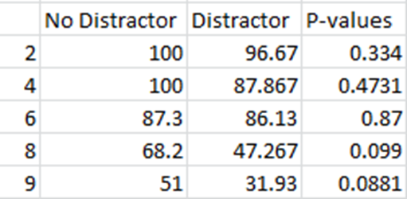

Image 6: Graph of correct answers with and without a distractor for each sequence.

Discussion
Our data shows that accessing long term memory did not have statistical impact on test participant’s ability to remember a series of colored dots. A t-test was used to analyze our data and the corresponding p-values were not below 0.05. Trends in our data show that the p-values do decrease as the test number of items to remember increased. The p-value went from 0.334 when participants had 2 colored dots to remember versus to 0.0881 when participants had 9 colored dots to remember. According to Peterson (1966), the average number of a series that a human can store in their short term memory is 7. We found this to be true. Our graph shows that the number of colored dots that participants remembered made a big drop at the number 6. During our test, some of the colors were repeated in the same trial. Since some of the colors were repeated, it was easier for participants to remember the order. We did not have the materials to analyze what colors were easier for the human brain to remember. As well as that possibility that some colors used were easier for test participants to remember, others could have been harder for participants to remember. This would make the test easier during some trials and harder than intended during others. The same color sequences were repeated for the first and second trials in test one and test two, as well as the other corresponding sequences. This may have impacted test participants results because they had seen the color sequence before and the sequences may have been easier to remember a second time around. The fact that the average capacity of short term memory is 7 would make sense because there was a big drop in correct answers when test participants were asked to remember 8 colored circles. If this project were to be performed again a more beneficial way to conduct the test would be to make sure that colored were not repeated in the same sequence in both tests. Another method to make the test more accurate would be to not repeat the same color in various trials.
Bibliography
Buckner, R. L., Raichle, M. E., Miezin, F. M., & Peterson, S. E. (1996). Functional Anatomic Studies of Memory Retrieval for Auditory Words and Visual Pictures. The Journal of Neuroscience, 16, 6219-6253. http://www.jneurosci.org/content/16/19/6219.short
Martin, R. C. (2005). Components of Short-Term Memory and Their Relation to Language Processing: Evidence From Neuropsychology and Neuroimaging. Current Directions in Psychological Science, 14(4), 204-208. http://neuropsychologyclub.files.wordpress.com/2012/11/components-of-stm-n-relation-to-language-processing4.pdf
Peterson, L. R. (1959). Short-Term Retention of Individual Verbal Items. Journal of Experimental Psychology, 58(3), 193-198. http://hs-psychology.ism-online.org/files/2012/08/Peterson-Peterson-1959-duration-of-STM.pdf

