Sally Askew and Lexi Orlinsky
15 January 2014
The Effects of White Noise on Short Term Memory
Abstract
Many studies have been completed analyzing the effect of distractors on short term memory. The distractors include sine wave speech, various musical genres and white noise. White noise is noise consisting of many different sound waves that maintain a constant pattern. In this study, the effect white noise has on one’s short term memory, specifically their ability to recall sequences of colors using a computer generated scratch program, was tested. A t-test was utilized to assess the probability of the distractor causing a statistical difference between the data sets. It was found from this study that white noise does not affect one’s short term memory.
Introduction
Short term memory is the information one can recall between 15 and 30 seconds after it is perceived through the five senses. There are many different distractions that can affect one’s short term memory. These distractions can include different variations of music, irrelevant speech and the timing of irrelevant noise. Gustavson et al. (date not found) compares the effects of lyrical and instrumental music on one’s ability to recall three to five letter words. The results of this study revealed that the type of music did not affect the participant’s ability to recall the words previously displayed before them. Roy (2009) also compared the effects different types of music had on short term memory. Roy juxtaposed the effects of classical and moderate rock music on one’s ability to remember a series of flashing lights. Roy’s results demonstrated that classical music negatively affects one’s ability to remember a sequence of flashing lights more than moderate rock music did.
Experiments have also been conducted that test the effect of color on short term memory. Nemes et al. (2012) tested if different hues within the red, green, blue and yellow spectrums impacted one’s ability to remember those base colors. Nemes concluded that blue and red were harder to remember than yellow and green.
Tremblay et al. (2000) tested the effects of speech and sine wave speech on one’s ability to remember a sequence of consonants by utilizing sine wave speech. Sine wave speech is when normal human speech is distorted and muffled. The subjects were given a computer and had to recall the set of consonants that were shown for 800 milliseconds with a 200 milliseconds break between the slides. While the letters were being displayed either irrelevant speech was being played or the sine wave speech. The results indicated that irrelevant speech negatively affected one’s ability to remember the sequence more than edited irrelevant speech did. Macken et al (1999) tested whether or not the timing influenced the effect of irrelevant sound on recalling a sequence of nine numbers. This test consisted of a participant remembering 84 different sequences of the digits 1-9. There were 14 sequences for each of the six auditory distractions used. Macken’s results showed that the timing of the irrelevant sound did not alter the results of the test.
Previously completed research shows that classical music and irrelevant speech negatively affects short term memory. It was decided to research the effect of white-noise on one’s ability to recall a sequence of colors.

Methods
Sixteen female students from Roland Park Country School, ages 14 to 15, participated in this study. This experiment was created using the Build Your Own Block Scratch program. On a Lenovo Think Pad computer, each student was shown a screen giving them instructions (see figure 1). Students could interact with the program by clicking the spacebar on the keyboard to go to the next slide. Each participant was then shown a sequence of colored circles on a white background (see figure 2). The colored circles were red, orange, yellow, green, blue, purple, pink, black, white and brown. After each student was shown a sequence of circles, they were asked to recall the order of the colored circles on a separate sheet of paper (see figure 3). Each student was shown a sequence of two circles, four circles, six circles and then eight circles without any background noise for five seconds. The students were then shown a sequence of two circles, four circles, six circles and then eight circles with white noise from the website, www.simplynoise.com playing loudly at a computer volume level of 50 through noise cancelling headphones.
Figure 1: Instructions Screen
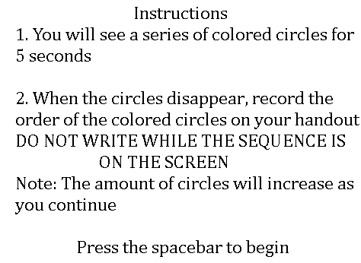
Figure 2: Example of Sequence of Circles

Figure 3: Second Instructions Screen
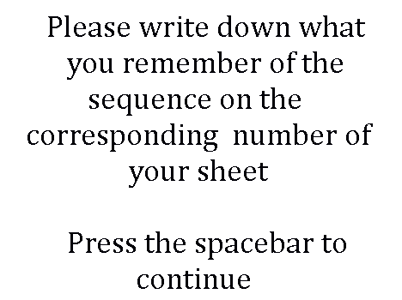

Results
The averages percentages correct within each of the 4 sequences were graphed (see figure 4). Evident from the graph, the results when no sound was played steadily declines as the length of the sequence increases. The results when sound was played plateaus from the 2 to 4 sequences and then declines before reaching 6 sequences. The two lines appear to intersect at 5 which indicate the distractor started to create an impact at a sequence of 5 circles. A t-test was utilized to assess the probability of the distractor causing a statistical difference between the data sets. From the t-test, p-values were found (see figure 5). All the p-values were higher than 0.05 which indicates that there was no statistical difference between the presences of white noise versus no white noise when testing its effect on short-term memory.
Figure 4: The Line Graph of Colors Correct

Figure 5: P-Value Table
Sequence | P-Value
2 | 1
4 | 0.172037
6 | 0.844178
8 | 0.110602

Discussion
It was found that white noise is not a distractor on short term memory. Overall, the statistical data indicates that there is not a significant difference between the results when the experiment was taken with white noise and without white noise. The p-value for the sequence of 2 colored circles is 1, which means that there is no statistical difference between remembering 2 colored circles with or without white noise. This is due to the fact that there was only a small amount of colors that the student was required to remember. The p-value for the sequence of 4 colored circles is 0.172037, which also means that there is no statistical difference between remembering 4 colored circles with or without white noise. Although the p-value is significantly lower than the p-value for the 2 colored circle sequence, it cannot be concluded that there is a difference because the p-value is not 0.05 or below, which means that there is not a 95% chance that they are different. The difference between the p-values for a sequence of 2 colored circles and 4 colored circles could be due to the fact that there is more information to remember. The p-value for the sequence of 6 colored circles increases significantly to 0.844178, which also indicates that there is no statistical difference between remembering the sequence with or without white noise. This dramatic increase in the p-value could be due to the fact that the colors used in the 6 circle sequence allowed the participant to group the colors based on their relations to each other. For example, one of the color sequences was orange-black-red-green-white-purple. Participants could easily group together orange and black because they are Halloween colors, and red and green because they are Christmas colors. The p-value for the sequence of 8 colored circles is 0.110602, which also means that there is no statistical difference between remembering 8 colored circles with or without white noise.
According to the graph, the two variables—no white noise and white noise—are somewhat similar until the number of circles reaches 5. At this point, the variables split. This split could occur because it reaches the point where it is difficult to remember all of the colors. In the future, this experiment could be completed without colors that could be grouped. This experiment could also be performed using shapes instead of colored circles. This would be an interesting way to see if white noise impacted one’s ability to recall shapes, even though it does not impact one’s ability to recall colors. Also, this experiment could be completed with the sound of a noisy café being played in the background to see whether or not this sound has similar effects on short term memory.

Work Cited
Banbury, S. P., Macken, W. J., Tremblay, S., & Jones, D. M. (2001). Auditory distraction and
short-term memory: Phenomena and practical implications. Human Factors, 43(1), 1-11.

Brown Noise. N.d. Simply Noise. Web. 15 Dec. 2014. <http://simplynoise.com/>.

Flowers, P. J. (2001). Patterns of attention in music listening. Bulletin of the Council for Research in Music Education, 148, 48-59.
Gustavson, A., Hanneken, K., Moldysz, A., & Simon, B. (n.d.). The effects of music on short-
term memory and physiological arousal. The University of Wisconsin-Madison, Medical
Sciences Center.
Peterson, L. R. (1966). Short-term memory. Scientific American, 90-95.

Roy, S. E. (2001). The effects of different types of music on cognitive
processes. National Undergraduate Research Clearinghouse Site.

Tremblay, S., Nicholls, A., Alford, D., & Jones, D. (2000). The irrelevant sound effect: Does
speech play a special role. Journal of Experimental Psychology: Learning, Memory, and Cognition, 26(6), 1750-1754.

