The Effect of Sugar Maples on Nitrogen Levels in the Soil

Kathleen Miller, Alex Rubin, and Kate Walsh

Abstract
Nitrogen in the soil is an essential element and can form three major chemicals including nitrite, nitrate and ammonia. The E.S.S.R.E. Biota Survey 2015 showed that there had been a dramatic increase in the nitrogen level of the soil compared to the previous years. New sugar maple trees were planted in E.S.S.R.E Microclimate 4 within the past year. Since sugar maple trees have been known to improve nitrogen cycles, we hypothesized that the sugar maple trees were the cause of the increase in the nitrogen levels of the soil in Site 4. 15 soil core samples that were 15 cm deep and 2¼ in diameter were taken from 0.5, 2.5, 4.5, 6.5, and 8.5 meters away from the sugar maple tree. These samples were then tested for nitrite, nitrate, and ammonia levels (ppm). The results confirmed that the nitrogen levels in Microclimate 4 have stabilized, but there was almost no correlation between the distance from the tree and the amount of nitrogen, disproving our hypothesis. In the future we would study the potential effect of other new plant life on the nitrogen cycle. We would test for nitrogen and phosphorus in both the plants and in the soils adjacent to those plants to see if the expected correlation in nitrogen phosphorus levels in plants and soil is present.

Introduction
Nitrogen is an essential element for life on earth. However, the majority of nitrogen is found in the inert form of nitrogen gas (N₂). Most organisms typically are not able to use this form of nitrogen as their primary source and instead rely on the forms made accessible by numerous soil microbes in a process known as the nitrogen cycle. In the soil, different groups of bacteria perform a process known as nitrification, and through this process, three forms of nitrogen are changed from one to another, transforming nitrogen gas into first ammonium, then ammonium to nitrites, and finally nitrites to nitrates (CTAHR, 2015). This cycle stays “healthy” in an environment when the levels of each form show normal fluctuations (for example where there are high levels of Nitrate Nitrogen, we should observe low levels of Ammonia and Nitrite). The nitrogen in the soil in these forms is then available for plants to use to produce the critical amino and nucleic acids they need (Kimball, 2013), and animals then get their nitrogen from the plants that they eat, as well as eating other animals that have eaten plants (Gardiner, 2007). So, healthy levels of nitrogen in the soil are critical to the health of the organisms in the environment.
However, from 2001-2014, the levels of nitrate found in the soils in E.S.S.R.E. Microclimate 4 steadily dropped and through a series of experiments performed in 2009, 2013, and 2014, it was determined that the explanation for this decrease in nitrate is the steady invasion of white grass growing in this site during the timeframe (de la Reguera and Ahmad, 2009; Kuser, Laria, and Shay, 2013; Garber, McCoach, Shephard, and Soudan, 2014).
But, according to the 2015 E.S.S.R.E. Biota Survey (E.S.S.R.E., 2015), the various nitrogen levels have suddenly started to display normal values. The only known change in the microclimate from last year to 2015 is the planting of three new types of trees in the area: Acer rubrum (red maple), Quercus alba (white oak), and Acer saccharum (sugar maple). Two of each kind of tree were planted and since research from the Ecological Society of America has shown that areas with large numbers of sugar maple trees tend to have soil with high levels of nitrification (Lovett & Mitchell, 2004), we hypothesized that the newly planted sugar maple trees are the cause of the Newly observed “healthy” “fixed” nitrogen levels in Microclimate 4.

Method
In Quadrant 3 of E.S.S.R.E. Microclimate 4 (N 39.35733; W 076.63840), 15 soil samples 15 cm deep and 2¼ cm in diameter were taken on July 15, 2015 at 2:00pm in a line moving due east starting from the sugar maple tree in Quadrant 3. 3 of the samples were taken 0.5 meters from the sugar maple tree; 3 of them were taken 2 ½ meters from the tree; 3 of them at 4 ½ meters from the tree; 3 of them at 6 ½ meters from the tree; and 3 of them at 8 ½ meters from the tree. The samples farthest from the tree contained no plant life and served as the negative control. All 15 samples were simultaneously tested for their levels of nitrite (ppm), nitrate (ppm), and ammonium (ppm) using a LaMotte Model STH-14 test kit. On July 17, 2015, the second set of samples were collected and tested at 9:30am. A third set of samples were taken and tested on July 20, 2015 at 9:30am. A fourth and final set of samples were taken and tested on July 21, 2015 at 9:30am.
Results
Figures 1-3 represent the overall trends determined for the different common forms of nitrogen found in soils collected between July 15 and July 21, 2015 in E.S.S.R.E. Microclimate 4.
Figure 1
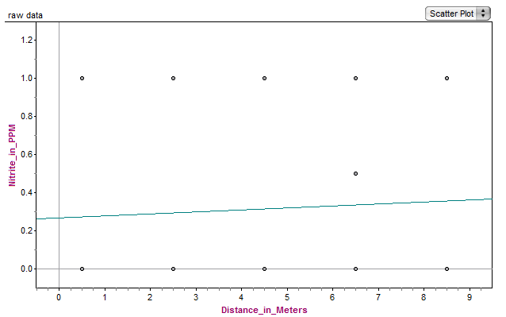
Figure 1 equation: Nitrite = 0.0104Distance + 0.26; r² = 0.0042

Figure 2
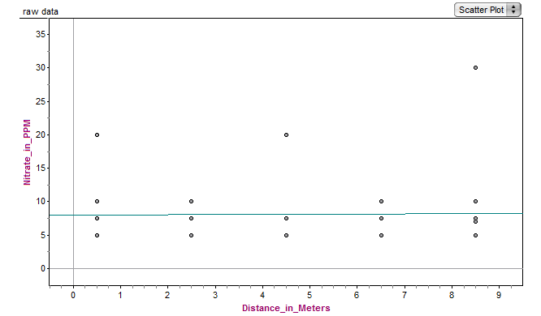
Figure 2 equation: Nitrate = 0.0271Distance + 7.9; r² = 0.00036

Figure 3
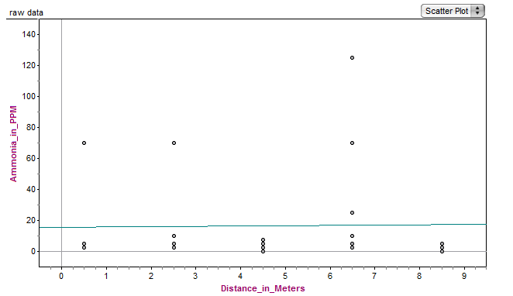
Figure 3 equation: Ammonia = 0.208Distance + 15; r² = 0.00053
Figures 4-7 represent the daily average trends determined for the different common forms of nitrogen found in soils collected between July 15 and July 21, 2015 in E.S.S.R.E. Microclimate 4. All p-values were determined using 2-variable t-testing.

Figure 4 Table 1 p-values for July 15 Data
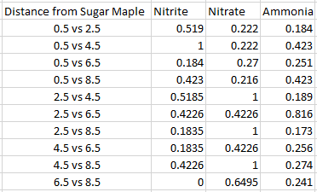

Figure 5 Table 2 p-values for July 17 Data
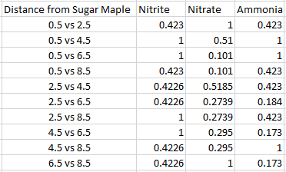

Figure 6 Table 3 p-values for July 20 Data
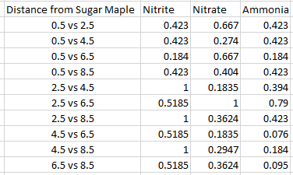

Figure 7 Table 4 p-values for July 21 Data
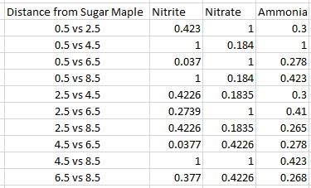

Discussion
While Figures 1-3 would seem to affirm our hypothesis that it was primarily the sugar maples recently planted in the E.S.S.R.E. Microclimate 4 that improved the nitrogen cycle, the r² values (0.0042, 0.00036, 0.00053) clearly show that there was no correlation between the distance from the sugar maple tree and the levels of nitrite, nitrate, and ammonia found in the soil. However, a statistical analysis of Figures 4-11 reveals that our larger supposition that Microclimate 4 is once again experiencing a healthy nitrogen cycle is strongly supported. Table 1 shows that on July 15, the ammonia and nitrite levels between the different collection sites have significant differences (e.g. p=0.173 and p=0.184) while the nitrate levels do not. Furthermore, Table 2 shows that on July 17, only the nitrate levels (e.g. p=0.101) had significant differences between the sites; while Table 3 shows that July 20 had no statistically significant fluctuations in the levels of any of the chemicals. Finally, on July 21, the nitrate levels in particular had a lot of significant differences (e.g. p=0.184) between the different collection sites, and such regular fluctuation in levels is indicative that the nitrogen cycle in Microclimate 4 is once again healthy. In fact, the nitrogen cycle is healthier than it has been for the past fifteen years (de la Reguera and Ahmad, 2009; Kuser, Laria, and Shay, 2013; Garber, McCoach, Shephard, and Soudan, 2014); our research simply precludes that it is the sugar maple that is the exclusive source of the change.
Interestingly, other findings (Egbunine, Meisler, Rao, & Ribant, 2015) indicate that the expected correlation between microbial life in the soil and the phosphorus cycle in Microclimate 4 is also more stable than it has been in a number of years (E.S.S.R.E., 2001-2015). Nitrogen and phosphorus cycles are two of the most important processes in soil and for both to resume healthy activity simultaneously is unusual. Further research on these topics could show that a common environmental cause might be responsible for the improved health of both cycles. Though it is known that the sugar maples are not exclusively responsible for the chemical levels, research in the future could be conducted on whether the other recently planted trees and new plant life in Microclimate 4 is the source of the newly observed biogeochemical stability. In the future, we would conduct a similar experiment to ours, except use some of the other trees and plant life instead of the sugar maples. Furthermore, we would test for nitrogen and phosphorus in the plants and the soil located adjacent to those plants to see if the expected correlation in nitrogen and phosphorus levels in plants and soil is present.

Acknowledgements
We would like to thank our sponsors, Dr. Holliday Cross Heine, The Jennings Family, and Human Capital Development, Inc, for funding our research. We would also like to thank Mr. David Brock for running the E.S.S.R.E. program and supporting us as we conducted our research, and our amazing TA’s; Annie Blalock, Kendall McCoach, and Emma Wilson, for helping us every step of the way. Finally, we would like to thank Roland Park Country School for allowing us to use their campus for research.

References
College of Tropical Agriculture and Human Resources. (2015) Nitrogen. University of Hawaii at Mānoa. http://www.ctahr.hawaii.edu/mauisoil/c_nutrients01.aspx.
de la Reguera, E. & Ahmad, R. (2009) Unpublished Data. E.S.S.R.E. http://essre.rpcs.org/2009/TA%20Research/.
Egbunine, A., Meisler, E., Rao, N. & Ribant, M. (2015) The Potential Effect of Mycorrhizal Fungi on Phosphate Levels in the Soil. E.S.S.R.E. Research Results. http://essre.rpcs.org/ESSREResearch.htm
E.S.S.R.E. (2001-2015) E.S.S.R.E. Longitudinal Data. http://essre.rpcs.org/ESSRE%20Survey%20Data/ESSRE%20Data%2001%20to%2005.htm.
E.S.S.R.E. (2015) E.S.S.R.E. Microclimate Data Base. http://essre.rpcs.org/ESSREMicroclimateSurvey.htm.
Garber, J., McCoach, K., Shephard, P. & Soudan, N. (2014) The Explanation for Dropping Nitrate Levels. E.S.S.R.E. http://essre.rpcs.org/2014/WhiteGrass/Nitrators%20Paper.pdf.
Gardiner, L. (2007, May 7) The Nitrogen Cycle. National Earth Science Teachers Association. http://www.windows2universe.org/earth/Life/nitrogen_cycle.html.
Kimball, J. (2013, September 27) The Nitrogen Cycle. http://users.rcn.com/jkimball.ma.ultranet/BiologyPages/N/NitrogenCycle.html.
Kuser, M., Laria, G., & Shay, M. (2013) Influences on Nitrate Leaching in the Soils if an Eastern Deciduous Forest; A Case Study. E.S.S.R.E.
Lovett, G. & Mitchell, M. (2004) Sugar maple and nitrogen cycling in the forests of eastern North America. The Ecological Society of America. http://www.caryinstitute.org/sites/default/files/public/reprints/Lovett_and_Mitchell_Frontiers_2004.pdf.

