Alexandra Reed Rubin
Alexandra Anne Martinson
January 16, 2015
Short Term Memory
Abstract
Short term memory is the capacity for holding a small amount of information in one’s brain, active and readily available to use. Studies have proven that just looking up for a second from a current task can double in mistakes. This study analyzes how listening to a 15 second audio clip can affect one’s short term memory. Fifteen 9th grade Roland Park Country School students were tested using a scratch program made on Lenovo Yoga computers. A t-test was used to verify the conclusion that listening to a 15 second audio clip, meant to be a distractor, proved to make the test subjects receive a better score.

Introduction
Short-term memory is the capacity for holding a small amount of information in one’s brain, active and readily available to use. It can be known as people’s active or primary memory. Distractors are the main way to decrease the capacity within short-term memory.
According to Ghose (2013), even very small distractions such as looking up from what one is doing even for a few seconds can cause a loss in short term memory and result in double the amount of mistakes. In the study, they used 300 undergraduate students both men and women. The students were asked to do several simple tasks such as picking out vowels or all the red colored letters in a sequence. Then, two letters showed up on the computer screens and they were asked to type the letters they saw. This only took a few seconds but it proved that after they were done typing in the letters, they lost their train of thoughts and almost doubled their mistakes. From the experiment, they concluded that short, quick or little distractions can negatively impact someone’s train of thought or thinking process and that people can easily be distracted from anything.
Rugg and Andrews (2009) did a study on how background noises affect people’s concentration and heath. In the study, they concluded that distractions affect people’s health by creating a higher stress level for people. A higher stress level decreases people’s brain function including their memory and ability to learn.
In another study done by Benson (1988), the major problem was that children are having too many distractions while they are doing their homework. The article’s purpose was to find a solution to this problem by asking four 6th grade classes and their teachers to take an investigation survey of homework distractions. The student were 10-12 years old and were from an upper middle class suburban community. The results of the research was that 52% of the students said that the phone was the most troublesome homework distraction. 51% of student said that TV was a big distraction. 41% of the people said that parents, brothers, and sisters were distracting. 38% said that general noise was a distraction and 37% said that music was a main distraction. The results concluded that children are having too many distractions while they are doing their homework so they came up with solutions to help with their distractions which included self-awareness, self-discipline and parental support.
Based off of previously completed studies, this study will analyze how listening to a 15 second audio clip affects one’s ability to remember an increasing sequence of numbers. In this experiment it was determined to test one’s short term memory by using the audio clip from the hunger games trailer.

Methods
For this short term memory project, fifteen 9th grade Roland Park Country School girls were tested in order to determine the effects of television on one’s short term memory. This was done by making the scratch program on Lenovo computers. The test takers were told to follow
the instructions shown in image 1 as they came up on the screen. The program showed an increasing series of numbers, starting with 3, then 5, then 7 and finally 9 numbers in a row (shown in images 2-5). These series of numbers showed up on the screen for only 3 seconds giving the test taker only a short amount of time to memorize them. After the numbers disappeared, then the person taking the test was required to record the numbers they recalled in the appropriate spot on a handout provided for them. The handout that the students were given also had three initial questions. The questions were do you watch television while you study? Do you study in a quiet or noisy environment? And finally what is your favorite television show? After the test subjects had finished the control round the distractor was brought in. The distractor was the noise of the hunger games Mockingjay part one trailer in the background while the people were trying to look at the numbers and recall them. After they were finished taking the test the tests were graded using an answer sheet that was previously written up. For every number the test subject got correct a point was given to them, for example if she got 3 out of 5 correct her score on that section was a 3.
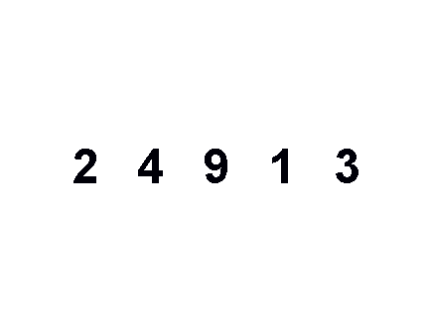
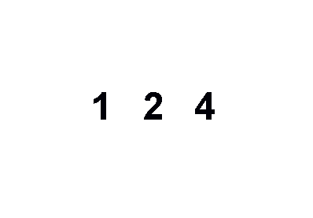
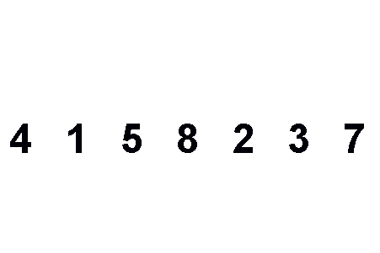
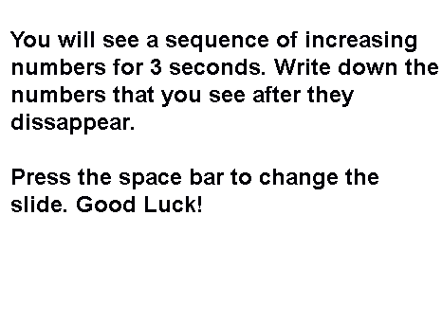
Image 2: 3 numbers
Image 4 : 7 numbers
Image 3 : 5 numbers
Image 1 : Instructions

Image 5 : 9 numbers
7 1 3 2 5 4 9 8 6

Results
T-tests assess whether the means or averages of two data sets are statistically different from each other. A t-test was completed in order to determine if the distractor had an impact. From the t-test, a p-value was determined. The values obtained are in Figure 6 below. The p-value is found by doing a t-test on a graphing calculator. The p-value should be between 0.01-0.05. If the p-value is less than 0.05, it indicates that there is a difference between the data sets so the distractor had an impact. The r² values should be greater than 0.05 to show that it had an impact. The r² values for the experiment were 0.883 and 0.8541. Shown below is Graph 1 which represents the average percent correct for the different amount of data tested.

Graph 1: Average Percent Correct for the Number Correct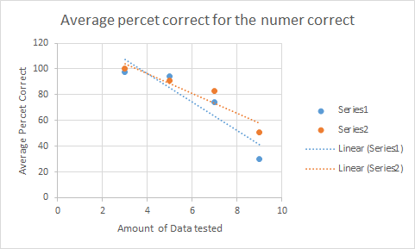
Figure 6: P-values
Number of Numbers in a Sequence | P-value
3 | 0.3343
5 | 0.5651
7 | 0.3988
9 | 0.0113

Discussion
In the experiment, it was concluded that the noise of television in the background was a positive distraction. For 9 numbers without the distractor the average percent correct was 30.33 and with the so called distractor the average percent correct was 50.1. This shows a positive effect on the test subjects. This is was also what happened in 2 out of the 3 more trials. The percent change was not positive in one of the trials. However, from the p-values, it was concluded that only one out of the four trials made a clear impact which was when 9 numbers were tested. This was most likely because most people cannot remember more than 7 items in their short term memory at once. Because the r² values were above the 0.5 threshold, the conclusion that was drawn is reliable data. Observed from the graph, as the amount of data tested went up, the average percent correct went down. When the test- taker was tested on a sequence of 3 numbers, the average percent correct was nearly 100% with and without the distractor. On the other hand, when the test- taker was tested on a sequence of 9 numbers, the average percent correct was around 50% and 30%, much lower than the sequence of 3 numbers. In the experiment test subjects were asked 3 questions. These were designed to help to see if this person in particular had a bigger chance of getting the numbers right or wrong because they asked about what television shows that they typically watch and if the show was much different than the noise of the show being played, it was expected that they would be more flustered and it would distract them more. These questions helped with grading the tests. They gave the grader an insight on what kind of person the test subject was. Therefore it was able to reason whether or not the amount of questions correct for that individual made sense. These questions helped come to the final conclusion that the noise of television has a positive impact on short term memory. In the future, there should be more research done to make a final conclusion that TV is not a distractor. The reason that this should be researched in more depth is because in the experiment there were only 15 people tested. From the data collected the result and conclusion is true. There unfortunately have been many studies that have shown that TV does distract people and TV should not be watched while doing homework. To prove that the conclusion drawn was correct this experiment should be tested on hundreds more people. Once the experiment has been tested on that many people if the conclusions are still the same then the final conclusion can be drawn that TV does help with short term memory. Another way to improve the experiment would be by using less numbers in the sequences. This would help to make the experiment better because some of the data did not follow the paths of the other data collected when there were a lot of numbers. For example the 9 number sequence was following a much different pattern than the other 3 sequences which had less numbers. The t-test showed that 9 numbers had an effect on the test subjects but the other 3 trials did not have a noticeable effect. This is why it is believed that making the sequence of numbers shorter would make the data more consistent.

Bibliography
Benson, R. (1988). Helping pupils overcome homework distractions. The Clearing House, 61, 370-372. http://www.jstor.org/stable/30181004?seq=1#page_scan_tab_contents
Ghose, T., & Science, L. (2013). Tiny distractions can double mistakes. Scientific American. http://www.scientificamerican.com/article/tiny-distractions-can-double/
Goldman, J. (2011). Do cartoons affect child attention span? Mr. Epidemiology. http://mrepidemiology.com/2011/09/26/do-cartoons-affect-child-attention-spans/
Jabr, F. (2014). How the brain ignores distractions. Scientific American. http://www.scientificamerican.com/article/how-the-brain-ignores-distractions/
Rugg, M., & Andrews, M. A.W. (2009). How does background noise affect our concentration? Scientific American. http://www.scientificamerican.com/article/ask-the-brains-background-noise/
Vanhuele, M. (2006). Consumers immediate memory for prices. Journal of Consumer Research. http://www.jstor.org/stable/10.1086/506297?Search=yes&resultItemClick=true&searchText=short&searchText=term&searchText=memory&searchText=and&searchText=noise&searchText=distractions&searchUri=%2Faction%2FdoBasicSearch%3FQuery%3Dshort%2Bterm%2Bmemory%2Band%2Bnoise%2Bdistractions%26amp%3Bprq%3Dshort%2Bterm%2Bmemory%2Band%2Bnoise%26amp%3Bhp%3D25%26amp%3Bacc%3Don%26amp%3Bwc%3Don%26amp%3Bfc%3Doff%26amp%3Bso%3Drel

