Rachel Clemons and Ava Drum
7 Bridges of Konigsberg Notes

History of Leonhard Euler:
Leonhard Euler was born on April 15, 1707 in Basel Switzerland. He was an academy scholar and worked in the fields of geometry, trigonometry and calculus.

Background on the 7 Bridges of Konigsberg:
The 7 bridges of Konigsberg was based on modern day Kaliningrad, Russia. 7 bridges were built over the river that ran through the city.

The Scheme of the 7 Bridges of Konigsberg:

For centuries mathematicians have pondered Euler's discovery of the relationships between vertices, edges, and degrees, in the 7 bridges of Konigsberg. It is impossible to cross all the seven bridges using a Euler path.
What is a Euler Path? A Euler path is a path that covers every edge of the shape only once. For example, a Euler path is possible for a square with a single line through it. 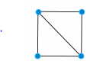
(show in video how the pencil will trace each edge)

Your turn: Please use the piece of paper given to you and find which of the following can or cannot have a Euler path. A good way to do this is to trace along each edge without removing your pencil from the paper. Start at one of the vertices (corners). You have 45 seconds.
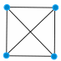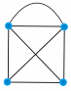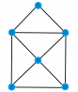
A B C
Shape A does not have a Euler path. There is no way to trace along each of the edges without retracing at least one edge. (show why this is not possible)
Shapes B and C both have a Euler path. It is difficult. (draw out both paths)

Is there a way to determine if a Euler path can be drawn? Euler helped to figure this out:
Let’s draw some basic diagrams and count the number of vertices in each shape and the number of edges that meet at each vertex, also known as a degree.

 | Number of Vertices | Number of Even Degrees | Number of Odd Degrees
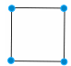 | 4 | 4: (two edges meet at each vertex) (draw this) | 0 (there are no vertices where three or five edges meet)
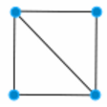 | 4 | 2 | 2
 | 4 | 0 | 4
 | 4 | 2 (top two vertices) | 2 (bottom 2)
 | 6 | 4 (very top 3, middle) | 2 (bottom 2)

A Euler path works for shapes that have 0 or 2 odd degrees ONLY

This leads back to the Bridges of Konigsberg. The map looks like this
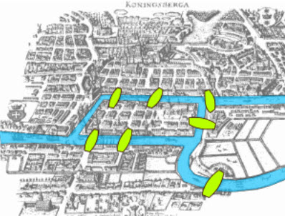
Here is another way the bridges can be drawn
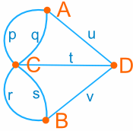

 | Number of Vertices | Number of Even Degrees | Number of Odd Degrees
 | 4 | 0 | 4

Therefore, there is no possible way to cross each bridge once because there are 4 odd degrees in the diagram.

The easiest way to make the 7 bridges of Konigsberg possible is to take away the bridge in the middle
Bibliography

http://www.biography.com/people/leonhard-euler-21342391
http://www.mathsisfun.com/activity/seven-bridges-konigsberg.html
https://nrich.maths.org/2484
