,Alzheimer’s Archaea Nano-Capsule
Description
Abstract
We envision Nano technological robots with the ability to untangle beta-amyloid buildup using the micro-organism, Archaea, without totally destroying the beta-amyloid. The robots will be able to sense whether the clumps have been detangled. Once the beta-amyloid is detangled and before the Archaea can totally consume all of the beta-amyloid, the robots will retrieve the Archaea. The Nano robots would be injected through the back of the neck into the carotid artery, which is in the neck, where it will be remotely controlled up to the cerebrum and into the brain. The robots will also be remotely controlled out of the brain.

Present Technology
Currently there is no cure for Alzheimer’s but there are drugs that work to slow the deterioration of the brain. The two major kinds of drugs are cholinesterase inhibitors and memantine which both help stabilize the brain’s communication network.
Cholinesterase inhibitors prevent the breakdown of the neurotransmitter responsible for learning and memory, acetylcholine. The scientific principle of cholinesterase inhibitors is that to stabilize the communication to and from the brain, the minor parts of the brain need to be stabilized first. The molecules in cholinesterase inhibitors attach to an enzyme and decrease the function activity of the enzyme, while memantine regulates the activity of glutamate in the brain. Memantine’s scientific principle is that it stops the blockage of the brain’s communication by stopping excess glutamate from reaching the brain. The first drug improves brain communication by keeping the chemical signal for it present, while the second prevents an excessive amount of glutamate in the brain cells from blocking communication and speeds up cell damage. The memantine breaks down glutamate because excessive amounts of it create a greater flow of calcium to the cells. This calcium breaks down the cells in the brain which leads to dementia. As the disease progresses, cholinesterase inhibitors may stop working. The problem or set back in in the present day drugs are that they don’t stop Alzheimers but they slow down the memory loss. These chemicals all impact transmission of the neurotransmitter that the brain uses for communication. If the way that the transmission is emitted is improved, the Alzheimer’s could be cured.

Alzheimer’s History
Alzheimer’s is a disease that was identified on November 4, 1906 by German physician, Dr. Alois Alzheimer. He identified a clump of brain cell abnormalities that built up to the disease called Alzheimer’s. Mental deterioration in old age has occurred throughout history, but only in the early 1900s, when one of Dr. Alzheimer’s patients died with severe memory loss, was Alzheimer’s presented as a different disease of cerebral cortex. After a brain autopsy, Dr. Alzheimer found neurotic plaques and neurofibrillary tangles in the brain of the deceased patient.
Before 1987, there was no technology or scientific studies on Alzheimer’s as an official disease. However, the invention of the electron microscope in 1931 contributed in the ability to study brain cells in more detail. Also in 1968, development of cognitive measurement scales for assessing cognitive and functional decline in older adults helped correlate symptoms with amount of damage in the brain.
In 1987, part of the U.S. Senate approved the first effective treatment for Alzheimer’s. In 1990, scientists were contemplating whether the “Nerve Growth Factor” (NGF) could reverse or slow the deterioration of the brain. Scientists were able to better understand complex nerve cells in the brains of Alzheimer’s patients and research susceptibility genes. In addition, scientists were also able to have several drugs approved. The Alzheimer’s drug, tacrine (Cognex), was the first drug to be approved by the FDA in 1993. Over the next ten years, several other drugs including donepezil (Aricept), galantamine (Razadyne), mementine (Namenda), and rivastigmine (Exelon) were approved. In 1995, some thought that there was a possibility of anti-inflammatory drugs helping people who were diagnosed with Alzheimer’s.

Future Alzheimer’s Technology
Our cure for Alzheimer’s is to inject nano-technology containing Archaea in a capsule filled with acid into the neck which will travel through the carotid artery, directly to the brain. After the capsule has been shot through the carotid artery into the brain, the capsule will be remotely navigated to the beta-amyloid clumps. There will be a camera placed inside, so that the controller will be able to see. The Archaea will be released, and it will attach itself to the protein. Then, the Archaea will start to eat away at the buildup. After a certain period of time in the brain, the capsule will self-destruct.
Our capsule will be made of a flexible tissue that is acceptable for the body. This tissue will be artificial and man-made so that every blood type can accept it. The capsule will contain the microorganism, Archaea because Archaea eats proteins like beta-amyloid. The Archaea can only survive in an acidic environment, so it will travel through the body in the capsule. We will shoot the capsule into the bloodstream through the neck by using a syringe. The capsule will be inserted into the carotid artery that flows directly to the brain. The capsule will have a microscopic motor that will propel it through the bloodstream. A camera will be located on the top of the capsule, so that scientists will be able to locate it to the sections of the brain with the plaques. Scientists/ doctors will steer the capsule’s propellers using a remote control.
When the capsule diffuses into the brain’s lobes containing the beta-amyloid plaques, the Archaea will start its job. The camera will show the scientists/ doctors the inside of the brain, and they will be able to detect the clumps of protein. Once seeing the clumps, the doctors will signal the capsule to open and attach to the neurotransmitters. The Archaea will move out of the capsule and start to feed off of the protein. When the doctors see that the beta-amyloid has thinned, they will close the capsule and, therefore stop the archaea’s feeding. The doctors/ scientists will be able to watch the archaea’s progress through the camera.
Controlled by the scientists, the capsule will then move throughout the brain to other beta-amyloid clumps. Once completing its job, the capsule will self-destruct and give off a liquid that kills the Archaea.

Breakthroughs
The scientific studies needed for our future technology include nano-technology that can enter the body. For the human body, this nanotechnology does not exist today. However it does exist for technology such as the iPod- nano. The body would see the machines as foreign and it would try to remove it from the body. Another challenge that has deterred our technology from being created is that the microorganism Archaea only survives in an acidic environment and therefore would not survive in the brain long enough to consume the protein beta-amyloid clumps. An experiment that addresses the problem of the Archaea not being able to survive in the brain is to place the nano technology inside a capsule filled with acid to sustain the Archaea. To do this we would have to have the capsule be flexible so the nano technology can still function inside and it would be made of prosthetic material that the body accepts. We would test the different acids and materials used in the capsule.
Another breakthrough is how the nano-technology will safely travel through the artery. It will be controlled carefully in order to not damage any of the artery or its surroundings.

Design Process
To treat Alzheimer’s our group first brainstormed ideas for future technologies to treat this disease. We came up the idea of getting shots into the brain that can release chemicals that can untangle the beta- amyloid. We rejected this idea because shots that are created are not always safe for your internal body and many people fear needles. We also considered creating a propeller that moves through the brains watery environment that has hands or suction cups that move clumps of protein. We decided not to use this as our future technology because it would be hard to control the propeller and it could be unsafe and difficult to leave and enter the brain. The idea we are using for our future technology is better than the shot idea because chemicals in the shot would be more difficult for it to untangle beta-amyloid than an actual microorganism in the brain doing it physically. The propeller idea is kind of related to what my group is actually doing for the future technology idea but not as safe and has many more problems or setbacks. We also originally wanted to have an injection shot into the spinal cord. We decided not to inject it into the spinal cord, because it is extremely painful. We now instead are injecting the capsule into the carotid artery located in the neck, which travels directly to brain. This is less painful and a less complicated route into the brain.

Consequences
There are many consequences for our future technology. Some of them are positive but there are also some negatives .This technology can possibly save many lives of people diagnosed with Alzheimer’s. Since there is no current technology to completely cure this disease, this could be a great help in society. Also from this technology there can be negative consequences and problems. The Archaea can take over the brain or the robot could cause issues in the brain which can be a serious problem. Also while the process of untangling the beta-amyloid, other things than the beta-amyloid might accidently be removed or damaged.

Bibliography
Alzheimer's Disease Health Center. WebMD, 2005. Web. 15 Jan. 2014. <http://www.webmd.com/alzheimers/cholinesterase-inhibitors-for-alzheimers-disease>.
Calbiochem Inhibitors. EMD Millipore Corporation, 2014. Web. 15 Jan. 2014. <http://www.millipore.com/life_sciences/flx4/inhibitors>.
A History of Alzheimer's Disease. BrightFocus, 2000. Web. 15 Jan. 2014. <http://www.brightfocus.org/alzheimers/about/understanding/history.html>.
Major Milestones in Alzheimer’s and Brain Research. Alzheimer's Association, 2014. Web. 15 Jan. 2014. <http://www.alz.org/research/science/major_milestones_in_alzheimers.asp>.
News Medical. Newa Medial, n.d. Web. 24 Jan. 2014. <http://www.news-medical.net/news/20140120/Researchers-identify-protein-in-brain-that-plays-critical-role-in-memory-loss-seen-in-Alzheimers-patients.aspx>.
What We Know Today About Alzheimer's Disease. alzheimer's association, 2014. Web. 15 Jan. 2014. <http://www.alz.org/research/science/alzheimers_disease_treatments.asp>.

Sample Webpage 1

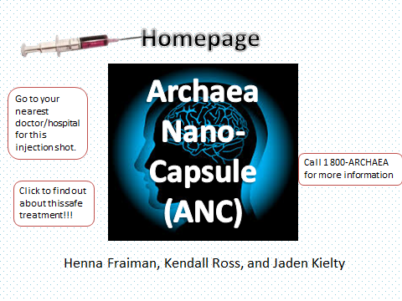
Sample Webpage 2
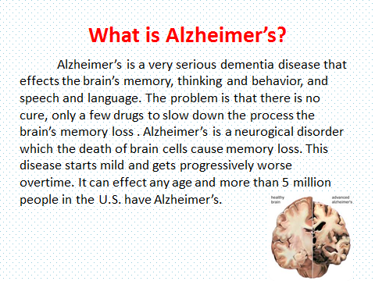
Sample Webpage 3
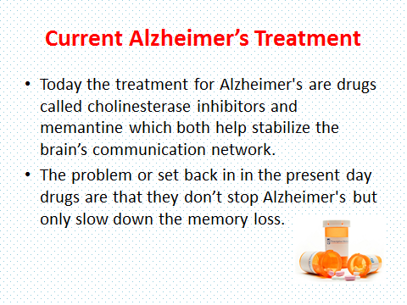
Sample Webpage 4
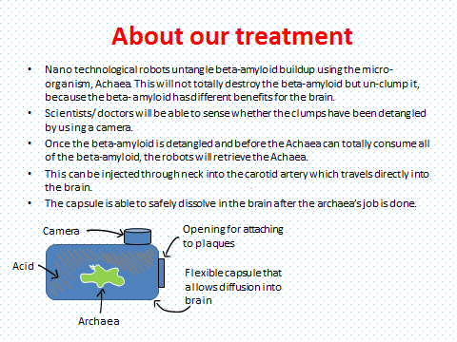

Sample Webpage 5
