Egg Drop Experiment

Henna Fraiman

Part II. Pre- Test Measurements



**First Test:**

Times: .87, .86, .7, .92 Average = .84 seconds

Measurement of vertical distance = 5.16 meters

Acceleration: 14. 626 meters per second

Final Velocity: 12.288 meters per second / 27.483 miles per hour

Part III. Modifications:

10 ways to Modify

1. Bubble wrap
2. Balloons
3. Parachute
4. Flour
5. Rice
6. Strings
7. Duct tape
8. Cotton balls
9. Marshmallows
10. Cupcake holders

For final Test use plastic bag as parachute, 2 balloons with string, and bubble wrap around egg and outside of the tetrahedron.

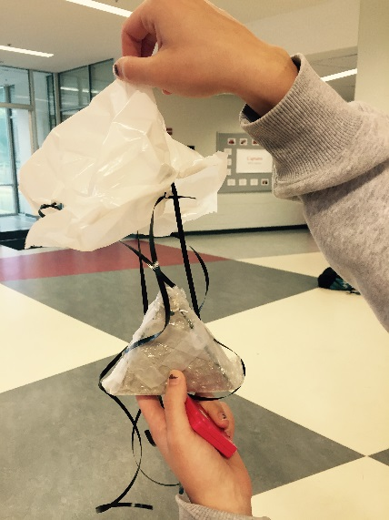 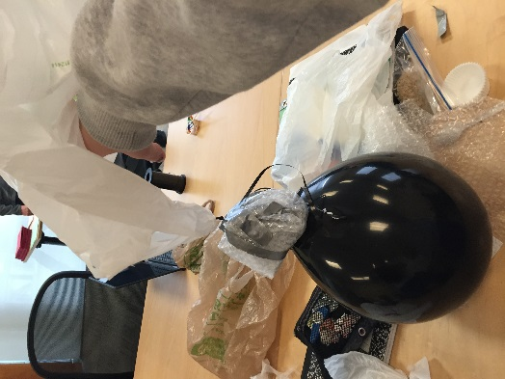



Time: 1.31 Seconds

Measurement of vertical distance = 5.16 meters

Acceleration: 6.013 meters per second

Final Velocity: 7.877 meters per second / 3.521 miles per hour

Final modifications:

We added two balloons and made the parachute a plastic bag. We attached the plastic bag to string that was duct taped onto it.

(I did not get a photograph of it)



Part IV. Entry, Descent and Landing

Weight of egg: 60.8 g

Time of fall: 3.14 seconds

Vertical height of drop: 9.69 meters

Acceleration: 1.96 meters per second

Final Velocity: 6.15 meters per second / 13.757 miles per hour

Pictures of my calculation work:

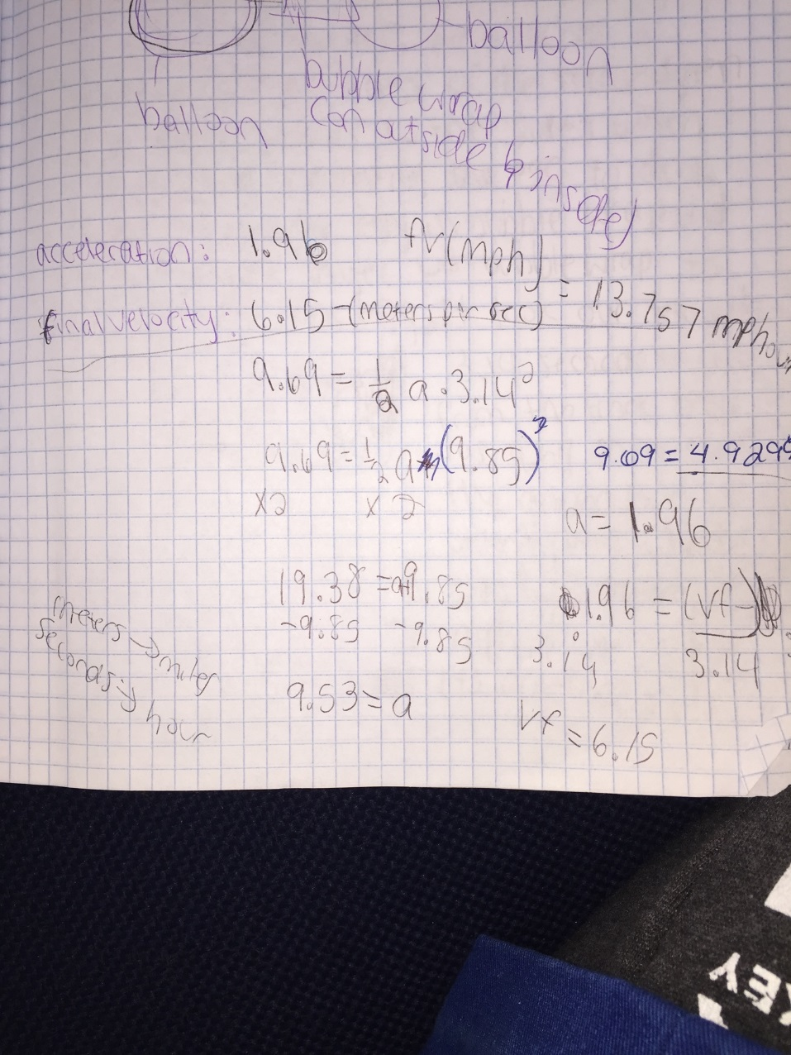

Part V. Write- Up

For this design, my partner and I decided to attach a paper bag at the top of the tetrahedron with strings. This traps more air making it fall slower. We attached 2 balloons to the sides of the tetrahedron. This gave a softer landing to the egg and prevented the egg to crack. We wrapped the egg in bubble wrap to insulate the egg. It took our tetrahedron 3.14 seconds to fall from the track that had a vertical height of 9.69 meters. Its initial velocity was 0 and the final velocity is 6.15 meters per second. In miles per hour it has a final velocity of 13.757. Its acceleration is 1.96. In conclusion, our egg did not crack after being dropped because off the slow landing from the parachute and the cushion from the balloons and bubble wrap.