The Impacts of Sodium Chloride, Magnesium Chloride, and Calcium Chloride Solutions on Concrete
Ellie Loane and Hyo Shin
Roland Park Country School
May 24, 2016

Abstract
The purpose of this research was to determine the best chemical to effectively remove snow while causing the least corrosive damage to concrete and the environment. Due to the many different options for snow removal solutions, it is often hard to find the perfect chemical that effectively removes snow and ice while causing the least damage to concrete. In this experiment, concrete samples were submerged in magnesium chloride, calcium chloride and sodium chloride solutions in order to determine if the solutions would deteriorate the concrete. Over the course of five weeks the mass of concrete samples and the volume of solutions were measured and recorded. There has not been enough evidence for chemical or physical deterioration for any of the chemicals tested. Furthermore,the research resulted in an accumulation of data which contrasted previous reports conducted. The contrasting data resulted in inconclusive information about the chemical and physical deterioration effects of the solutions.

Background Information
According to Meyer (2014), concrete is a composite material that is made up of a mixture of Portland cement and water; within which are embedded particles of a combination of fine and coarse aggregates. Concrete is a versatile construction material that is used in a variety of different structures worldwide such as bridges, roads, and dams. Portland cement is made up of four mineral components; tricalcium silicate, dicalcium silicate, tricalcium aluminate, and tetracalcium aluminoferrite, each of which have their own hydration properties (Meyer, 2014). The chemical reaction to form concrete occurs when solid tricalcium silicate (Ca3SiO5) reacts with water to produce a calcium silicate hydrate and calcium hydroxide, releasing 173.6kJ of energy during this reaction (Popp, 2016).
A hydrate is a “particular form of a solid compound which as water in the form of H2O molecules associated with it” (Wagner, 2014). Hydration is “the incorporation of molecular water into a complex with the molecules or units of another species” (Johnston, 2014). When concrete is formed the four main cement minerals react at different rates and form different solid phases when they hydrate. During the cement hydration process all the minerals dissolve into the same pore solution (Thomas & Jennings, 2008).
Since sodium chloride (NaCl), magnesium chloride (${MgCl}_{2}$), and calcium chloride (${CaCl}_{2}$) will be used for snow on roads, their effectiveness can be shown by their freezing point depression. Freezing point depression is the temperature difference between a solution’s freezing point and a pure solvent’s freezing point. They all lower the freezing point of snow and causes the snow to freeze at a lower temperature. The addition of sodium chloride to water lowered the freezing point by 9.545 degrees Celsius below the actual freezing point of water. The addition of calcium chloride and magnesium chloride lowered 14.318 degrees Celsius below the freezing point of water. These salts lower the freezing point because the attraction between water and these salts produces energy and in order to freeze, the energy needs to be removed and that’s why ions lower the freezing point. By just looking at the freezing point depression of all three solute, calcium chloride and magnesium chloride are more effective than sodium chloride. However, NaCl is the most commonly used snow and ice control substance out of three. In 26 states in the U.S., sodium chloride, magnesium chloride, and calcium chloride are used 65.38%, 26.92%, and 34.62% in time respectively (Mussato et al., 2004). According to(VDOT, n.d.), NaCl is most commonly used in snow and ice control because it is abundant and inexpensive. When applied to the road it create brines which keeps snow and ice from bonding to the pavement.
Research has shown that sodium chloride, magnesium chloride, and calcium chloride can cause varying degrees of damage to concrete as a result on specific chemical reactions with various phases of the cement paste. Research conducted by Musatto et al. concluded that when sodium chloride is used the surface distress to concrete is more likely to be caused by physical properties such as freezing and thawing, rather than chemical properties. Magnesium chloride causes the most deterioration among the three compounds because of the chemical reaction between magnesium and the cement paste causes the cement paste to combine with the expansive forces generated through magnesium hydroxide formulation, and this accelerates the concrete deterioration. Calcium chloride also had deterioration effects on concrete to a greater extent than sodium chloride but a lesser extent than magnesium chloride. The reactions between the solutions and concrete lowers the pH, a measure of acidic/basic a solution is, of the solution, making it more acidic. This also lowers the passivation of rebars, which means the coating of outside the rebars that are supposed to protect them from corroding become weaker. This then leads to a severe corrosion(Mussato et al., 2004). Although a similar research has been conducted to figure out which salt causes the most deterioration, no definitive evidence has been concluded.
Based on the background information about the salts used for snow removal on concrete, an experiment was designed to determine which solution would have the greatest deterioration impact on concrete.

Method
Ten concrete samples were created based on the development protocol; 3 concrete samples were placed in NaCl solution, 3 concrete samples were placed in ${CaCl}_{2}$solution, 3 concrete samples were placed in ${MgCl}_{2}$solution and 1 sample for negative control was placed in H2O. The initial masses of the concrete samples were measured and then they were each placed in a plastic cup. 1000 mL of each of the solutions were then created. Based on the calculations of the moles (see appendix) of each (2.566 mol), 150 g of sodium chloride, 284.63g of calcium chloride, 244.31g of magnesium chloride were used to make 1000 mL aqueous solutions in volumetric flasks. 200mL of solutions were then poured on top of their respective samples in order to completely submerge the concrete samples and covered with saran wrap to prevent evaporation. The samples were left alone for 25 days until the first data set was collected. Six different data sets were collected over the course of 54 days, and during these data sets, the mass of the concrete samples and volume of solutions were recorded in order to determine the correlation between the two variables. The following variables could not be controlled for: the temperature of the room, and the amount of days between each data collection.

Results
As shown in Graph 1, the positive slope conveys that the mass of all of the concrete samples increased. The slope for the mass change of the concrete in MgCl2 was the greatest. Its slope was 0.3465, which is higher than rest of the slopes, 0.164, 0.1313, 0.1371(For NC, CaCl2, NaCl respectively). The negative slope in Graph 2 represents the decrease in each solution’s volume over time. ${MgCl}_{2}$ had the steepest slope of -.7183 meaning it had the greatest decrease in volume. (see Table 1)

Graph 1: Change in Mass of Concrete Samples
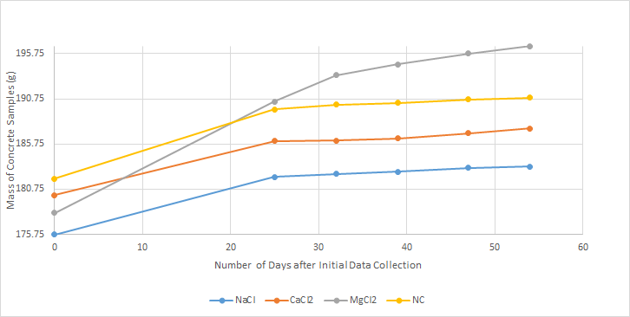

Graph 2: Change in Volume of Solution
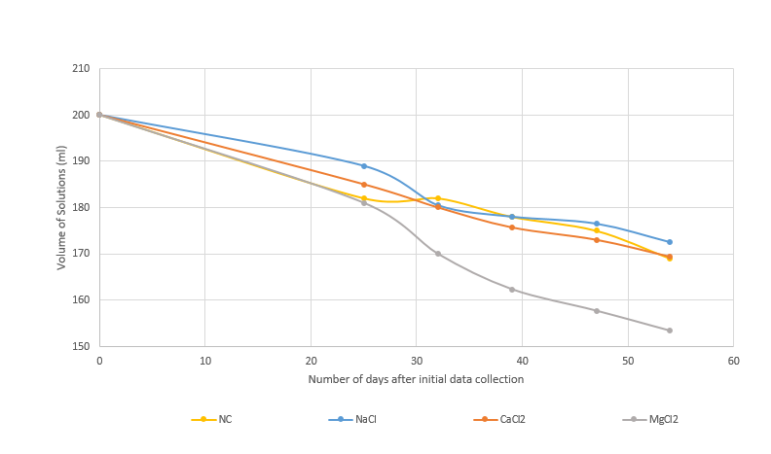

Table 1: Line of Best Fit Equations
 | Mass of Concrete Samples | Volume of Solutions
NaCl | y=0.1371x+177.06 | y= -0.4156x+200.9
CaCl2 | y=0.1313x+181.21 | y= -0.4611x+200.64
$${MgCl}_{2}$$ | y=0.3465x+180.1 | y= -0.7183+202.09
NC | y=0.1641x+183.53 | y= -0.4384x+200.15

Discussion
We submerged concrete samples in each of the solution to determine what effect they would have on the mass of the concrete samples and volume of solutions. Over time we collected the mass of the concrete samples, and we expected the mass of the solutions to decrease because based on our research, decrease in mass of concrete samples would indicate deterioration. We collected the volume of solutions to see if there would be any evaporation. This was important because we needed to control the volume of the solution so all the concrete samples obtained the same amount of solution. Despite previous reports which state that snow removal chemicals cause a deterioration in the concrete visible through a decrease in mass, our findings resulted in no visible deterioration and an increase in the concrete’s mass. Our research did not find a conclusive evidence for the deterioration of the concrete. There was an indirect correlation between the mass of the concrete and the volume of the solutions; as the volume of the solutions decreased, the mass of the concrete samples increased. While the NaCl solution had a 14% decrease in mass, the concrete samples in NaCl solution had a 4.3% increase in mass. ${CaCl}_{2 }$solution had a 15.33% decrease in mass and the concrete samples in ${CaCl}_{2 }$had a 4.1% increase in mass. ${MgCl}_{2}$solution had a 23.33% decrease in mass and the concrete samples in ${MgCl}_{2}$solution had a 10.37% increase in mass. The Negative Control solution had a 15.5% decrease in mass and the concrete samples in the solution had a 4.9% increase in mass. (see Figure 5 in the appendix for calculations) ${MgCl}_{2}$had the greatest increase in mass because as the solution reacted with the concrete, it formed a layer of salt on top of the concrete which caused in increase in mass. (see Figure 1) ${CaCl}_{2}$ also formed salt residue which impacted the concrete’s mass (see Figure 2). As the volume of the solution’s decreased, the mass of the concrete samples increased because the concrete samples absorbed the solution and this caused an increase in mass.
One of the reasons why our data shows that our concrete samples increased in mass is because we weighed our concrete samples while they were wet, instead of waiting for them to dry completely. Drying them completely is significant because the mass of the concrete samples need to be completely isolated from the water of the solution. By weighing the concrete samples while they were wet, we did not allow the solutions that the concrete absorbed to leave the solution and this impacted our data. The first sample of the NaCl solution evaporated and negatively impacted our data results but lowering the average volume of the solution. During one of the data collection samples the first sample of ${CaCl}_{2}$ was spilled, and ten mL of the solution was lost.
If we were to do this experiment again, we would wait several hours for the concrete samples to dry completely in order to isolate the concrete’s mass from the added mass of water of solution on the surface of concrete samples. Although drying them completely would allow the concrete samples to be isolated from the water, it wouldn’t be isolated from the salt. Therefore we can also brush off the residue of salt on the surface of concrete samples when they’re visible to completely remove them from the concrete because they can add mass to the mass of concrete samples and our data would change. We can also seal the plastic cups more carefully so we can control the evaporation better.

Bibliography
Meyer, Christian. (2014). Concrete. In AccessScience. McGraw-Hill Education.
http://dx.doi.org/10.1036/1097-8542.154600

Mussato, B. T., Gepraegs, O. K., & Farnden, G. (2004). Relative Effects of
Sodium Chloride and Magnesium Chloride on Reinforced Concrete. Journal of the
Transportation Research Board, 1866, 59-66.

Popp, A. (2016). Introduction to Concrete [PowerPoint Slides]. Retrieved from
https://rpcs.myschoolapp.com/app/student#topicdetail/106715/3205535/3205536/264269/0/0.

Thomas, J., & Jennings, H. (2008, August 14). 5.3 The Hydration Reactions. Retrieved May 17, 2016, from http://iti.northwestern.edu/cement/monograph/Monograph5_3.html

Virginia Department of Transportation. (n.d.). Winter Weather Tools for Clearing Roads. Retrieved May 18, 2016, from http://www.virginiadot.org/travel/resources/snow/2014-2015_Winter_weather_tools_for_clearning_roads.pdf

Appendix
Step-by-Step Procedure:
- Create ten samples of concrete following sample development protocol
- Place each concrete sample into separate plastic cups
- Label the plastic cups “1 NC”“1 NaCl” “1 ${MgCl}_{2}$” “1 ${CaCl}_{2}$” “2 NaCl” “2 ${MgCl}_{2}$” “2 ${CaCl}_{2}$” “3 NaCl” “3 ${CaCl}_{2}$” “3 ${MgCl}_{2}$” place each of the concrete samples in the cups.
- Weigh each of the concrete sample using an analytical balance and record it on the chart.
- Make an aqueous solution of NaCl
  - Using an analytical balance and a scoopula, add 150 g of NaCl (2.566 mol) to a 1000 mL volumetric flask
  - Fill ¾ full with distilled water then shake.
  - Do not fill to the line until the solute is completely dissolved.
  - Fill to the line and shake again.
- Make a aqueous solution of calcium chloride
- Using an analytical balance and a scoopula, add 284.63 g of calcium chloride (2.566 mol) to a 1000 mL volumetric flask
- Fill ¾ full with distilled water then shake.
- Do not fill to the line until the solute is completely dissolved.
- Fill to the line and shake again using a rubber mitten since the solution is hot.
- Make a aqueous solution of magnesium chloride
- Using an analytical balance and a scoopula, add 244.31 g of magnesium chloride (2.566 mol) to a 1000 mL volumetric flask
- Fill ¾ full with distilled water then shake.
- Do not fill to the line until the solute is completely dissolved.
- Fill to the line and shake again using a rubber mitten since the solution is hot.
- Using a 100 ml graduated cylinder, pour 200 mL of NaCl solution into each of the three NaCl concrete samples.
- Using a 100 ml graduated cylinder, pour 200 mL of ${MgCl}_{2}$ solution to each of the three ${MgCl}_{2}$ concrete samples.
- Using a 100 ml graduated cylinder, pour 200 mL of ${CaCl}_{2}$ solution to each of the three ${CaCl}_{2}$concrete samples.
- Using a graduated cylinder, pour 200 mL of distilled water to the NC sample of concrete
- Place saran wrap over each cup
- After 25 days since the first data collection, remove the submerged concrete samples from the solution and let them dry on paper towels and record following:
  - Mass of concrete using an analytical balance
  - Volume of solution using a 100 mL graduated cylinder
  - Observations of each concrete sample
- Repeat step 12 and 13 after 32 days, 39 days, 47 days, and 54 days since the first data collection.

Data Tables
Mass of Rebar Corresponding to Each of the Concrete Sample
Corresponding Concrete Sample | Mass of Rebar (g) | Final
1 NaCl | 21.55 | 21.488
2 NaCl | 26.0940 | 26.159
3 NaCl | 24.5039 | 22.867
1${CaCl}_{2}$ | 24.22 | 24.262
2${CaCl}_{2}$ | 24.21 | 24.223
3${CaCl}_{2}$ | 21.32 | 21.345
1${MgCl}_{2}$ | 24.33 | 24.436
2${MgCl}_{2}$ | 26.1358 | 24.542
3${MgCl}_{2}$ | 23.24 | 23.243
NC | 22.8862 | 26.127

Change in Mass (g) of Concrete

Date | 1 NC | 1 NaCl | 2NaCl | 3NaCl | 1${CaCl}_{2}$ | 1${CaCl}_{2}$ | 1${CaCl}_{2}$ | 3${MgCl}_{2}$ | 3${MgCl}_{2}$ | 3${MgCl}_{2}$
3/14 | 181.9 | 181.03 | 181.5 | 170.0 | 188.9 | 160.0 | 191.4 | 181.1 | 176.5 | 182.8
4/7 | 189.6 | 186.52 | 188.4 | 175.8 | 195.4 | 165.3 | 197.6 | 190.9 | 187.9 | 192.5
4/14 | 190.1 | 187.1 | 188.8 | 176.1 | 195.2 | 165.3 | 197.9 | 194.8 | 191.5 | 193.8
4/21 | 190.3 | 187.2 | 189.1 | 176.3 | 195.4 | 165.4 | 198.3 | 195.9 | 192.9 | 194.9
4/29 | 190.7 | 187.6 | 189.8 | 176.9 | 195.8 | 166.1 | 199.0 | 196.9 | 194.2 | 196.2
5/6 | 190.9 | 187.8 | 196.6 | 176.9 | 196.4 | 166.4 | 199.6 | 197.8 | 195.1 | 196.9

Change in Volume (mL) of Solutions
Date | 1 NC | 1NaCl | 2NaCl | 3NaCl | 1${CaCl}_{2}$ | 1${CaCl}_{2}$ | 1${CaCl}_{2}$ | 3${MgCl}_{2}$ | 3${MgCl}_{2}$ | 3${MgCl}_{2}$
3/14 | 200 | 200 | 200 | 200 | 200 | 200 | 200 | 200 | 200 | 200
4/7 | 182 | 0 | 189 | 189 | 184 | 190 | 181 | 183 | 180 | 180
4/14 | 182 | 179 | 180 | 181 | 181 | 188 | 171(10 ml was spilled) | 166 | 171 | 173
4/21 | 178 | 158 | 176 | 180 | 176 | 181 | 170 | 158 | 163 | 166
4/29 | 175 | 84 | 175 | 178 | 173 | 178 | 168 | 153 | 160 | 160
5/6 | 169 | 26 | 171 | 174 | 171 | 174 | 164 | 149 | 155 | 156

Figure 1 (Magnesium chloride samples, picture taken on May 6th, last data collection)
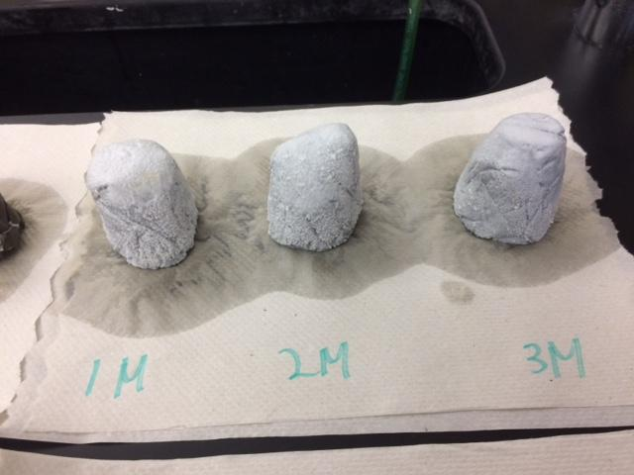
Figure 2 (calcium chloride samples, picture taken on May 6th, last data collection)
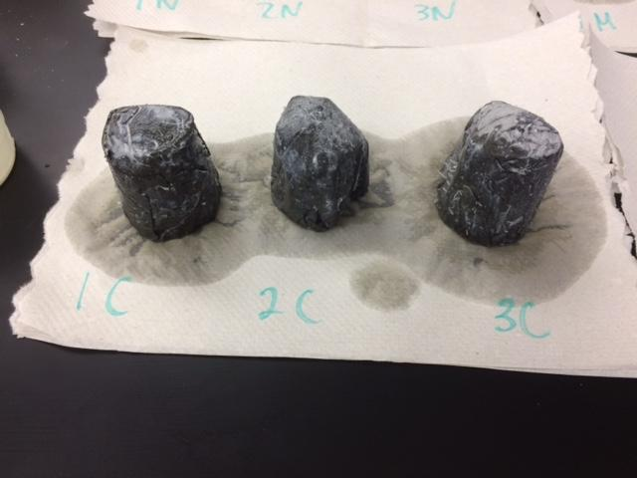
- Calculations
Figure 3. Calculations to find grams
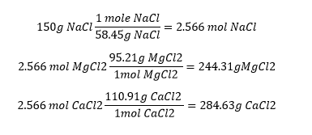

Figure 4. Calculations to find temperatures
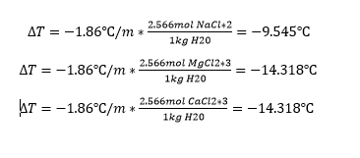
Figure 5. Calculation to change volume of solutions to mass and then calculate percent change (g/ml=%)
