Abstract
The future technology for asthma treatment is called Leukotriene Inhalers. The inhalers purpose is to counteract the amount of Leukotriene that the immune system is producing. Leukotriene is a fluid that seeps into the lungs and causes asthma. The technology of the inhalers is made to treat asthma. DNA/ RNA are extracted from the cells in the cells in lungs, so that the new medicine can replace it. The medicine is inhaled and travels into the lung cells where it will take the place of the removed DNA/RNA. From there the medicine begins its job of preventing the immune system from producing excess leukotriene. When the Leukotriene count gets lower, the asthma is being treated. The Leukotriene inhalers are easy to take, and will counteract excess leukotriene from getting into the lungs in order to make the asthma victim breathe easier.

Present Technology
Leukotriene modifiers are one of the treatments used to treat asthma, and there are three types of modifiers that are available. One is zafirlukast. It is a leukotriene synthesis inhibitor, and is recommended for children 7 years of age and older. The next is montelukast, and it is used for long-term management of children over the age of 2 years. Finally, the last one is zileuton, which is recommended for 12 years of age. It works by stopping the natural formation of certain natural substances that cause swelling, tightening, and mucus production in the airways. It prevents wheezing, shortness of breath, coughing, and chest tightness that’s caused by asthma. The FDA approved three of them into two classes. First class prevents leukotriene binding and includes zafirlukast and montelukast. The second classification is zileuton, which are leukotriene inhibitors that focus on synthesis inhabitation. The leukotriene modifiers including all three types of them decrease the body's production of excess mucus and fluid. There are two ways to block the production of leukotrienes. One is to block leukotriene synthesis by enzyme inhibition, and the other is to interfere with the binding of a leukotriene to its receptor. But while all these drugs work, the side effects of these modifiers are flu-like symptoms, feeling nervous or excitable, nausea or vomiting, nasal congestion, dyspepsia, pharyngitis, and macular rash. Leukotriene modifiers are linked to psychological reactions including agitation, aggression, hallucinations, depression and suicidal thinking. It can cause headache, stomachache, skin rashes, and inflammation of the blood vessel. Furthermore, these drugs are also not as effective as inhaling steroids.

History
In the past 100 years, there have been 4 types of drug treatment for asthma. But, Belladonna alkaloids were introduced in 1905 and chemically synthesized entities in the class that are still in use. Before the use of adrenergic stimulants, the only treatments for asthma were those found in traditional Asian medicines. The Asian medicines included herbal remedies that helped with anti-inflammation, inhibition of airway smooth muscle contraction, and immunomodulation. (the modification of the immune response or the functioning of the immune system by an immunomodulator) Smoking certain plants like Datura stramonium helped asthma symptoms. Datura stramonium included alkaloids of belladonna which have the effect of helping the body breathe. Western medicine began using adrenergic stimulants approximately 100 years ago. Systemic treatment with corticosteroids was introduced in the mid-20th century. In 1914, anticholinergics by injection or inhalation were considered first-line therapies. By mid-1950s metered dose inhalers had been invented for the delivery of epinephrine and isoproterenol to the airways. The past 40 years have been focused on the development of the asthma treatments used 100 years ago; cromones, antileukotrienes, and anti-IgE.

Future Technology
In the future, the current technology will be much more improved. The leukotriene modifiers will no longer be an oral medication but, an inhaled medication. The medication from leukotriene modifiers will be placed inside the flu viruses. The viruses with the medicine inside, is then put into the lung cells. Before the viruses are put into the lung cells, the DNA and RNA from the virus cell must be completely removed otherwise it will not stop the leukotriene from being produced by cells. DNA and RNA control the function of the cells. Removing the DNA and RNA will allow the medicine to enter the lung cells. Normally flu viruses enter the body to infect the cells in the body. In this case, we are using the flu viruses to insert medications into the lung cells, without using machinery. Instead of the flu viruses infecting the body and making it sick, it will help the body by using the medicine that is inside the virus and preventing leukotrienes from being made. The medication can be inserted into the virus because the DNA and RNA have been removed. The viruses will attach to the cells and it will prevent the cells from producing the leukotriene. After the gas enters the body, it enters the lung and attaches to the cells and prevents the leukotriene from causing tightening of airway muscles and production of excess mucus.

Breakthroughs
Many breakthroughs are necessary for our future technology to be a success. A way to safely convert the flu viruses into an aerosol spray, a way to remove the nucleic acids from inside the flu virus, and a way to insert the medicine into the virus are all necessary breakthroughs that are needed. Before inhaled leukotriene modifiers can become a reality, scientists must discover the correct amount of the flu viruses that inhaled into the body. A way to weaken the lungs is a needed for our technology to work. White blood cells fight off infections that are brought by viruses in our body. A type of white blood cell called eosinophil that controls the mechanisms that cause allergies and asthma. Reducing the amount of eosinophil may help the virus that we will insert so it will actually be attached to a lung cell without being attacked by white blood cell eosinophil. The eosinophil is mainly located in the lung tissues in the immune system. The experiment would be done to test if the DNA and RNA can be removed the flu virus and replaced by the medicine and work in the body. Getting a cell that has a flu virus is the first step. Next, is the DNA and RNA extraction process, which includes breaking open the flu virus then, mixing the DNA with cold ethanol or isopropanol and put into an apparatus. Then the DNA pellet is washed with cold ethanol and centrifuged. After the DNA is removed, take the shell of the virus, and check if there is any part of nucleic acids left behind by an agarose gel under a UV light. Finally, the virus is replaced with the medication and enters the body and attached to a lung cell. As a result, it will reduce the amount of leukotriene produced by lung cells and help the patients breathe better. The data will tell whether or not the technology works.

Design Process
We came up with two ideas for our future technology. Both ideas were to convert the form the leukotriene modifiers, which is pill, into gas form. First idea that we came up with was to make the leukotriene modifiers into powder, and then we mix it with water. After the power completely dissolved in the water, the solution will evaporate by a heat source. The evaporated gas will be inhaled by people. Second idea was to combine the flu virus with the chemicals inside the leukotriene modifiers, and convert the virus into gas. After the gas enters the body, it goes into a cell and prevents the leukotriene from causing tightening of airway muscles and the production of excess mucus. We chose the second idea because it is better and more practical than the first one. The first idea was to capture gas. We couldn't come up with a good way to capture the gas. Also, our teacher challenged us to come up with another idea because the first one was not practical. Our chosen future technology is better than the rejected one because we don’t have to capture gas.

Consequences
There are few consequences that come with the new technology of the Leukotriene Modifiers. The one main focus is the consequences that come with the removal of DNA/RNA from the cell which is necessary for our procedure. Acute effects of DNA damage on cell cycle progression can occur and has in the past though not very often. This can lead to transient arrest in the G1, S, G2, and M phases and on DNA metabolism which includes reproduction of DNA in the cells. The removal of DNA from the cell can lead to permanent damage in the DNA sequence affecting single genes or chromosome aberrations that may involve multiple genes and their biological effects. This, however, has a very low and slim chance of happening and is one consequence that is slightly more dangerous and affective than others. There are positives that come along with the negatives. By extracting DNA from the body, scientists will be able to put The DNA/RNA samples into a virus which will prevent the cells in the lungs from making Leukotriene. Removing DNA/RNA will treat the patient by lessening the Leukotriene count, and treating the asthma. This is a definite positive as the Leukotriene the cell produces is what causes asthma. By extracting DNA it is also possible to make the medicine into a virus which is inhaled instead of swallowed, making it safer for the patient to take. These are the few consequences that have very slim chances in happening, and usually don’t when there is somebody trained and very intelligent with the knowledge of the procedure that is extracting DNA from the cell.

Bibliography

"Asthma: One Hundred Years of Treatment and Onward." PubMed. National Center for Biotechnology Information, n.d. Web. 7 Jan. 2014. <http://www.ncbi.nlm.nih.gov/pubmed/15778490>.
Bacteriophage. Telegraph. N.p., n.d. Web. 27 Jan. 2014. <http://www.belfasttelegraph.co.uk/news/health/virus-that-eats-bacteria-that-causes-clostridium-difficile-could-spell-the-end-for-hospital-superbug-29667335.html>.
Chu, Eric K., and Jeffery M. Drazen. "Asthma One Hundred Years of Treatment and Onward." ATS Journals. American Thoracic Society, n.d. Web. 5 Jan. 2014. <http://www.atsjournals.org/doi/full/10.1164/rccm.200502-257OE#.UsrSYtJDuSp>.
"DNA Extraction." DNA. N.p., n.d. Web. 7 Jan. 2014. <http://dna.fiu.edu/Advanced%20DNA%20Typing%20lectures/extraction%2010-dee.pdf>.
"First Aid Training for Asthma Attack." Health Information. WordPress, n.d. Web. 22 Jan. 2014. <http://www.migration24x7.org/asthma/first-aid-treatment-for-asthma-attack/>.
Frea, Rick. "The History of Asthma Medicine." HealthCentral. N.p., n.d. Web. 7 Jan. 2014. <http://www.healthcentral.com/asthma/c/52325/153250/history-medicine/>.
Genetics Home Reference. N.p., n.d. Web. 7 Jan. 2014. <http://ghr.nlm.nih.gov/handbook/therapy/procedures>.
Horwitz, Randy J., Kelly A. McGill, and William W. Busse. "The Role of Leukotriene Modifiers in the Treatment of Asthma." ATS Journals. American Thoracic Society, n.d. Web. 5 Jan. 2014. <http://www.atsjournals.org/doi/full/10.1164/ajrccm.157.5.9706059#.Um719HCsim5>.
Influenza Virus. ABC Health & Wellbeing. N.p., 8 Feb. 2013. Web. 27 Jan. 2014. <http://www.abc.net.au/health/library/stories/2004/07/08/1831345.htm>.
"Leukotriene Modifiers." Palo Alto Medical Foundation. Palo Alto Medical Foundation, n.d. Web. 7 Jan. 2014. <http://www.pamf.org/asthma/medications/oral/leukotrines.html>.
"Leukotriene Modifiers and Allergies." WebMD. WebMD, n.d. Web. 7 Jan. 2014. <http://www.webmd.com/allergies/leukotriene>.
"Lung Cancer Cell." LiveJournal. N.p., n.d. Web. 10 Jan. 2014. <http://nsibai.livejournal.com/246806.html>.
Lung X-ray. Livestrong. N.p., n.d. Web. 27 Jan. 2014. <http://www.livestrong.com/article/123656-reasons-crackling-lungs/>.
Mayo Clinic. Mayo Foundation for Medical Education and Research, n.d. Web. 7 Jan. 2014. <http://www.mayoclinic.org/diseases-conditions/asthma/basics/definition/CON-20026992>.
"Project." Art Science Bangalore. N.p., n.d. Web. 27 Jan. 2014. <http://2011.igem.org/Team:ArtScienceBangalore/Project>.
Rice, George. "DNA Extraction." Microbial Life. Educational Resources, n.d. Web. 27 Jan. 2014. <http://serc.carleton.edu/microbelife/research_methods/genomics/dnaext.html>.

"Singulair (montelukast)." ODS Medical. N.p., n.d. Web. 28 Jan. 2014.
<http://odsmedical.com/
singulair-montelukast-prescription-drug-singulair-information-rx-singulair>.
"What Is Asthma?" National Heart, Lung, and Blood Institute. N.p., n.d. Web. 7 Jan. 2014. <http://www.nhlbi.nih.gov/health/health-topics/topics/asthma/>.

Web Pages

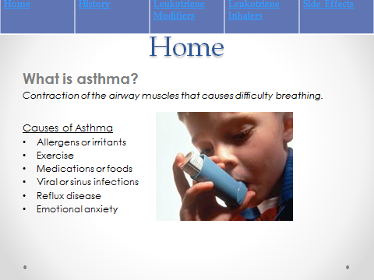

Web Pages

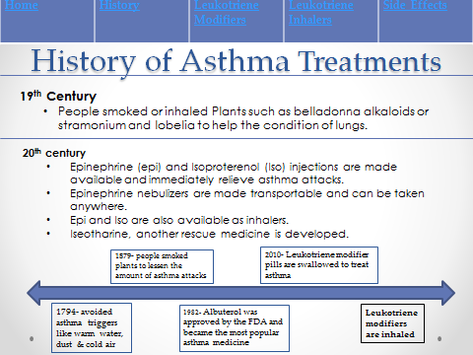

Web Pages

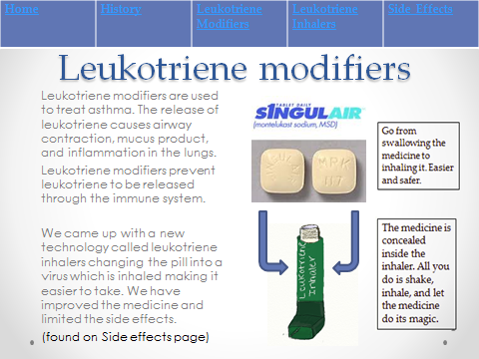

Web Pages

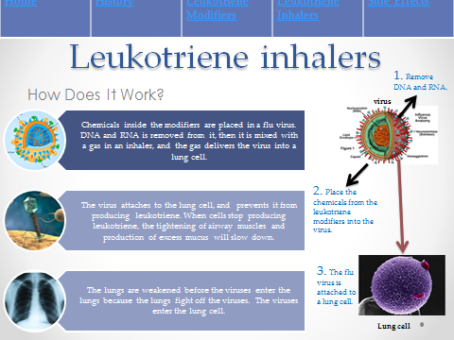

Web Pages

