Hyo Shin, Valerie Hinkle
15 January, 2016
Impact of Pop Music and White Noise to Short Term Memory
Abstract
Short term memory (STM) is a type of memory that stores small amounts of information for short periods of time. STM can be negatively impacted by distractors, such as music and visual interruptions. This study investigates how pop music and white noise impact STM as distractors. The subjects were given a series of shapes to memorize and write down in a sequence while listening to silence music, white noise, and pop music respectively. It was found that music had no effect on STM, however as the number of shapes that people had to memorize increased, the ability to remember those shapes in sequence decreased. Based on our findings, we would test the ability to remember shapes in sequence and the ability to remember a string of words in proper sequence, both with an auditory distractor. This would be interesting in developing an understanding of how STM works with certain parts of the brain.
Introduction
Short term memory (STM) is a type of memory capable of storing small amounts of information for short periods of time and in most instances, this information is only stored until it is no longer needed. However, these memories can be strengthened if the information is repeated (Colman, 2015), and they can be influenced by numerous factors such as noises, visual distractions, physical environment, and social media. For example, according to Gregory (2004), STM is reduced if the items of a sequence of information sounds similar. Elicott and Cowan (2005) concluded that fast speed music leads to impaired task performances. Hence, the impact of exposure to music in general has been shown to have negative influence on people’s short term memory. However, little work has been done on the impact of specific types of music. Therefore, this study explores the question, “Will white noise or pop music hinder one’s ability to remember shapes in a sequence?” We hypothesized that pop music will hinder one’s ability to remember shapes in a sequence more than white noise will.
Methods
30 test subjects ranging from high schoolers to adults of all ages were tested for the impact of pop music and white noise on short term memory. The method used to test the participants was a series of slides with shapes on them. The participants used a program called scratch to view the shape sequences. This program was created by MIT students, and was used in this experiment to show shapes in a sequence for 5 seconds each, before showing an instruction screen telling them what to do next (see figure 1). The program was written using the many functions of scratch and displayed and run when the green flag is clicked. The slides started when the green flag was clicked. The participants were shown a slide with 2 shapes on it, a triangle and a circle, for 5 seconds. An instruction slide was shown after the 5 seconds were finished, and they were each asked to remember and write down the shapes they saw in the order they appeared on the slide previous, into the corresponding box on their sheet (see figure 2). Next, they were show a slide with 3 shapes, a triangle, a star, and a circle, for 5 seconds (see figure 3). They were again asked to recall and write down the shapes they saw in the order that they were on the slide, in the corresponding box on their sheet. The next slide had 4 shapes, a circle, a diamond, a triangle, and a square, and were shown for 5 seconds as well. The participants were asked to remember the shapes they saw in the order that they were on the slide, and record them into the corresponding box on their sheet. The next slide had 6 shapes, a star, a circle, 2 squares, a diamond, and another triangle, which were shown for 5 seconds. Each participant was asked to remember the shapes they saw in the order that they were on the slide, and record them into the corresponding box on their sheet. The next slide was shown for 5 seconds and contained 8 shapes, a diamond, a square, a circle, 2 triangles, a star, a square and a circle. The participants were asked to recall the shapes they saw in the order that they were on the slide, and record them into the corresponding box on their sheet. The last slide had 11 shapes on it, 2 stars, a triangle, a square, 2 circles, a star, a diamond, a square, a triangle, and another star, and these were also shown for 5 seconds. The participants were asked to remember the shapes they saw on the slide in order, and record them into the corresponding box on their sheet. For each of these instructions slide, they were allowed as much time as they needed to remember the shapes and record them on their paper before they were instructed to press space to move on to the next set of shapes. After these 6 slides were complete, the next instruction slide prompted the participant to press space for the next section of the test. The program loooped and the same slides were shown for 5 seconds each, and then the instruction slides asked each person to write down the shapes they saw in the order in which they appeared o
5n the slides, but this time there was white noise playing out loud as a distractor. For the third and final run-through of the program, instead of white noise, a pop song called Ex’s and Oh’s by Elle King played as the distractor. As the experiment progressed, the number of shapes per slide increased, thus the level of difficulty rose.

Figure 1
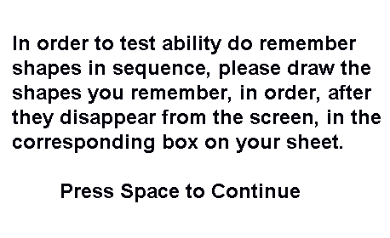
Figure 2
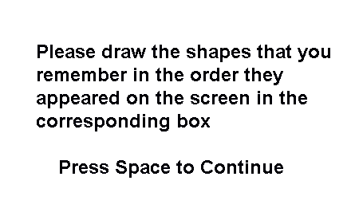
Figure 3

Results
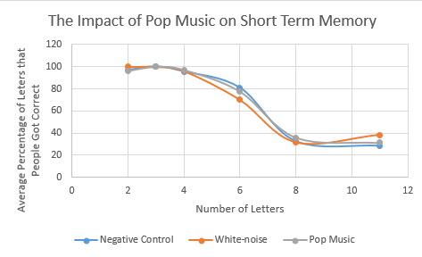
Table of P-values
 | p-value (negative control and white noise) | p-value (negative control and pop music
2 | 1.00 | 0.34
3 | 1.00 | 1.00
4 | 0.82 | 0.67
6 | 0.26 | 0.71
8 | 0.88 | 0.60
11 | 0.02 | 0.26

Discussion
The hypothesis is not supported through this experiment. The hypothesis was that pop music will distract people and prevent people from remembering shapes. However, as the graph shows, there is not much a difference in terms of the subjects’ performances between no noise and pop music. The lines follow the same trend, which means that the noises including white noise and pop music did not affect the subjects’ performances on the short term memory test. For future research, we would test the impact of music on remembering shapes versus remembering sentences, because the only factor that impacted the STM was the quantity of the shapes and not the distractors white noise and pop music. The proof for this is in the p-values(p-value range = 6.11E^-8 to 3.816E^-50). All the data from the 2 shape tests was compiled and compared with all the compiled data from the 6 shape tests to get a p-value (p-value=6.11E^-8). All the data from the 2 shape tests was compiled and compared with all the data compiled from the 11 shape tests for a p-value (p=3.816E^-50). These p-values are proof that only the number of shapes affected STM because both of them are extremely close to 0. Our hypothesis was disproven because when we compared the p-values from distractor 1, the white noise, with 6 shapes (p=0.26), and distractor 2, the pop music, with 6 shapes (p=0.71), the white noise had p-values lower than the pop music, against the negative control of no distractor. This is the opposite of our hypothesis, since we thought that pop music would be more distracting than the white noise, which turned out not to be true. Instead, the pop music distractor returned results similar to the negative control, while the white noise distractor was further off. Additionally, the white noise distractor with 11 shapes was the only test with a p-value of actual proof (p=0.02). However, this was only 1 section out of 3 different tests, and therefore shows that our experiment wasn’t the most accurate.
Bibliography
Colman, A.(2015). short-term memory. In A Dictionary of Psychology. : Oxford University Press. Retrieved 19 Nov. 2015, from http://www.oxfordreference.com/view/10.1093/acref/9780199657681.001.0001/acref-9780199657681-e-7612.
Elliott, E. M., & Cowan, N. (2005). Coherence of the Irrelevant-Sound Effect: Individual Profiles of Short-term Memory and Susceptibility to Task-Irrelevant Materials. Memory & Cognition, 33(4), 664–675. http://www.ncbi.nlm.nih.gov/pmc/articles/PMC2669750/
Brown, J.(2004). short-term memory. In The Oxford Companion to the Mind. : Oxford University Press. Retrieved 13 Jan. 2016, from http://www.oxfordreference.com/view/10.1093/acref/9780198662242.001.0001/acref-9780198662242-e-767.

