Henna Fraiman, Payton Bennett, Kendall Ross, Hyo Shin

Step 1

The environmental problem we chose that negatively affects our local community is air pollution. Air pollution in the Baltimore lowers Maryland’s property values, detracts from tourism, and is expensive to clean. It also affects people's lives, contributing to the death of 113 people per year in Maryland, which is more than any other state in the U.S. The Maryland Department of the Environment said Maryland's air quality is improving, but some counties continue to be marked as "nonattainment areas" by the U.S. EPA. If we are to get air pollution under control, we need improvement in the "nonattainment areas" in the Maryland.

Some factors that cause air pollution include cars, trucks, trains, boats, and commercial heating systems. We said car’s emission of gas is one of the most influential factors in air pollution. To make this less influential factor, we could use water as an alternate energy source instead of fossil fuels.

Step 2

Air pollution is a big problem in many areas including Baltimore. Air pollution can cause many diseases, sicknesses, and also death depending on how bad the air pollution is. Air pollution can also be very expensive to clean out. When the total number of deaths adds up, which is 113 deaths a year in Maryland, it can be very costly to pay for medical expenses. Also the asthma attacks that take people away from jobs will add up and affect the community. The impact of fossil fuels is the most common reason for air pollution in America, and all but two percent of the nation’s energy production comes from fossil fuels. The carbon that is produced by power plants in the U.S is 2.5 million metric tons, which contributes a lot to the air pollution. About 2,000 people a year die from fossil fuels and it can also cause global warming. We need to replace the fossil fuels by finding an alternate energy source, and we believe that we can do this using our project. The fossil fuels are damaging our environment and we need renewable energy like the rain water that we are using in our project, to stop burning coal and oil. Our project data showed that our turbine generator does create electricity, and so therefore it can be used as an alternate energy source.

Step 3

We took a couple weeks to figure out exactly which project our group was going to experiment, and once we did we started to design it. Our team’s project steps included using a voltmeter to determine how much electricity was generated in 5 places of a pipe. We first drilled five holes in a 15cm diameter pipe, and each hole was 10cm away from each other top to bottom. (See figure 5) We then used the volt meter and connected it to our turbine generator. We originally had another pipe which was 10 diameters, but the turbine didn’t fit into the pipe. We tried to make a smaller turbine out of the mini plastic cups, but it didn’t spin because the wheels were too small for any electricity to generate, and because of this we ended up using the 15cm diameter pipe. (see figure 7) We poured water onto the turbine to see how much electricity the turbine generator was generating in each height of the pipe. We made the turbine by cutting a plastic cup into 8 small blades. We cut off the bottom of the cup and we drilled a hole in the center of it which became the center of the wheel. (See figure 6) We made a data table to determine the average of the electricity generated for each height. Each team member had a specific job which was to pour the water at an angle into the pipe to spin the turbine while another person held the pipe and generator together. Another person filled the water to 1 3/4 liters, and the last person connected the voltmeter to the generator and pressed hold when the amount of volts reached its peak. We continually tested water turbines in the pipe over the course of many weeks until we found one that spun when water was poured. We collected and recorded data in a week. Resources we used to complete this experiment were a pipe, voltmeter, turbine wheel, generator, and water. The voltmeter indicates whether any energy is being generated and how much energy is being generated. This way of measuring the energy will tell you if the amount of energy generated is enough to have this turbine as an alternate energy source. Many people in Baltimore already know of the problem with our current energy source, and many different people such as scientists and researchers helped with our data, analysis, and conclusion because they gave us the necessary information on different portions of our project. To let people know of this problem we will inform them through the media. Our solution is unique because we use unique materials and we created another use for rain.



Step 4

1. We cut off the bottom of a plastic cup

2. We cut out 8 blades for the turbine generator and cut out 8 slits in the circle to put the blades in.

3. We used glue to connect blades to the circle of the generator

4. We drilled 6 holes 10 centimeters apart from each other into a 62 centimeter tall, 15 centimeter diameter circular pipe (See Picture "")

5. We connected the turbine generator to the pipe (See Picture "")

6. We put the generator 10 cm above the bottom of the pipe

7. We poured 1.5 liters of water into the drain pipe at a consistent rate

8. We measured how much electricity had been generated by using the voltmeter

9. We recorded the highest amount of electricity generated in a table

10. We places generator 10 cm above the previous location inside the drain pipe

11. We repeated steps 7 through 10 four times

12. We repeated steps 5 through 10 for a second set of data

We had to keep the consistent rate of water, and same amount of water to retrieve an accurate result. One of our team members measured how much time it took each time while another member poured water into a pipe. The water pouring person had to practice pouring water into pipes because we wanted the consistent rate of water every time. If we didn’t keep the consistent rate of water, the energy that is released by the generator would not be accurate.

We had five holes of different heights on walls of each pipe and we attached the generator to each hole. We had three trials of collecting data. We attached the generator in different holes to figure out which one generates the most energy for each pipe. As result, the middle 3 hole generated the most energy in trial 2 and 3 for the large pipe.

Step 5

Our data is quantitative. When we poured water into the pipe from 50 cm, 30cm and 10 cm from the bottom, we got less electricity than when we poured water from 40cm, 20cm, and 0cm. We figured out that every twenty centimeters generated the most electricity. The most interesting part is that there is a wave pattern in our data and water flows in waves. The water's behavior in the pipe is the same as if it is in the ocean. When we compared 50 cm and 40cm, we got .0979560753 as a p value, which means that there is 91% chance that the amount of electricity generated from 50cm and 40 cm from bottom are going to be different. We know that there is only about 18 % chance that that 40cm from bottom produce less than 20 cm from bottom since we got .8251021913 as a p value. There is only about 2% chance that 20 cm from bottom generates different amount of energy from 0 cm from bottom, which indicates that there is a low chance that twenty centimeters apart holes will generate the same amount of energy (See Figures 1-3).

We only need 120 volts to power a light bulb, which means one generator can produce enough energy to power one light bulb with just one small generator. And we got approximately146.72 volts as the average of the averages for each height. Our solution impacts the problem. We collected enough energy to power a light bulb which means that our solution can possibly reduce the amount of energy that’s used in our community by using our generator. One of the problems was when the generator did not work. Another was when our turbine blades did not fit in the pipe. We had to make our own turbine blades out of a plastic cup. We had to cut them so they fit in the pipe. We had to have the same size of blades. One of our pipes was too small, so we did not use it. We also had trouble at first when pouring the water on the turbine at the right angle. If we have another opportunity to do this project, we would make the blades before we buy the pipe so that we would make sure it fit before we bought it.

Step 6

If our project were to be shared with people in our community, it would have a big impact on it because it would give our community a renewable energy source that costs less than fossil fuels. Our project has not yet been shared with the community because we have not yet gotten the chance. We have not yet shared our project with the media because we didn’t have the time after we finished our project. Our suggestions to be able to share our project with others and expand it, would be to sell the items that are needed for making our project and the right instructions. All communities are positively affected from our project, because all communities struggle with air pollution and unrenewable energy sources such as fossil fuels. We will share with other our knowledge of how fossil fuels negatively affect our communities, and how to use rain water to create electricity, instead of using fossil fuels which harm people and the environment. This project could take one day up to weeks depending on how much rain falls in that particular area. Once the rain falls, it won’t take long to create the electricity. We will share our solution by letting our communities know by making flyers and putting things out on the media about our project and the solution to our problem. We recommend to use sustainable materials like plastic cups to make the turbine, and the rain water to create the electricity in the rain spouts.

|  |  |  |  |  |  |  |
| --- | --- | --- | --- | --- | --- | --- |
| 15 cm pipe |  | Amount of energy generated (volt) | | | | |
| Trial 1 | Trial 2 | Trial 3 | Trial 4 | Average |
| 50 cm from bottom | 145.5 volts | 98 volts | 171 volts | 130 volts | 136.13 volts |
| 40 cm from bottom | 168 volts | 199.9 volts | 178 volts | 148 volts | 173.48 volts |
| 30 cm from bottom | 128 volts | 46 volts | 139 volts | 194 volts | 126.75 volts |
| 20 cm from bottom | 186.7 volts | 168 volts | 157 volts | 195 volts | 176.68 volts |
| 10 cm from bottom | 30 volts | 85 volts | 137.4 volts | 111 volts | 90.85 volts |
|  | 0 cm from bottom | 159.3 volts | 193 volts | 159.6 volts | 193.9 volts | 176.45 volts |

Figure 1

Figure 2

Figure 3

|  |  |  |  |  |  |  |
| --- | --- | --- | --- | --- | --- | --- |
|  | 50 cm | 40 cm | 30 cm | 20 cm | 10 cm | 0 cm |
| 50 cm | - | .0979560753 | .7960351335 | .071570988 | .1586829418 | .0756638541 |
| 40 cm | - | - | .2274301944 | .8251021913 | .0282788296 | .8452171571 |
| 30cm | - | - | - | .2013593755 | .3862131741 | .2037281909 |
| 20 cm | - | - | - | - | .0265902075 | .9868485226 |
| 10 cm | - | - | - | - | - | .0258386922 |
| 0 cm | - | - | - | - | - | - |

Figure 4

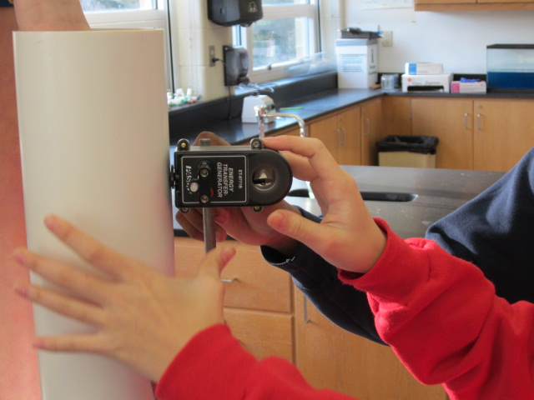

Figure 5

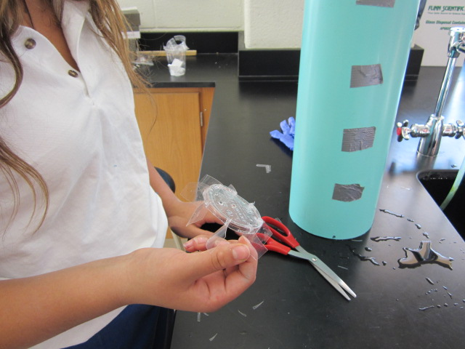

Figure 6

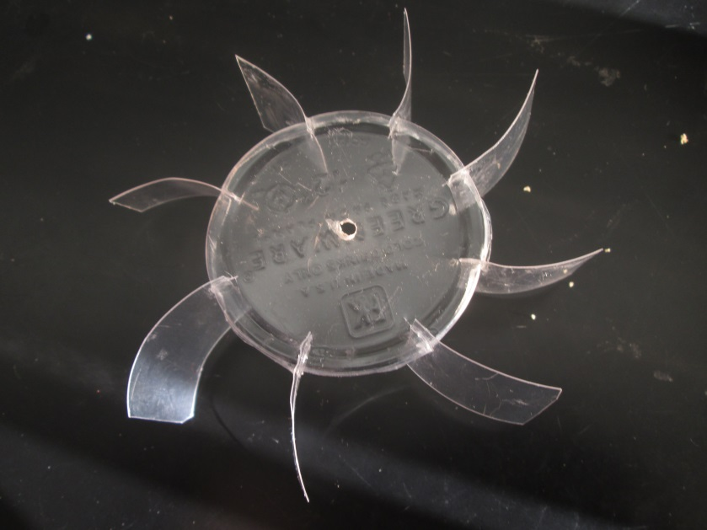

Figure 7

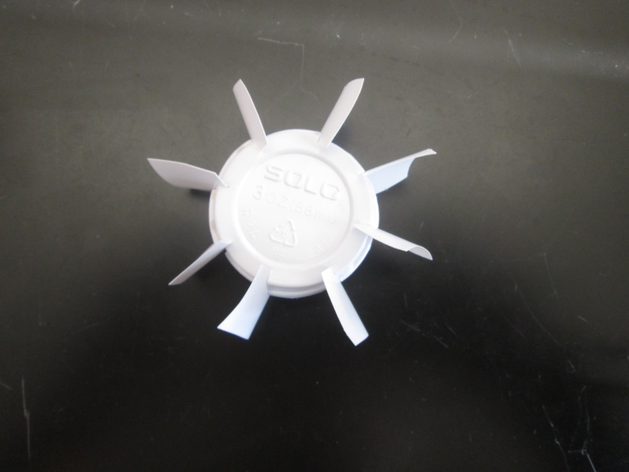

Figure 8

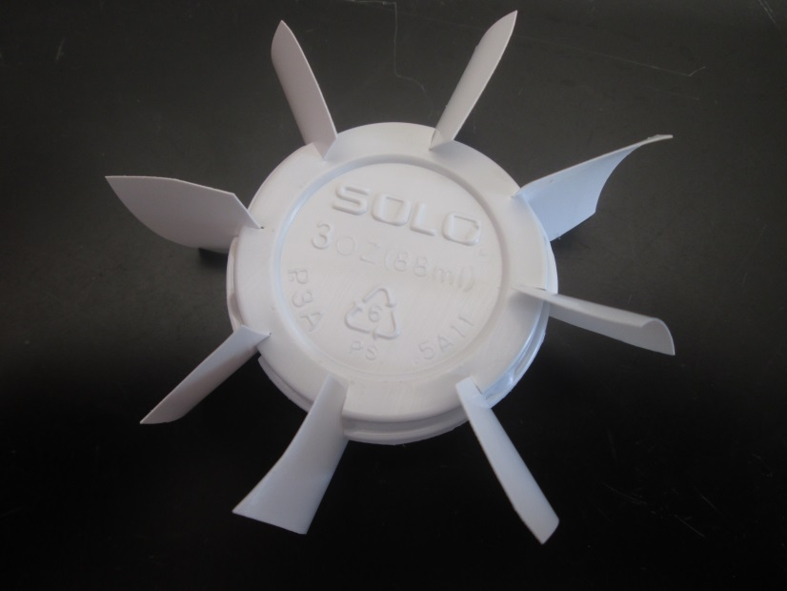

Figure 9

