Olivia Cohen
and
Ilana Moffet’s
Water Bottle Rocket Lab

Abstract:
For this project we investigated what modifications could be made to a bottle rocket to make it fly the farthest distance possible. For this we had to utilize Newton’s 3 laws as well as the Impulse-Momentum Theorem and the concepts of projectiles. In our research we found a design using fins and a nose cone made out of a second bottle. We used this for our original design, potting the fins on the nose cone to help move the center mass towards the top of the rocket which we found in our research would be beneficial. After testing the rocket once using 340 ml of water, it only went 15.5 meters, and we decided to add 100 grams of sand to the nose cone to increase the mass as well as double the amount of water we were using to increase the time of the impulse. After our second test, the rocket went 24.1 meters, and it was still unstable in the back during the flight. So we moved the fins to the back of the rocket, using still the same amount of sand and water, and the flight was successful, going 79.7 meters. In conclusion we found that it was most beneficial to launch the rocket at a 45 degree angle. It is also necessary to put the fins at the back of the rocket. 680 ml of water was most beneficial to use when launching the rocket.

Table of Contents:
Section Page Number(s)
Introduction 4-6
Description of Original Design 6
Results 6-7
Analysis/Discussion 7-8
Conclusion 8
Appendices:
Materials 8-9
Methods 9
Graphics: ---
Wing Design 10
Body and Nose Cone 11
Full Rocket 12
References 13

Introduction:
A water bottle rocket is a type of rocket that is typically made out of a soda bottle filled with water, and then pressurized with air until it launches off the launch pad. Water bottle rockets are propelled upward by the water coming out of the bottom of the rocket. The rocket is able to accelerate more with more water. Water is used in these bottle rockets because it is a very dense liquid, so it gives the rocket a lot of inertia for the rocket to push against. Air is used to pressurize the rocket by being packed tightly inside to give it a lot of energy. When the water starts coming out of the bottom of the rocket, the air pushed on the water while the water is pushing on the air until the rocket is propelled forward(5). The fuel of the rocket is water and the energy to the rocket is air. There are two key pointers to keep in mind when building a rocket, which are: the higher the center of mass, the more stable the rocket will be and the less the bottle rocket weighs, the farther it will go(3). Another important concept of bottle rockets is that the fins one may choose to attach need to be balanced on both sides, because if they are not, one side could get more force which would derail the flight pattern of the bottle rocket.
The application of Newton’s Laws is very important to be able to make a successful water bottle rocket. Newton’s first law helps explain why water bottle rockets fly. In his law, it says that an object at rest stays at rest and an object in motion stays in motion unless acted upon by an unbalanced force. The pumping of air into the bottle acts as an unbalanced force to set the rocket in motion. Newton’s first law can also be referred to as the law of inertia which is an objects resist to a change in motion. One would want their rocket to have a lot of inertia, so the rocket resists change. The inertia of the rocket is directly proportional to the mass, so you want a larger mass for more inertia. The second law states that the acceleration of an object is indirectly proportional to its mass and directly proportional to the net force of the object. This law helps explain that the more water that is in the rocket, the heavier the rocket will be, therefore there is more force needed to propel the rocket a great distance. It is also tells that the more air pumped into the rocket, the higher it will fly because it will have a greater acceleration to the large force of the air. Newton’s third law states that for every action, there is an equal and opposite reaction. When the rocket is launched the air comes out the nozzle and shoots downward, which propels the rocket upward as the opposite reaction force. Another example is the greater the force of the water streaming out of the bottle and downward, the higher the rocket will be shot up- it is the opposite reaction to the water coming downward(5).
Impulse is a force applied to an object for a specific amount of time which will be equal to the object's change in momentum. The Impulse-Momentum theorem is much like Newton’s 2nd law of motion and it states that the size of the force times the time the force is applied will equal the impulse or put into an equation: f x t = I. This theorem is significant to bottle rockets because the larger your impulse is the more momentum your rocket will have. This means it is necessary to maximize the size of the starting force on the rocket and the time that that force takes this way the impulse and change in momentum will be greater, resulting in a lot of momentum. It is important that the water takes as long as possible to completely exit the bottle rocket, because the longer it takes the longer there is a force acting on the bottle rocket and the larger the impulse will be. It is also important that the pressure or force be large to increase the impulse and change in momentum. A large momentum is desirable because a large change in momentum means a large change in velocity, and the faster the bottle rocket is going the father it will go. This is proven by the logic of projectiles.
A projectile is any object in free fall which means the only force acting on it is gravity. Although the bottle rocket is not technically in free fall because air resistance is acting on the rocket, the concepts of projectiles relate to the bottle rocketry. A projectile has two components – horizontal and vertical. Once launched, the horizontal component velocity never changes because only the vertical component is acted upon by gravity. The vertical component velocity will have an acceleration of -9.81 m/s². There are two kinds of projectiles, an angled projectile and a horizontal projectile. It is important to understand the concepts behind the two types of projectiles to know how to place your rocket when launching. A horizontal projectile would not be most efficient to use when launching. For a horizontal projectile, the initial force only acts horizontally, therefore the initial velocity is 0 m/s. This means that depending on the height at which the object is launched from, the object will not have very much time before it hits the ground and therefore it won’t be able to travel far. With this concept in mind, one can figure out what angle would be most effective in getting the rocket the farthest. The larger the vertical initial velocity is, the more time the rocket will have in the air because it will go up farther, and take longer for gravity to bring it all the way down to the ground. However, the larger the horizontal initial velocity is, the faster the object can go and the more distance it can travel in less amount of time. This is why it is important to balance these two velocities. As the angle of the projectile increases, the larger the vertical component’s initial velocity will be, and as the angle decreases, the larger the horizontal component’s initial velocity will be. So, it is most beneficial to launch the bottle rocket at an angle of 45°, as this creates the perfect balance between the two components and maximizes the distance, although sometimes the angle must be altered with other factors in mind like weight and structure.
NASA published a water bottle rocket design that tested successfully when launched. The rocket consisted of a 2 liter bottle soda as the base or body. The end of the bottle that was filled with water is called the nozzle, which is also helps propel the rocket forward. On the sides of the soda bottle are 3 fins to help stabilize the rocket. Attached to the bottom of the water bottle, is something called a payload which can be a parachute or just another part of a soda bottle. On the end of the payload is a nose cone which helps improve the aerodynamics of the rocket(2).
There are a few alterations that could be made to NASA’s design that could theoretically make the rocket travel farther. The mass of the rocket is complicated. For the launch, it is important to have a small mass so that the acceleration will be greater according to Newton’s 2nd law. Because the force is already set, the only way to increase the acceleration is by reducing the mass of the rocket. However, while the rocket is in flight, it is beneficial to have a larger mass to give the rocket more inertia to stay in flight and resist forces acting on it. This means that the mass must be altered and played with to get the right balance so that it will be effective for both the launch and the flight. Also more fins could be added to the design to stabilize the flight even more and also help with the mass issue. Finally, the design could be adjusted to make sure that the center mass is as close to the tip of the rocket or the nozzle that it can be because this too helps to stabilize the flight.

Description of Original Design:
Our water bottle rocket is made of a 2 liter soda bottle as the body, 12 cm of another 2 liter soda bottle as the nose cone, and 4 fins taped to the nose cone 8.5 cm apart. We chose to have 4 fins around the nose cone because we thought it would balance the rocket evenly on all sides and we learned in research the you want your center of mass towards the top of the rocket. We decided to use this simple model for our first test because it incorporates all the basic parts of a rocket so we thought that it would give us a good idea of what to add . The rocket weighs 110.9 grams not including the 340 ml of water we added to the rocket. We used 340 ml of water because in our research we found that a group got their rocket to fly the highest when adding 100 ml of water to a 20 oz bottle so we set up a proportion. The launch angle we used was 45° because when studying prior designs, they all worked best at a 45° angle.

Results:
Test Launch Data
Trial | Mass of rocket | Volume of water | Launch angle | Description of flight
1 | 110.9 g | 340 ml | 45° | the rocket went 15.5 meters so it was quite. unsuccessful. It also flew diagonally.
2 | 226.796 g | 680 ml | 45° | the rocket went 24.1 meters, so not successful again. When it was launched the back was too heavy compared to the front, so the rocket started wiggling and was unstable the entire flight.
3 | 181.437 g | 680 ml | 45° | SUCCESS!! it went 79.7 meters!!!!! the flight was very smooth

Adjustments:
After trial 1: cover the entire nose cone in duct tape, add 100 g of sand, use 640 ml of water (double water in trial 1)
After trial 2: take all the duct tape and fins off the nose cone, cover each fin individually with duct tape and attach them 8.25 cm apart on the body of the rocket

Analysis/Discussion:
Our original design was not very successful. This was due to the fact that we started with the fins on the nose cone of the rocket. While we thought this would be helpful with aerodynamics and adding mass to the nose cone, it actually made the flight of the rocket unstable. The back of the rocket flew around in all different directions. The first time the rocket was tested it only went 15.5 meters. Along with the fins being on the nose cone rather than the body of the rocket, the flight was also unsuccessful because not enough water was used for the launch – we used only 340 ml this time – and there was not enough mass in the nose cone. Because there was only 340 ml of water, the force of the water pushing the rocket up did not act for very long, therefore resulting in less momentum and a slower speed, and the rocket was unable to get very far. Also, because there was not enough mass in the nose cone, the center mass was not as close to the top of the rocket as it should have been to be successful. For our second trial we added 100 g of sand to the nose cone to increase the mass and fix the problem with the center mass. We also used more water – now 680 ml – to create a longer impulse and greater momentum. However, the rocket still only went 24.1 m because the fins were still on the nose cone rather than the body of the rocket, making the flight unstable. Finally, for our last test, we kept the sand and water the same, but we moved our fins to the rear end of the rocket to make the rocket more stable. This fixed the rest of the problems for the rocket and the rocket went 79.7 meters. If more time were given to us to work on this project, we would like to see what would happen if there was one set of fins on the rear end of the rocket and another set of fins on the nose cone.

Conclusion:
The following conclusions are supported by the results of this study:
- A water bottle rocket with 4 fins toward the bottom of the body of the rocket closer to the nozzle flies the farthest and smoothest.
- The 4 fins need to be toward the back of the body of the rocket or else the rocket will fly crookedly.
- A water bottle rocket launched at a 45° angle will give the rocket the best height and cover the most distance.
- 680 ml of water in the water bottle rocket will give a correct balance of mass to benefit both force and acceleration.
- Adding 100 g of sand to the nose cone will create a higher center of mass, so the rocket will go farther and stay balanced longer.
Appendices:
Materials:
- two 2 liter soda bottles
- duct tape
- recycled cardboard
- scissors
- tape
- glue
- ruler
- sand

**Cost: We used all recycled materials, so there was no cost.**

Methods:
- Empty out and clean the two 2 liter soda bottles
- Set aside one of the soda bottles to be kept whole and make sure there are no punctures in it
- Take the other soda bottle and cut it 12 cm from the bottom
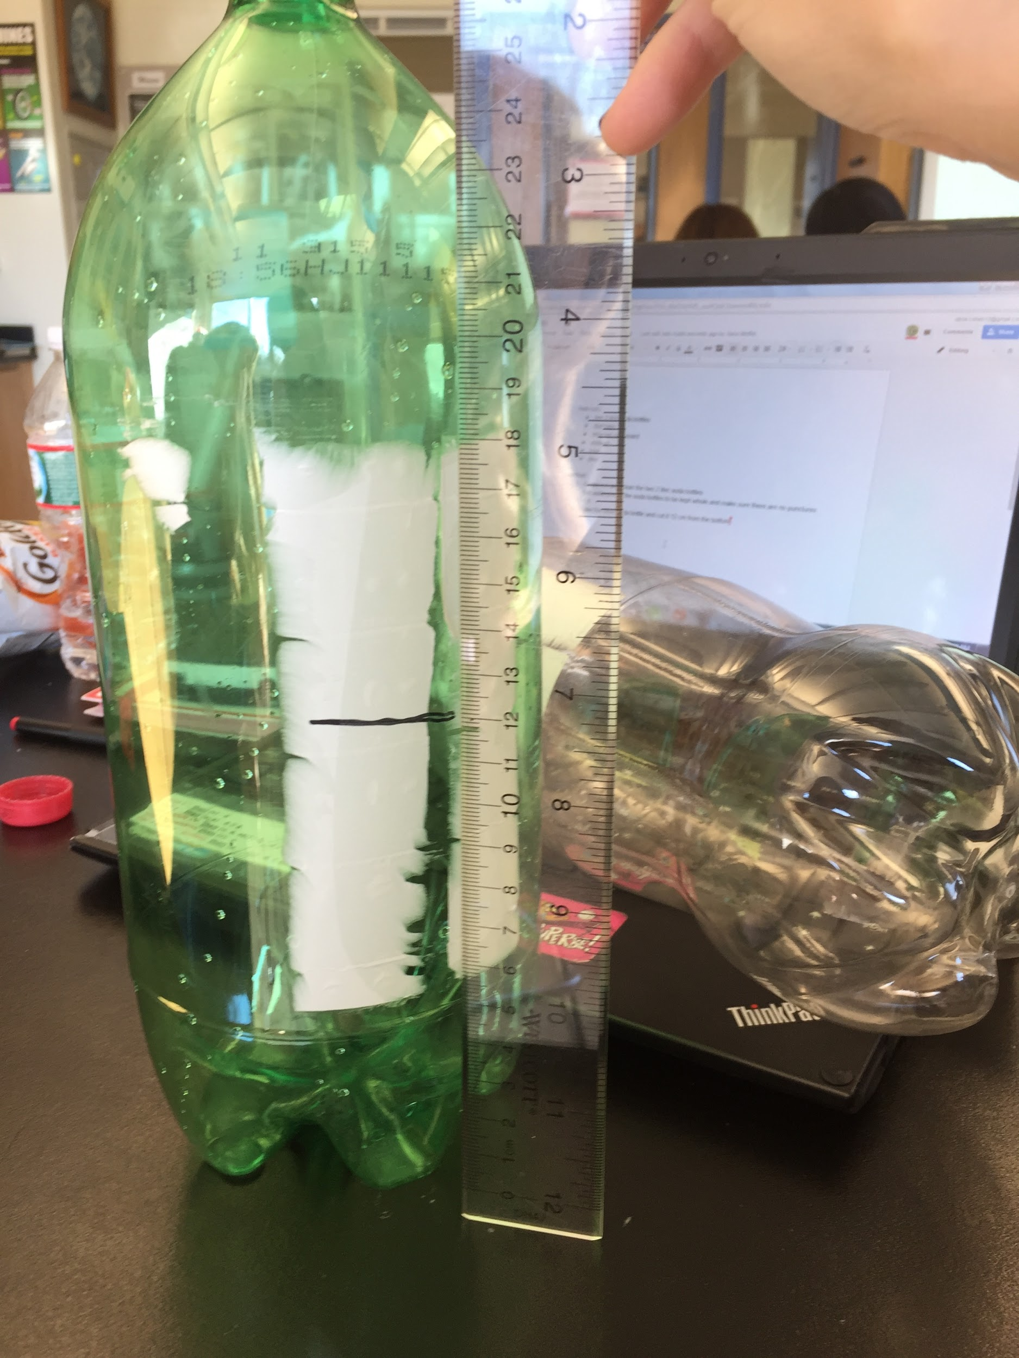
- Tape the cut soda bottle to the end of the soda bottle that was put aside
- On a piece of recycled cardboard, draw 4 right triangles with a base of 10 cm, height of 14 cm, and a hypotenuse of 17 cm
- Attach the 4 triangles around the body of the rocket 8.25 cm apart
- Fill the nose cone with 100 g of sand
- Fill the nozzle of the rocket with 680 ml of water
- Put the rocket on the pump at 45° and pump the air to 60 PSI

Graphics:
Wing Design

17 cm
14 cm
10 cm

Body and Nose Cone

nose cone- 12 cm of a 2 liter soda bottle
body of the rocket- 2 liter soda bottle = 25 cm
nozzle- the end of the soda bottle that makes the body = 2 cm

Full Rocket

8.5 cm apart
fin-
10cm x 15 cm x 17 cm
nose cone- 12 cm

100 g of sand
nozzle- 2 cm
body of rocket- 25 cm

References:
1. Bloomfield, L. A. (n.d.). How do water-bottle rockets work? Retrieved December 13, 2015, from Physics Central website: http://www.physicscentral.com/experiment/askaphysicist/physics-answer.cfm?uid=20080509041417
2. Charleston, J. A. (n.d.). All About Water Rockets. Retrieved December 11, 2015, from NASA website: https://spaceflightsystems.grc.nasa.gov/education/rocket/BottleRocket/about.htm
3. de Poesta, M. (2007). A guide to building and understand the physics of Water Rockets [Booklet Guide]. Retrieved from http://www.npl.co.uk/upload/pdf/wr_booklet_print.pdf
4. How Bottle Rockets Work. Retrieved December 13, 2015, from Water Rocket Manual website: http://www.waterrocketmanual.com/how_they_work.htm
5. Rosier, C., Loehman, R., & Priestman, L. Water Bottle Rockets: an Exploration of Newtonian Physics [Inquiry Template]. Retrieved from http://www.bioed.org/ECOS/inquiries/inquiries/water_bottle_rocket_inquiry.pdf

