Silver and Gold

Kennedy Manley and Quincy Sugiuchi
December 15, 2015

Abstract
The project being investigated was to launch a bottle rocket as far as possible. The rocket must consist of a two liter soda bottle which serves as the pressure chamber. The air inserted to the rocket by a tire pump will push against the water placed in the bottle to accelerate the bottle forwards into the air. In order to make this rocket successful, the rocket builders must decide the size and amount of fins, the type of nose cone, and the amount of water to be inserted in their rocket. As a team, we decided to build our rocket, Silver and Gold, with three fins, a round nose cone, and 900 mL of water. Silver and Gold was launched with a pressure of 60 and an angle of 45 degrees. As a result, the rocket went very high and very far. Silver and Gold travelled 104 meters although it would have gone much farther if it was not stopped by the tall fence on the field. In conclusion, large fins, a rounded nose cone, and a balanced rocket is what helped Silver and Gold travel this distance.

Table of Contents:

Introduction …………………………………………………………….. Page 3
Description of Original Design…………………………………………. Page 6
Results ………………………………………………………………….. Page 7
Analysis and Discussion ………………………………………………... Page 8
Conclusion …………………………………………………………….... Page 10
Appendices ……………………………………………………………… Page 10
References ……………………………………………………………..... Page 11

Introduction
A water bottle rocket is a two liter soda bottle filled with compressed air. The bottle also contains water which is released in an upwards direction. The water bottle rocket is composed of many different parts. The first part is the pressure chamber. The pressure chamber is the two liter soda bottle that is not altered in any way. The fins will help with direction and stability. The rocket also contains a nose cone. The nose cone is rounded because other models suggested a nose cone for optimal distance since the nose cone limits air resistance (NASA).
The water rockets work by applying force. The force that is applied happens through a bicycle pump attached to pipes. The air exerted from the pump adds pressure in the pressure chamber which causes the bottle to move. The pressure exerted is an unbalanced force. Water is put into the bottles to add mass so the bottle can go farther (Water Rocket Manual). To calculate force, the equation force=mass*acceleration is used. As learned from the equation, as mass increases the acceleration will decrease if the force is consistent. The force applied is determined by Mrs. Drake and we are trying to get the most acceleration.
Newton’s three laws can be observed within this bottle rocket project. Newton’s first law can be observed since an object at rest will not move until an unbalanced force acts upon it. The pump will be an unbalanced force as it pushes the rocket upwards. The bottle must have a lot of mass because it needs a large inertia to travel forward. The large inertia will prevent the bottle from being too light and unable to travel through the air without being greatly affected by air resistance. Newton’s second law can also be seen in this project because the amount of air determines the amount of force. The force needed increases by adding water since the water is mass. The water makes the rocket weigh more so the aforementioned equation can be used to show the correlation between force and mass. In order to maximize the acceleration, the mass should be minimized but the force should be large. However, the force is controlled by the teacher and we do not have control over the size of the force. Finally, Newton’s Third Law can be seen through this bottle rocket project because as the action forces, air and water, leave the rocket they create an equal and opposite reaction force which is necessary to propel the rocket upwards. As the air leaves the bottle, the bottle propels. Also, as the air presses on the water in the rocket, the water is pressing on the air (NASA).
The impulse momentum theorem is a determining factor in the launch of the bottle rocket. Momentum is any mass in motion. In this experiment the mass in motion will be the bottle rocket in flight. Impulse is a force exerted for an amount of time, but it is also equal to a change in momentum. At the launch of the bottle rocket the momentum will change as the rocket is propelled forward. The impulse needs to be maximized to create the most amount of momentum while the rocket is in the air. In order to do this the time will have to be as long as possible, which can be done with a larger amount of water inside the rocket. This is because of the force that the water exerts on the air being pumped into the rocket. More water means a longer amount of time that the air can press on the water, however as it is exemplified in Newton’s Second Law the mass of the rocket needs to be kept small in order to have a larger acceleration and more water also means more mass. In order to have large momentum and a large acceleration we must balance the amount of water inside our rocket and the mass of the rocket without the water.
In bottle rocketry the concept of projectile motion plays a large role in the distance that the rocket will travel. The bottle rockets will be launched from an angle, making them angled projectiles. This means that the angle from which the rocket is launched from determines the horizontal and vertical velocity. The goal of the rocket is to have the largest horizontal distance, so the horizontal velocity will have to be larger than the vertical velocity. To maximize both vertical and horizontal velocity the rocket would be launched from a 45 degree angle; this will cause the bottle rocket to travel the farthest it can without hitting the ground too early in it’s flight. Horizontal velocity will be affected by the air resistance, while vertical acceleration remains at 9.81 m/s/s; this means that the vertical velocity must have a large amount at the start, because vertical velocity determines how long the rocket is in the air. Projectile motion is a major contributing factor to the distance and velocity of the bottle rocket.
An existing design that may work is from the NASA website. In this design it provides all of the basic elements of a bottle rocket: a nose cone, fairing, fins, and a bottle for the base. The elements of this design will create a functioning bottle rocket, however it may not optimize the horizontal distance travelled. In this existing design it only shows two fins, but fins create in air stability. Having more fins will cause the bottle rocket to travel in a straight path during its flight, so having more than two fins will maximize in-flight stability. In our design we will add three fins, because not only will it create in-flight stability, but it will also contribute to the overall horizontal distance travelled. Another aspect of the NASA design is the nose cone, which is shown as a large cone on the top of the rocket. A nose cone is crucial to minimizing drag during the rocket’s flight, however after examining other sources it appears that a pointed nose cone will not minimize the drag as much as possible. Instead, a rounded nose cone would maximize the distance, because of the way air travels around it, resulting in a smaller drag. This already existing design also contains a fairing in the plan. Similarly to the nose cone, the fairing can help minimize drag, but it could also interfere with the placement of the fins. The fins, which should be placed at the back for optimal stability, cannot be attached properly on our design with a fairing. However, the addition of a fairing would create less drag, because the air would be directed straight behind the bottle, rather than to the sides behind the rocket. In addition to the existing design from NASA we will be adding our own research into our design, however the existing design could have worked separately from the research we found.

Description of Original Design
We chose to use three fins. Each fin is the shape of a right triangle. The two legs of the triangles are shorter than the hypotenuse which is connected to the bottle. One leg measures 12.7 centimeters and the other leg measures 8.25 centimeters. The hypotenuse is 15.25 centimeters. The fins are being used to support the rocket. The fins are useful because they allow the rocket to fly far since they allow the rocket to reach the intended destination and maintain balanced. The three fins are spread equally apart and are towards the back of the rocket. We put the fins towards the back of the rocket since our research said that provides maximum support. (Nakka, 2001) The nose cone is another top of a 2 liter soda bottle attached to the bottom of the first soda can. The nose cone will be helpful to reduce the drag and let the rocket travel through the air. Drag is pulling something forcefully with difficulty (Dictionary.com). This will help to eliminate air resistance as best as possible. The pressure chamber is a two liter soda bottle with no changes in it.
The original design had a mass of 94.13 grams. As a group, we thought this mass would work because it would not be too heavy or too light. If the rocket was too heavy, it would not be able to reach a maximum height since the mass would restrict it. Specifically, it would decrease the acceleration of the launch. However, if the rocket was too light the air resistance would stop the rocket and limit the total distance it could travel. Though, after our first test launch we realized we needed to add more mass to our rocket in order for it to travel farther. Therefore, the weight must be measured accurately for the rocket to not be too heavy and not too light.
In our original design, we added 1000 mL of water. We believed this was a good amount of water since it appeared to fill about 50% of the pressure chamber. The water is used as fuel because the water pushes on the compressed air and releases the water out of the bottle. After our first test, we realized we used the right amount of water. We could increase the amount of water by a little bit in order to increase the mass.
We will use a 45 degree launch angle. This launch angle will be useful in allowing the rocket to achieve the maximum height, but also travel a far horizontal distance. The 45 degree angle will let the rocket meet the necessary requirements for this project. A 45 degree angle will allow the horizontal and vertical initial velocity to be as equal as possible.

Results

Trial Number | Mass of Rocket | Volume of Rocket | Launch Angle | Description of flight | Distance Traveled
1 | 94.13 grams | 1000 mL | 45 degrees | The rocket travelled far initially, but then it was unable to travel any further and returned closer back to where it started because of the little mass. | 22 meters
2 | 107 grams | 1200 mL | 45 degrees | Went a decent distance, but there was trouble with the launch | 36 meters
3 | 107 grams | 1000 mL | 45 degrees | Traveled the farthest distance yet, but spun a lot in the air. | 63 meters
4 | 250 grams | 900 mL | 45 degrees | The rocket traveled very far and very high. It came to a stop when it hit the top of the fence on the RPCS field closest to the ward house. The rocket would have most likely gone much farther without this obstacle. Overall, it was a good flight. | 104+ meters

Analysis and Description
The final performance of the rocket, Silver and Gold, was very successful. The rocket travelled the farthest in the class. The rocket was launched at a 45 degree angle and a pressure of 60 psi. This pressure amount and the angle measure allowed for the rocket to travel a long horizontal distance and tall vertical distance.
The first practice launch was very unsuccessful. At this time, the rocket had a small mass of 94 grams. During the first practice launch, the rocket contained 1000 mL of water and was launched at a 45 degree angle. The little mass in the rocket at this point did not allow the rocket to travel a decent distance. The rocket traveled 22 meters during this first practice launch. As a team, we knew in order for the rocket to travel farther we would have to increase the mass. If the mass is increased, the inertia will be increased and the bottle will be less affected by air resistance.
The second practice launch was more successful than the first, but not successful enough. During the second practice launch, the mass of the rocket was increased to 107 grams. To add more mass to the rocket, we also increased the volume of water to 1200 mL. However, we did keep the launch angle of 45 degrees the same. This launch was able to travel 36 meters. The second practice launch went farther than the first, but we still needed it to travel much farther for a decent grade. However, during this launch, there was a lot of trouble with the pump used to launch the rocket, so a lot of water was lost.
The third practice launch was positive and the pump was thankfully working again. We decided to keep the mass of the rocket (107 grams) the same. We, however, lowered the volume of water to 1000 mL. Yet, we did also decide to keep the launch angle of 45 degrees the same. During the third practice launch, the rocket traveled 63 meters. The rocket spun a lot in the air and we contributed it to the rocket being unbalanced.
The final launch was the best launch. Before the launch, we made the wings larger and attached them all to the rocket. The larger fins will allow the rocket to be more balanced and travel farther. Thankfully, during the final launch the rocket had a fantastic flight and went 104 meters. The rocket was launched at a 45 degree angle and was filled with 900 mL of water. However, the new fins did increase the mass so the rocket was now 250 grams. The rocket was able to travel so far and high that it hit the wall on the RPCS field and returned to the ground. Without this wall, the rocket would have travelled much farther than 104 meters since it was still traveling at a fast speed and very high in the air.
If we had more time, we would have tested our rocket one more time after adding the larger fins but before the final launch. This would have allowed us to make sure the fins were in the correct place to make the rocket balance. Also, another test run would allow us to be more confident that our rocket would travel a distance to get us a grade we would be proud of!

Conclusion
The following conclusions are supported by the results of this study:
- 45 degrees is the optimal angle to launch the rocket from to maximize the vertical and horizontal velocity
- Adding a nose cone to the rocket, specifically a rounded nose cone, will create the least amount of drag during a flight
- Having larger fins that are placed at the back will create more stability
- Adding 900 ml of water to the rocket will also create a lot of momentum
All of these factors will contribute to how far the rocket travels and will maximize the distance travelled.
Appendices
Materials:
- Two Soda Bottles
- Cardboard
- Duct Tape
- Scissors
- Playdoh

Step by Step Procedure:
- Measure the size of the fins on a sheet of cardboard. They should be 17 cm tall, 12 cm wide, and have a hypotenuse of 17 cm.
- Cut three separate fins out
- To create the nose cone, cut the top of bottle 1 off
- Add playdoh tightly packed to the top of bottle 1
- Attach the cut off top of bottle 1 to the bottom/end of bottle 2 using silver duct tape
- Using duct tape, attach the fins created in steps 1 and 2 to the top of bottle 2. Therefore meaning, the fins should be close to the cap on bottle 2. The 5 inch side of the fins should be taped to the bottle and be sure to make the fins sturdy.
- Make a tiny ball using duct tape.
- Duct tape the duct tape ball to the top of the nose cone to make it round.
- Secure the nose cone and fins by adding another layer of duct tape to both.

Costs: No materials were bought.

Graphics:

Fins: 3x

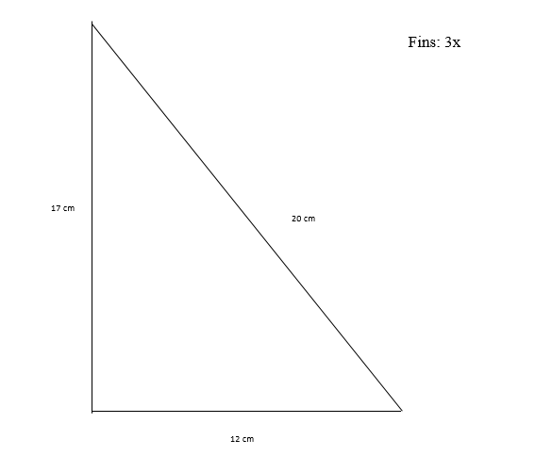

Nose Cone:
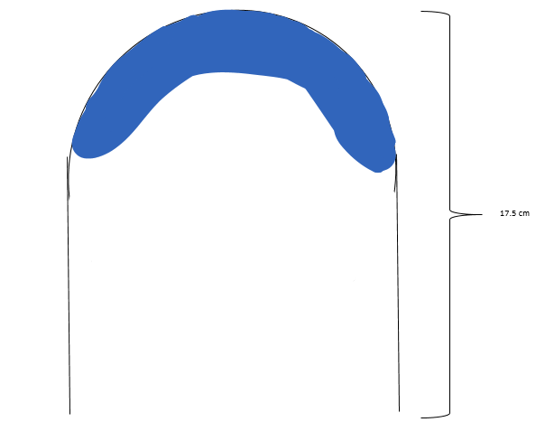

Soda Bottle:
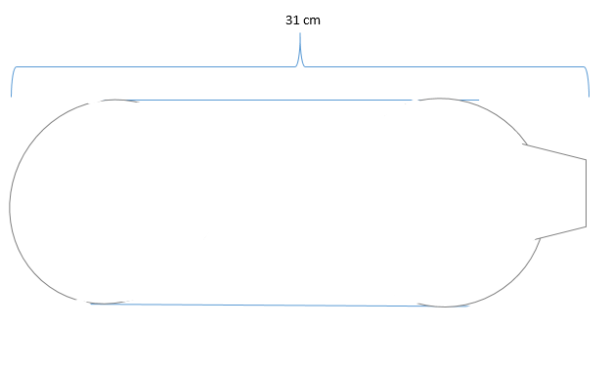

References

