Amber Bustard and Gabby Emge
Mr. Brock and Ms. Booker
STEM
1/7/15
Short Term Memory Research Paper
Abstract:
STM is information the brain retains for short spans of time. Many experiments have been conducted to see how STM can be affected by different factors, and previous scientists have concluded that distractors have an impact on one’s short term memory, although other scientists have concluded that distractors do not have an effect. This study was completed by increasing sound decibels to test if it increased or decreased one’s ability to recall a series of information. To complete this study subjects attempted to remember a series of colored dots using the program Scratch, as background white noise increased. After gathering the data it was concluded that background noise does not have an effect on one’s STM. As the sound level was increased to 25 decibels the amount remembered decreased for some of the quantities of dots, although the p values were often showed that it cannot be relied on. As the sound increased to 50 the amount remembered increased, although it was most likely due to the fact that the same color combinations were used for each volume test so the subjects already knew the combination. Further research can be conducted to discover if different sorts of distractors affect STM, such as visual distractors.

Introduction
Short Term Memory (STM) information retains in the brain for short spans of time. An example of short term memory being used is when one has to remember a list of information that is just given to them over a short period of time. For most people, the louder the distractor, the harder it is to retain information that they were just asked to remember, due to having to focus more on blocking the sound out, than actually focusing on the information presented to them. “It is clear from the previous discussion that high intensity background noise can distract, irritate, and hinder performance” (Elliott and Cowan 2005). We hypothesized “The increase in the volume of a distractor, will decrease one’s ability to recall a series of information over a short period of time,” based on prior evidence, that one has to exert more energy to memorize when there is an increased resistance (distraction), there is a decrease in reaction time, and one’s ability to recall a series of information. (Morgan, 1917). Morgan concluded “ It is evident from the severity of blows given in reacting that the subjects were in a state of greater tension in the noisy conditions rather than quiet.” This shows that the subjects are using most of their force to use their brain to block out the distractors. This force caused stress, and tension which deteriorates one’s focus to recall the given information.
Prior evidence has shown that distractions hinder your ability to retain information in the brain over a short span of time, however we were puzzled when Smith, Baranski, Thompson and Abel claimed “Our results suggest that the level of noise on the space station should not affect cognitive performance” (Smith, Baranski, Thompson, Abel, 2003). Although cognitive performance is different than short term memory, in our experiment one must focus on the information given to retain the knowledge. To do so, we tested, “What is the effect of increasing the volume of white noise on the subjects ability to recall a series of colored dots?’

Methods:
30 test subjects between the ages of 13 and 18 were shown a series of colored dots using a computer program called Scratch(see figure 5).
Figure 5
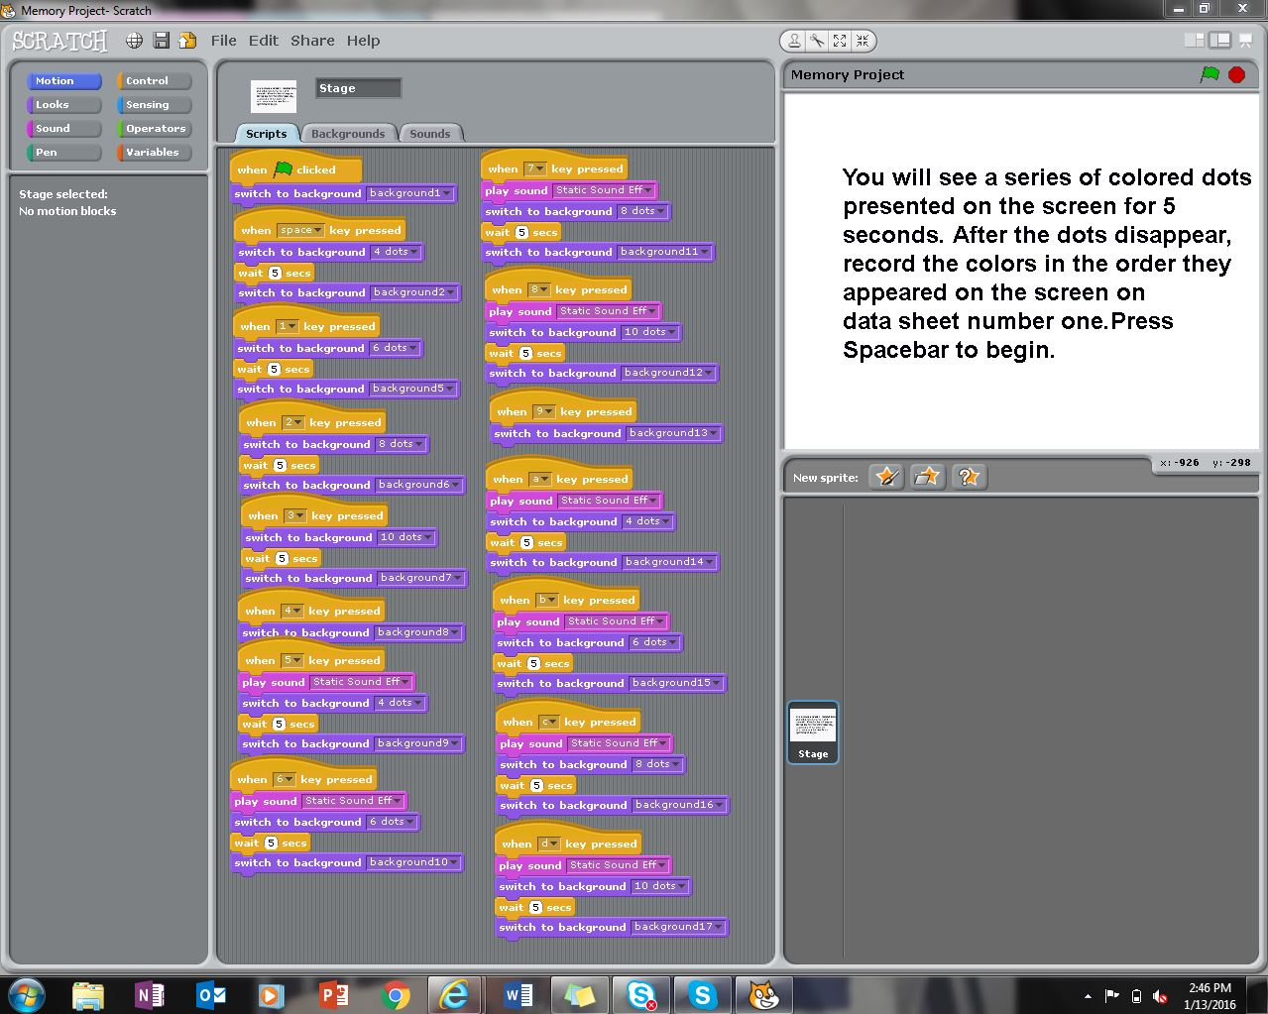

First, each subject was shown a series of four colored dots, red, green, blue, and yellow on the computer screen for 5 seconds (see figure 1). Immediately after, each subject was asked to write down the colors of the dots in the order that they appeared.
Figure 1
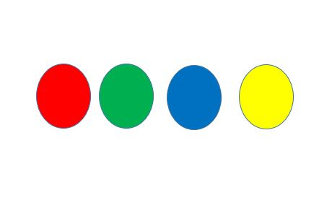
Next, each subject was shown a series of six colored dots, green, purple, blue, orange, yellow, and red on the computer screen for 5 seconds (see figure 2). Immediately after, each subject was asked to write down the colors of the dots in the order that they appeared.
Figure 2
Next, each subject was shown a series of eight colored dots, yellow, red, blue, orange, green, purple, black, and blue on the computer screen for 5 seconds (see figure 3). Immediately after, each subject was asked to write down the colors of the dots in the order that they appeared.
Figure 3
Next, each subject was shown a series of ten colored dots, purple, orange, blue, black, green, red, yellow, blue, gray, and purple on the computer screen for 5 seconds(see figure 4). Immediately after, each subject was asked to write down the colors of the dots in the order that they appeared.
Figure 4
Then, the subjects were asked to increase the volume of the laptop to 25. First each subject was shown a series of four colored dots, red, green, blue, and yellow on the computer screen for 5 seconds (see figure 1).
Figure 1
Immediately after, each subject was asked to write down the colors of the dots in the order that they appeared. Next each subject was shown a series of six colored dots, green, purple, blue, orange, yellow, and red on the computer screen for 5 seconds (see figure 2).
Figure 2
Immediately after, each subject was asked to write down the colors of the dots in the order that they appeared. Next each subject was shown a series of eight colored dots, yellow, red, blue, orange, green, purple, black, and blue on the computer screen for 5 seconds(see figure 3).
Figure 3
Immediately after, each subject was asked to write down the colors of the dots in the order that they appeared. Next each subject was shown a series of ten colored dots, purple, orange, blue, black, green, red, yellow, blue, gray, and purple on the computer screen for 5 seconds(see figure 4). Figure 4
Immediately after, each subject was asked to write down the colors of the dots in the order that they appeared. Finally, participants were asked to increase their volume to 50. The test was once again repeated with the white noise in the background, First each subject was shown a series of four colored dots, red, green, blue, and yellow on the computer screen for 5 seconds (see figure 1). Immediately after, each subject was asked to write down the colors of the dots in the order that they appeared.
Figure 1
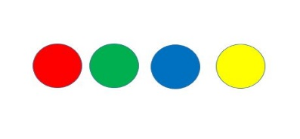Next, each subject was shown a series of six colored dots, green, purple, blue, orange, yellow, and red on the computer screen for 5 seconds(see figure 2) .
Figure 2
Immediately after, each subject was asked to write down the colors of the dots in the order that they appeared. Next each subject was shown a series of eight colored dots, yellow, red, blue, orange, green, purple, black, and blue on the computer screen for 5 seconds (see figure 3). Immediately after, each subject was asked to write down the colors of the dots in the order that they appeared.
Figure 3
Next, each subject was shown a series of ten colored dots, purple, orange, blue, black, green, red, yellow, blue, gray, and purple on the computer screen for 5 seconds (see figure 4). Immediately after, each subject was asked to write down the colors of the dots in the order that they appeared.
Figure 4
The participants in this test were a variety of people. The majority included Roland Park Country School students in grade 9, although some participants were in 10th 11th or 12th grade at RPCS. Some other participants also included family members. The test subjects were chosen by willing participants who were then showed the test. One subject was tested at a time.

Results
Graph 1

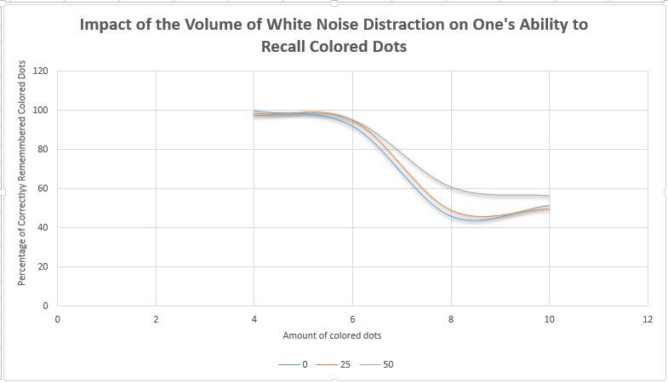
Table 1: Results of t-Test on experimental conditions vs. negative control

Amount of Colored Dots | Negative Control vs. volume level 25 | Negative Control vs. volume level 50
4 | p=0.18 | p=0.33
6 | p=0.83 | p=0.76
8 | p=0.68 | p=0.05
10 | p=0.35 | p=0.8

Table 2: Results of t-Test on 8 dots and 10 dots
 | 8 dot 25 volume vs. 8 dot 50 volume | 10 dot 25 volume vs. 10 dot 50 volume
P value | p=0.94 | p=0.9

Discussion:

Overall, the trend of the data does not support our hypothesis. As graph 1 clearly shows, the expected negative impact on recall of ever larger amounts of information was observed, but the impact of sound was negligible and statistically insignificant (with p-values ranging from 0.18-0.83; see Table 1) for all experimental conditions except for when subjects were shown 8 colored dots. However, while the 8 colored dot condition did show a statistically significant impact of sound when the sound level was raised to 50, the percentage remembered actually increased (p=0.05). This means that the variations in the volume of white noise most likely does not have an effect on the amount of colors that one can remember. If it did affect one’s short term memory then it would be more difficult to remember to series of numbers with an increase of sound, so the percentages for all the amount of dots would decrease even more than occurred in the negative control condition.
Since the percentages did not have a general trend, it is possible that the percentages increased more for the third trial because they already had the order of the colors remembered so it was easier to recall the colors. The 50 level test was most likely inaccurate due to this. Also the sound may not have completely affected it due to the outside sounds in the environment that they may have heard.
Due to these varied results we cannot come up with a complete conclusion since not all the trials have the same outcome, although we can say that we believe that white noise most likely does not have that much of an effect.
If sound was a big factor in the memorization of a series of colors then the percentage of colors remembered would decrease for at least 0-25 sound level, although it only decreased for half. That shows that the data is split in half, making is hard to be completely conclusive. To have more accurate results next time we can change the order of the dots for the trials with 25 and 50 level sound so they don’t already know the order. Also, they could do the experiment with headphones or in a quiet environment when there is not as much background noise so they would not be distracted with background noise and only focus on the sounds in the experiment. This are the two major parts of the experiment that had a large effect on the results and making it difficult to draw conclusions from. Another experiment with the factored in would change the results and make it easier to decide from them whether or not noise affects one’s short term memory.

Bibliography:
Smith, D. G., Baranski, J. V., Thompson, J. V., Abel, S. M. (2003). The Effects of Background Noise on Cognitive Performance. Noise and Health, 6, 3-16. http://www.noiseandhealth.org/article.asp?issn=1463-1741;year=2003;volume=6;issue=21;spage=3;epage=16;aulast=Smith
Elliott, E. & Cowan, N. (2005). Coherence of the Irrelevant Sound Effect. National Library of Medicine, 1, 664-675. http://www.ncbi.nlm.nih.gov/pmc/articles/PMC2669750/
Morgan.J. B. (1917) The Effect of Sound Distraction Upon Memory. The American Journal of Psychology 20, 191-208
http://www.jstor.org/stable/1413720?seq=1#page_scan_tab_contents
Hughes.H.W, Vachan. V, Jones, D. J. (2007) Disruption of Short-Term Memory by Changing and Deviant sounds: Support for a Duplex Mechanism Account of auditory distraction. Journal of Experimental; Psychology 33, 1050-1054
http://psych.cf.ac.uk/home2/jones_dylan/2007%20Voice%20deviation%20(Hughes%20Vachon%20&%20Jones).pdf

